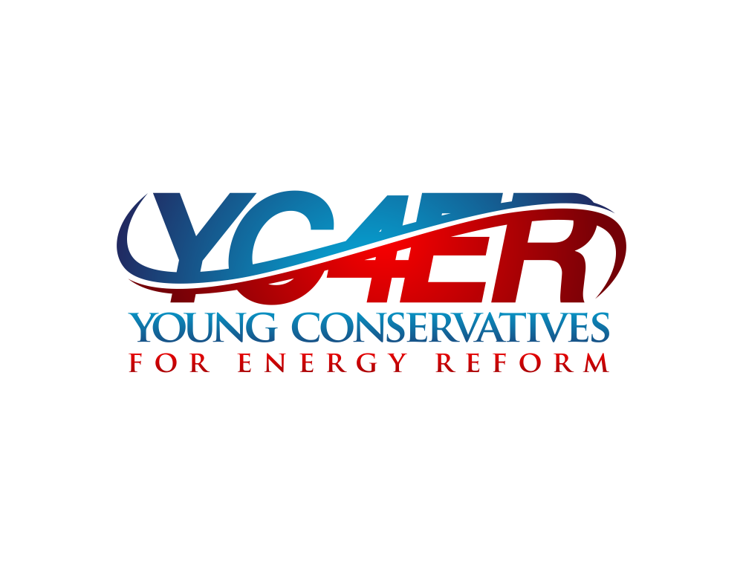

2012 - 2015 Media Audit

Produced by Cater Communications

The Republican Solution for Climate Change
Republicans have the ability to offer a market-based solution to climate change, so why aren’t they doing it?
TED HALSTEAD NOV 16, 2015
William F. Buckley, widely considered the father of modern conservatism, once opined: “Conservatives pride themselves on resisting change, which is as it should be. But intelligent deference to tradition and stability can evolve into intellectual sloth and moral fanaticism, as when conservatives simply decline to look up from dogma because the effort to raise their heads and reconsider is too great.” A perfect illustration is the GOP’s current stance on climate change—an issue Buckley himself took seriously.

In the face of overwhelming scientific consensus, today’s Republican leaders either deny climate science outright or insist that any solution, as Marco Rubio recently claimed, “would have a devastating impact on our economy.” This has relegated the GOP to playing defense at the moment that President Obama is turning climate mitigation into a central pillar of his legacy and heading to Paris to broker a global climate agreement. Republicans have backed themselves into a losing climate position that not only reflects poor science, poor economics, and poor strategy, but also betrays enduring conservative principles.

The party of Theodore Roosevelt has forgotten that stewardship stands among its most noble traditions. As Russell Kirk, author of The Conservative Mind, put it: “Nothing is more conservative than conservation.” It was Ronald Reagan, after all, who signed the Montreal Protocol, the most successful international environmental agreement to date. But today’s Republican leadership views stewardship as incompatible with free enterprise and limited government. This is a shame, as the conservative canon could offer America a better climate solution than Obama’s Clean Power Plan.

So what would a conservative alternative look like? Naturally, it would be market-based. It would begin by fixing a widely known flaw of free markets: their tendency to produce negative externalities—such as pollution—as a result of not being factored into market pricing. The obvious remedy is a carbon tax, which economists of all stripes overwhelmingly favor. Recent advocates include Henry Paulson and Gregory Mankiw, respectively secretary of the treasury and chairman of the council of economic advisers under President George W. Bush.
But what makes for good policy does not necessarily make for good politics. A carbon tax is usually considered a non-starter in the United States, both among the general public, to whom it sounds like all sticks and no carrots, and to the GOP, which views carbon taxes as a backdoor to larger government. This political calculus changes completely, however, if the money generated is returned to citizens in a revenue-neutral fashion. Two-thirds of Americans favor such an approach, according to a Stanford University/RFF poll.
The idea of a revenue-neutral carbon tax is hardly new. My colleagues Clifford Cobb, Jonathan Rowe, and I wrote about this 20 years ago in an Atlantic cover story. What’s new is that in 2008, the right-of center government in British Columbia introduced such a plan, and sufficient time has now passed to weigh the results. Fossil fuel use in British Columbia has since fallen by 16 percent, as compared to a 3 percent increase in the rest of Canada, and its economy has outperformed the rest of the country. So the benefits of this approach are no longer theoretical.

The next question is how revenue generated from carbon taxes should be returned to the American people. The Alaska Permanent Fund, which pays out an annual dividend to all residents, and was first introduced by a Republican governor in a state known for its libertarian tendencies, provides a useful precedent. But unlike the Alaskan model, which derives its revenues from resource extraction and therefore encourages fossil fuel use, a climate dividend funded by a carbon tax would encourage the precise opposite: efficiency and cleaner energy.

All citizens would suddenly have an economic stake in reducing greenhouse gases. There is no free lunch here, but rather a highly incentivized, à la carte, one: The bigger your carbon footprint, the more you pay; the smaller your footprint, the more you benefit as all revenue raised would be distributed equally. So if, for example, you choose to drive a gas-guzzler, your costs will go up, but if you switch to a more efficient car or public transportation, you come out ahead. Each year, both the carbon tax and corresponding dividend would increase, until the country reaches a low carbon economy.

Prominent Republicans such as former Secretary of State George Schultz and former Congressman Bob Inglis are already advocating such a plan—which they call Fee and Dividend—alongside liberals such as climatologist James Hansen. Meanwhile legislatures and citizens in states from Massachusetts to Washingtonare advancing their own versions of the idea, hinting at its bipartisan appeal. But the strategic upsides to Republicans may be the most intriguing.
Chief among these is a climate solution fully consistent with the philosophy of limited government. The popularity of climate dividends would ensure that a carbon tax remains revenue neutral—but the argument goes deeper. The logic of internalizing the environmental cost of carbon extends to pashing out all fossil fuel subsidies, which would shrink government. And over the longer term, as Paulson points out, “pricing carbon… will reduce the role of government, which, on our present course, increasingly will be called on to help communities and regions affected by climate-related disasters.”
What of the fears that tackling climate change could cripple the economy? As British Columbia illustrates, recycling carbon revenues back into the economy yields the opposite. Bill Gates (another carbon tax advocate), recently told The Atlantic that decarbonizing requires an unprecedented level of innovation. This so happens to be one of the main drivers of economic growth and higher living standards. Reinventing everything from transportation and energy infrastructure to homes and the appliances they contain will not only spur whole new industries, but also create vast numbers of jobs. This year, a REMI study found that pairing carbon taxes with climate dividends could generate 2.1 million new jobs in the United States over the next decade.
Could a climate solution that upholds conservative principles overcome the current lock that fossil fuel and related interests have over the GOP? Judging from the Republican presidential primary, the answer is a resounding no. But more encouraging forces are at work beneath the surface.
Jerry Taylor, president of the Niskanen Center, is lobbying Republicans topropose a carbon tax in exchange for dismantling Obama’s Clean Power Plan. A prominent GOP donor, Jay Faison, is spending $175 million to encourage Republican candidates to take climate change seriously. A number of Fortune 500 companies are voluntarily committing to carbon reductions. And grassroots groups like Young Conservatives For Energy Reform are gaining traction within the party. Add to that the moral weight of Pope Francis’s much-publicized plea to honor our collective responsibility as stewards of the earth.
Perhaps this explains the recent spike in the share of Republicans who acknowledge that climate change is occurring: from 47 percent to 59 percent in the latest University of Texas Austin poll, and from 47 percent to 56 percent in the latest University of Michigan one. Among younger Republicans and political independents —two key swing groups—support is considerably higher. Come the 2016 general elections, these numbers suggest that the Republican presidential nominee may well be cornered in an unpopular position for lack of a conservative climate solution.
How, voters will increasingly ask, can the GOP claim to be the party of the future, without a plan to safeguard it?
http://www.theatlantic.com/politics/archive/2015/11/a-conservative-approach-to-addressing-climate-change/415887/

OCTOBER 29, 2015

Will Conservatives Finally Embrace Clean Energy?

BY AMANDA LITTLE

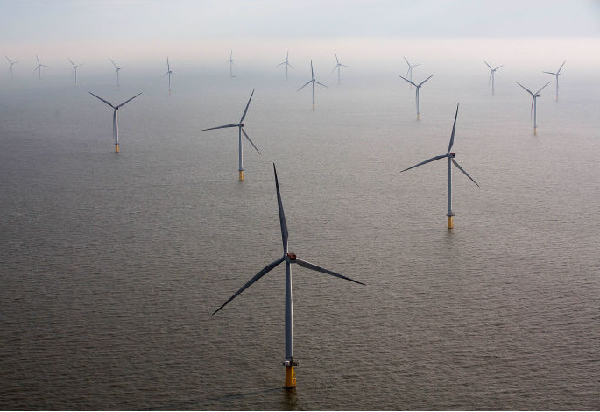

Just before Senator Chuck Grassley, of Iowa, took the stage at last week’s Conservative Clean Energy Summit, the event’s three hundred or so attendees were on their feet, pressing their hands to their hearts. They had sung along to a medley of anthems—“The Star-Spangled Banner,” “God Bless America,” “The Battle Hymn of the Republic,” the country-music chart-topper “Proud to Be an American”—as the conference room at the Capitol Hill Hyatt Regency was bathed in a splashy light show of stars and stripes. “It’s a privilege for me to be with people who believe that Jesus Christ is their personal savior and who are politically conservative,” Grassley said, “And it’s a privilege to get to speak to you about the virtues of a strong energy policy.” That rhetorical jump might have sounded abrupt to a passerby, but to the crowd it made perfect sense.

The summit was organized and hosted by Michele Combs, who heads up the group Young Conservatives for Energy Reform (Y.C.E.R.), and her mother, Roberta Combs, the president and C.E.O. of the Christian Coalition of America. Whereas Roberta has been a major player in the anti-abortion movement and has lobbied for the appointment of conservative Supreme Court justices, Michele is staking her career on a notably different cause. “Clean energy is not a Democrat issue. It’s a family issue,” she told me. “It’s about freedom and health and jobs and conserving our environment. It brings everybody together. Al Gore and I go way back—he’s a good friend—but he’s polarizing. He can’t get this message to our constituency.” The summit was part of an ongoing effort to move the issues of climate change and clean energy from the margins of the Republican Party to its mainstream. Although the Combses scarcely spoke at the event, they chose others to make their case—the executive of a solar-power company, a three-star and a four-star general, two congressman, and six U.S. senators.

Most of the summit’s audience appeared to range in age from eighteen to forty-five. Students and professionals had been flown and bussed in from around the country; there were representatives of the Christian Coalition, the Young Republican National Federation, and the thirty-one state chapters of Y.C.E.R. The stated goal of the event was simply to educate, but given how much collective political heat the speakers were packing it seemed clear that bigger questions were at play—questions about the future of a fractured G.O.P. “It is now time for the conservative cause to embrace energy reform and a clean environment,” Senator Lindsey Graham, of South Carolina, said via video link from the Presidential campaign trail. “Let’s not turn this over to the most liberal people in the country.” Clean energy, he added, is “the cause of a lifetime.”

There was an impressive amount of Republican self-critique among some of the speakers. Grassley, for instance, called out his colleagues for favoring fossil fuels over alternative energy. “You are going to find people in this town who say they are for ‘all of the above’ energy, but they’re really for none of the above and all of the below,” he said, underscoring his support for aboveground wind and solar resources. He and other speakers acknowledged that, from a consumer standpoint, belowground energy sources—oil and natural gas, in particular—are cheaper and more accessible now than they have been in years. Even more notable, however, are the trends in the renewable-energy marketplace: fossil-fuel prices fluctuate, but the costs associated with solar and wind power have been declining and will likely continue to fall. Indeed, nearly every speech was crammed with feel-good economic statistics: solar has become eighty per cent cheaper in the past five years; the U.S. clean-energy sector grew fourteen per cent in 2014, about five times as much as the rest of the economy. Senator Richard Burr, of North Carolina, cut to the chase. “Let me sum it up in one word: jobs,” he said.
Many of the speakers dodged both the issue of climate change and the pervasive conservative argument that fighting it will destroy, not create, jobs. Some of the most visible Republicans on the national stage, including the Senate Majority Leader Mitch McConnell and several Presidential contenders—Donald Trump, Ben Carson, and Marco Rubio—have made this argument before. (Trump, in a tweet, deemed climate science “bullshit.”) Rather than uttering the dreaded phrase, Senator John McCain, a former champion of climate legislation, spoke to the summit crowd about national security. Jeremy Symons, the director of climate and political affairs at the Environmental Defense Fund, advocated a big-tent approach. “It doesn’t matter whether you’re motivated by American energy independence, or by the promise of a clean-energy economy, or by breaking the power of monopolies over our home-energy choices, or by cleaner air, or by climate change,” he said. “What’s important is that you’re here.”

The long-term goal of Y.C.E.R., Michele Combs told me, is to help get “a comprehensive energy-reform bill” passed in the Senate soon after the next administration takes office—a bill that could also, in effect, break the congressional climate-legislation stalemate. No major Republican-backed climate or energy legislation has been proposed in the Senate since a cap-and-trade bill that Graham supported failed, back in 2010. (The Combses helped persuade Graham to take a leadership role on that bill, and they threw the support of the Christian Coalition behind it.) “We’re building grassroots to provide cover—to keep senators politically safe when they support energy reform,” Combs said. “First, we’re establishing common ground and a new terminology. Terms like ‘energy reform’ will bring a lot more conservatives to the table than ‘climate change.’ ”
If national polls are any indication, this is the time. A recent study from the University of Texas at Austin showed that fifty-nine per cent of Republican voters now accept climate science, up from forty-seven per cent just six months ago. A separate study from the University of Michigan showed similar results: fifty-six per cent of Republican respondents said that they believe global warming is a real and immediate concern, up from forty-seven per cent a year ago. The shift may have been driven, at least in part, by growing concerns about extreme weather phenomena—the withering drought in California, for example. “It’s getting harder to ignore nature,” Keith den Hollander, the thirty-eight-year-old chairman of the Christian Coalition of Michigan, told me. “Do I think that our climate’s changing? Yeah, I do. I mean, I’ve seen more severe winters than in the past, definitely some strange weather patterns.
It’s too early to know what measures a comprehensive, Republican-backed energy-reform bill might contain—and whether they would satisfy Democrats. Partisan conflict on this issue continues to smolder. Right now, twenty-six states are suing President Obama for his recent effort to regulate carbon-dioxide emissions under the Clean Air Act. But a growing number of conservative congressional leaders are trying to stake a claim on the climate issue. Yesterday, Graham and a group of his colleagues—Kelly Ayotte, of New Hampshire; Mark Kirk, of Illinois; and Lamar Alexander, of Tennessee—announced the formation of a Senate Energy and Environmental Working Group. Last month, eleven Republicans in the House introduced a resolution to address “the causes and effects of climate change.” It’s progress, albeit slow.
But is there time to wait for Republican leaders to inch their way toward climate legislation? A critical environmentalist might argue that an event like the Conservative Clean Energy Summit can’t establish a framework for carbon-emission reductions that are big enough and fast enough to keep warming below two degrees Celsius and stave off the worst impacts of climate change. Roberta Combs counters that such impatience inevitably backfires. “The liberals want to do it all at once—they want to solve this issue in one fell swoop,” she said. “That’s why they can’t get anything done. In reality, it has to be bit by bit. You have to bite the elephant one piece at a time, because it’s too big to swallow whole.”
http://www.newyorker.com/tech/elements/will-conservatives-finally-embrace-clean-energy

By ERIC WOLFF
10/22/15 10:03 AM EDT

With help from Nick Juliano, Matt Daily, and Alex Guillén

GOP POLLSTERS WARN AGAINST DISMISSING CLIMATE SCIENCE: "Participants [at Capitol Hill forum] warned that candidates risk alienating moderate swing voters if they reject climate science or oppose clean energy in the GOP primary. During a panel discussion among Republican pollsters, Glen Bolger of Public Opinion Strategies said candidates risk being perceived as 'a dinosaur when it comes to energy policy' if they ignore clean energy. Instead, he said they should tout jobs created by wind and solar development, reduced health care spending that comes with cleaner air and national security benefits tied to reduced dependence on foreign oil." Pro's Darren Goode has more from yesterday's event put on by Young Conservatives for Energy Reform and the Christian Coalition.
http://www.politico.com/tipsheets/morning-energy/2015/10/pro-morning-energy-wolff-210865#ixzz3pQwojlh2

GOP pollsters say candidates should not dismiss climate change
By Darren Goode
10/21/2015 06:02 PM EDT

Republican presidential candidates should embrace clean energy and climate change to pick up support in a general election, GOP operatives urged Wednesday, even as their party's presidential field has stayed mostly mum.

Young Conservatives for Energy Reform and the Christian Coalition brought Republican lawmakers, activists and pollsters to Capitol Hill for an event arguing clean energy was a winning natural security, economic and moral message for voters.

Participants warned that candidates risk alienating moderate swing voters if they reject climate science or oppose clean energy in the GOP primary. During a panel discussion among Republican pollsters, Glen Bolger of Public Opinion Strategies said candidates risk being perceived as "a dinosaur when it comes to energy policy" if they ignore clean energy. Instead, he said they should tout jobs created by wind and solar development, reduced health care spending that comes with cleaner air and national security benefits tied to reduced dependence on foreign oil.

The gathering comes as Hillary Clinton's campaign is labeling Republicans as anti-science in a broader-brushed effort to paint the party as out-of-step with the public on a variety of evolving issues, including gay marriage, women's health and normalizing relations with Cuba.

"Clean energy issues are more important for Republicans in the general election to underscore that they are not just living in the past," Bolger told POLITICO after the event. "What you'll see is those ideas will be ratcheted up come the general as long as we don't have a candidate like Donald Trump who has no idea what the hell he's going to say."

None of the upper-tier GOP presidential candidates have released ideas to tackle climate change. Florida Republicans Jeb Bush and Marco Rubio, who have released the two most comprehensive energy proposals so far in the GOP field, have focused mainly on spurring fossil fuels and reducing federal regulations. In a video message at Wednesday's event, South Carolina Sen. Lindsey Graham, a long-shot candidate, said, "We should not cede ground to our liberal friends on this issue."

Another pollster warned that while Republicans should not reject the reality of climate change outright, they also should put forward their own proposals to address it.

"Conservative voters do not reject climate change out of hand; it's what causes it and what do we do about it," said Dan Judy of North Star Opinion Research, who has conducted polls for Rubio.

https://www.politicopro.com/energy/story/2015/10/gop-pollsters-conservatives-push-clean-energy-climate-change-068536

ADVOCACY:

Young conservatives huddle on clean energy, not climate change
Evan Lehmann, E&E reporter
Published: Thursday, October 22, 2015

A large roomful of Christian conservative activists gathered in a hotel basement yesterday to bone up on the positions they would carry into their meetings with lawmakers and aides.
They heard about Islamic fundamentalists, statistics about the likelihood of being killed in a fuel convoy and the idea that exporting U.S. oil is the nation's best "weapon" against Iran and Russia, if you exclude the options with bullets.
It was a summit on clean energy for young conservatives, which focused on national security more than climate change. According to some of these activists, the event reveals a comfortable way for a younger generation of Republicans to speak about "energy freedom" like solar power and growing amounts of domestic natural gas for transportation and electricity.
Environmental aspects are present, but they take a back seat to concerns about helping poor families pay the electric bills and keeping Americans safe from bullies overseas.
"It's not a climate issue," said Tyler Duvelius, 22, the state energy director for the Ohio chapter of the Christian Coalition, which helped organize the event. "It's a family issue."
Perhaps 200 or 300 hundred activists attended the Clean Energy Summit organized by the Christian Coalition and Young Conservatives for Energy Reform. Afterward, they intended to meet with lawmakers and their aides to convey their support for cleaner sources of energy.
Renewable energy was a prominent theme. So was oil drilling. Solar speakers received applause, alluding to the strong support among conservatives for distributed energy systems that can power homes without much help from utilities.
Perhaps more popular were discussions about the nation's booming oil and gas production. Lawmakers like Sens. John McCain (R-Ariz.) and Tim Scott (R-S.C.) pointed to a future of growing American influence that they say can squeeze the economies of Russia and Iran. Both lawmakers support ending the longtime ban against exporting domestic oil.

GOP promotes clean energy jobs
McCain, who campaigned for president in 2008 on a platform that included a cap-and-trade program to reduce carbon dioxide emissions, didn't mention climate change or renewable energy.
There were also presentations advocating the expansion of the production tax credit and the investment tax credit. The PTC for wind expired last year, and the ITC is scheduled to drop from providing 30 percent of the cost of a solar project to 10 percent at the end of 2016.
In North Carolina -- where nearly 400 megawatts of solar electric capacity was installed last year, making it the fourth-largest producer in the country -- some Republicans talk optimistically about a clean energy future.
"Jobs," said Sen. Richard Burr (R-N.C.). "When we talk about this transformation to clean energy, we're talking about creating jobs in the United States."
Energy efficiency was also a popular theme. Sen. Rob Portman (R-Ohio), who is pushing an efficiency bill with Sen. Jeanne Shaheen (D-N.H.), said there are better ways to address wasted energy and greenhouse gas emissions than President Obama's power plant regulations known as the Clean Power Plan.
He also pointed to the Tropical Forest Conservation Act, a law passed in 1998 in which the United States forgives debt to equatorial nations in exchange for not clearing forest tracts. Portman, who introduced the original bill as a member of the House, is trying to reauthorize the initiative and expand it to include coral reefs. He told the group yesterday that deforestation is the third- or fourth-largest source of atmospheric carbon dioxide.
"Those groups come in and you end up protecting these forests that would otherwise be burned with huge increases in CO2," Portman said. "That doesn't cost a single job, folks."

Warming threatens military bases
One of the clearest voices on climate change came from a military veteran. Retired Air Force Gen. Ronald Keys, whose last assignment was commander of the Air Combat Command, told the group that the military sees rising temperatures as a threat to its operations, training and bases.
Solar panels and small wind turbines can reduce the need for convoys to carry diesel fuel for electric generators needed to run computers, lights and air conditioning in hostile regions, he said. For every 24 convoys, one soldier is killed or badly injured, making combat vulnerability "a big deal for us," Keys said.
Climate change is also affecting stateside bases. Up to 30 facilities are exposed to the impacts of sea-level rise like erosion and flooding, he said.
"That's gonna be a problem for Virginia politicians," Keys said, "because at some point someone may come to them and say, 'You know, let's pick up Langley Air Force Base lock, stock and barrel, and we're gonna move it to Oklahoma.'"
Meanwhile, drier conditions in the West are complicating training exercises that use ordnances that might ignite forest fires, he said.
In an interview after the event, Keys expressed frustration with the lack of discussion about climate change in Congress. He serves as chairman of the CNA Military Advisory Board, a group of 17 retired generals and admirals overseeing research into the threat of warming to national security.
It determined in 2007 that climate change is a "threat multiplier." In a report last year, the group said the risks of warming are "as serious" as some of the nation's greatest challenges, including its deterrence policies toward a nuclear-armed Soviet Union and current-day terrorism.
Keys faulted Republican lawmakers yesterday for promoting uninhibited oil production, without considering the impact it would have on greenhouse gases. He noted that some of those same lawmakers face rising sea levels that could impact military bases in their states. Those vulnerabilities will be considered when the Department of Defense looks at which bases it should shutter in the future, he said.
"You betcha," Keys said in the interview. "People will be worried about losing their bases. Well, they should have been worried about that 15 years ago and done something about it."
http://www.eenews.net/climatewire/stories/1060026741/search?keyword=%22YOung+Conservatives+for+Energy+Reform%22

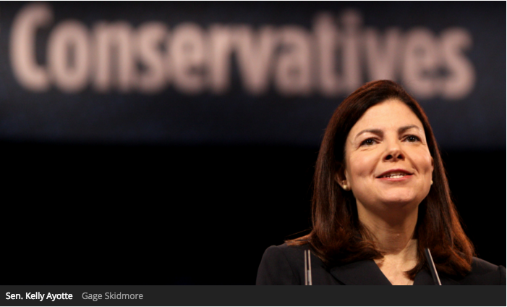

Getting warmer: More Republicans are starting to take climate change seriously
By Lisa Hymas on 30 Oct 2015

Sen. Kelly Ayotte (N.H.) is angling to turn herself into a Republican leader on climate change — at least in part to fight a 2016 reelection challenge from a climate-hawk Democrat.

Last Sunday, Ayotte became the first GOP senator to express support for President Obama’s Clean Power Plan, which will rein in CO2 emissions from electric utilities. On Wednesday, she released an ad touting that position and her other efforts to protect the environment. And on Thursday, she announced the formation of a new Senate Energy and Environment Working Group, which a spokesperson said will “talk about ways to build support for protecting the environment and climate and promoting cleaner energy production while also helping the economy.”

The new working group will include three other Republican senators who’ve acknowledged that climate change is a real problem: Lamar Alexander (Tenn.), Lindsey Graham (S.C.), and Mark Kirk (Ill.). Kirk, like Ayotte, is facing a tough reelection race in a moderate state. He appeared to waffle on climate science earlier this year, but has apparently settled on saying it’s a real, human-caused problem and trying to do something about it.
Politico’s Andrew Restuccia writes, “The establishment of the working group shows the shifting political dynamics at play over environmental policy, with some in the GOP worried that Republicans’ skepticism of mainstream climate science and opposition to air and water regulations isn’t sustainable in the long-term.”
We see a similar dynamic at play in the House, where Rep. Chris Gibson (R-N.Y.) is rounding up a handful of Republicans who want to shift the party’s approach on climate change (and inoculate themselves against election-season charges of obstructing climate action). Last month, as noted by Grist’s Ben Adler, Gibson and 10 other House Republicans introduced a resolution affirming their acceptance of climate science and their support for (as-yet-undefined) action to cut greenhouse gas emissions.
And these more climate-friendly congressional Republicans have some big-money backers. Jay Faison, a wealthy North Carolina businessman, has donated to Graham and other GOP candidates, and he plans to spend $175 million to push the GOP to address climate change. Andy Sabin is another wealthy businessman supporting Republicans who want to cut carbon emissions. In an interview with Grist earlier this month, Sabin named Ayotte, Kirk, Graham, and Gibson as Republicans he’s excited about.
Some of those same names cropped up last week at the Conservative Clean Energy Summit in Washington, D.C., a first-of-its-kind gathering of Republicans pushing for “energy reform.” Amanda Little, who’s been interviewing conservative climate leaders for a Grist special series, attended the conference and reported on it for The New Yorker. From her piece:
The summit was organized and hosted by Michele Combs, who heads up the group Young Conservatives for Energy Reform (Y.C.E.R.), and her mother, Roberta Combs, the president and C.E.O. of the Christian Coalition of America. … “Clean energy is not a Democrat issue, it’s a family issue,” [Michele] told me. … The summit was part of an ongoing effort to move the issues of climate change and clean energy from the margins of the Republican Party to its mainstream. Although the Combses scarcely spoke at the event, they chose others to make their case — the executive of a solar-power company, a three-star and a four-star general, two congressman, and six U.S. senators. …
The long-term goal of Y.C.E.R., Michele Combs told me, is to help get “a comprehensive energy-reform bill” passed in the Senate soon after the next administration takes office — a bill that could also, in effect, break the congressional climate-legislation stalemate. … “We’re building grassroots to provide cover — to keep senators politically safe when they support energy reform,” Combs said. “First, we’re establishing common ground and a new terminology. Terms like ‘energy reform’ will bring a lot more conservatives to the table than ‘climate change.’”
No matter what they call it, changing most Republican politicians’ hearts and minds will be a tough slog. The majority of GOP members of Congress still don’t accept the well-established science of climate change, and even those who do are more likely to criticize Democrats’ proposed solutions than to propose their own.
It’s a good sign that Ayotte feels she needs to support climate protections if she wants to be reelected. We might see more of that from her GOP colleagues in the Senate, all of whom need to be elected by statewide constituencies. But in the House, Gibson and his fellow resolution signers are anomalies — they’re in moderate districts, while most of their Republican colleagues are in dark-red districts and risk being primaried out of office if they call for cutting CO2 emissions.
If Combs and her allies could change that dynamic, it would be huge. It’s highly unlikely to happen anytime soon, but you won’t find anyone better positioned to lead the charge. As Little wrote in the intro to a Grist interview with Combs, she’s “possibly the most impassioned and unexpected messenger on clean energy and climate change the GOP has ever seen.” And with a mom who’s president of the Christian Coalition, she’s certainly got conservative cred.
http://grist.org/climate-energy/getting-warmer-more-republicans-are-starting-to-take-climate-change-seriously/

The following reporters also attended the Conservative Clean Energy Summit. Their stories will be added to the audit upon publication.

Timothy Gardner, Energy & Environment Correspondent at Reuters

Coral Davenport, Energy & Environment Correspondent at The New York Times

Tana Kantor, Publisher of TGE Ink

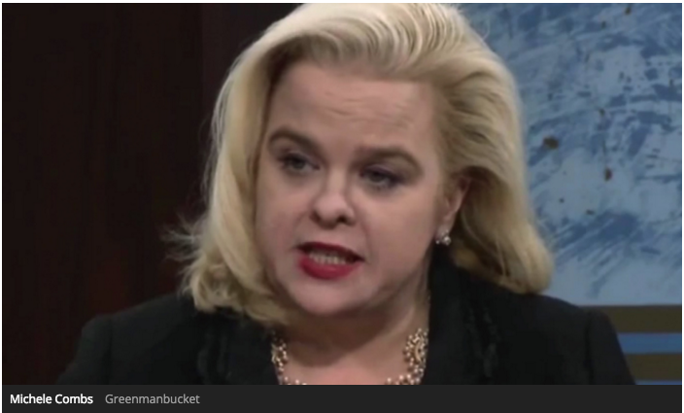

From the Christian Coalition to climate change: One conservative activist’s story
By Amanda Little on 5 Oct 2015

Think Al Gore, but a lot more charismatic, and a lot more Republican, and female — with curling, platinum blond hair, plenty of bling, and a honey-sweet South Carolina drawl. That gives you a rough sketch of Michele Combs, founder and chair of Young Conservatives for Energy Reform, and possibly the most impassioned and unexpected messenger on clean energy and climate change the GOP has ever seen.
“I love Al Gore,” says Combs, “but he’s the wrong messenger for us. And he’ll admit that. He made this issue polarized. And that’s what we have to tackle every day.”
The daughter of Christian Coalition President Roberta Combs, Michele jumped into politics at age 21 when she became state chair of the South Carolina Young Republicans and a protégé of Lee Atwater, campaign manager for George H.W. Bush. She later built a special-events company that produced hundreds of events for members of Congress, the White House, and the Republican National Convention. Along the way, she befriended many high-level party members.
That proved to be a big help in 2012 when she founded Young Conservatives, which is now building grassroots campaigns on energy reform and climate change in every state in the country, and working to convince environment-minded Republican senators to craft a comprehensive energy bill. She’s also working on the state level to help pass clean-energy legislation, like bills to set up net-metering systems that make it easy for homeowners with solar panels to sell their excess electricity into the grid.
We spoke with Combs recently to find out why she’s taking on this issue and what it will take to engage Republicans — young and old, moderate and right-wing — on climate change.
——
Q. What first got you fired up about energy reform?
A. It started when I was pregnant with my son — he’s now 14. You know how the doctors say, “Don’t eat fish.” So I asked my doctor why, and she said because of the mercury. Well, I said, “Mercury? Where is it coming from?” I began to research it on my own, and found that it came from coal-fired power plants. I was shocked. I thought, “This is something I need to get involved with.” But then I thought, ”Ahh! No, Michele, this is a liberal issue.” Then I thought, “A liberal issue? No! It’s a conservative issue, it’s a family issue — we need to protect our fetuses from mercury. It’s an American issue — we need to protect ourselves, our children, we need to protect everybody from mercury. Mercury’s a really bad thing.”
Q. How did that translate into political action on energy and climate?
A. I started on a mission to find out what was going on with our air, and why there is such a disconnect with the Republicans and the Democrats on this issue. So I got invited to this trans-partisan energy forum in Colorado in a real hippie town right outside of Boulder. There were a few conservatives there, but it was mostly liberals, about 30 of us, and we sat around this lake, and there was this gong, and they meditated, and I was thinking, “What the heck am I doing here?” One of people there was Al Gore. I was like, “Oh my Gosh, I am just in the throes of environmentalism!” But he was so kind to me, and while we’re very different, we became very close. I didn’t look at him as this liberal-monger Al Gore, I just looked at him as a person, and I learned a lot from him.
He introduced me to Larry Schweiger, who at that time was the president of the National Wildlife Federation. Larry said he’d been wanting to meet Republican senators and congressmen, and would I like to consult? I said, “Yes, of course,” because I really like him, and he’s a great Christian. I introduced him to my mother, and it ended up that the Christian Coalition started partnering with NWF. We were one of the ones that got [South Carolina Sen.] Lindsey Graham involved in the climate and energy issues, because Lindsey Graham and my mother are very, very close.
Q. How did you transition your focus from mercury to climate change?
A. The climate issue is not the defining issue for our organization at all, but, if we have clean air, it’s going take care of climate change. So if you don’t agree [with climate science], that’s fine, because we all agree on clean air. Clean energy is the next moonwalk, it’s the next frontier, and this country is the best country in the world. It’s so innovative and we can do anything, we can lead the world in this issue. I see it bringing jobs, and more importantly, clean air! I mean, who doesn’t want clean air?
Q. Tell me how your mom has influenced your work as an activist.
A. My mom is one of my biggest inspirations. She was a very successful businesswoman who became involved in politics and then she joined up with the Christian Coalition. The No. 1 thing the Bible talks about is to take care of the elderly, the widows, the environment, and so forth, so that tradition informs the Christian Coalition. My mom has taken a lot of heat for going after some of these issues, but she believes in her heart that this is what she needs to do. I took my thinking and my values from her example, with the idea that I would expand on it.
Q. So you see your environmental work as an extension of the Christian Coalition’s mission?
A. Yes, yes. Definitely. This is all about supporting the health and security of American families.
Q. Don’t Christians disagree about whether the Bible says God wants people to protect the Earth and its resources, or whether God has given us those natural resources to exploit and extract?
A. I don’t really deal with the Christian community. The Christian Coalition members are Christians, but they are Christians who are politically active. We focus less on faith and scripture and more on family advocacy. Our deal is all about education, about reframing the message. I love Al Gore, but he’s the wrong messenger for us. And he’ll admit that. He made this issue polarized. And that’s what we have to tackle every day. We have to educate conservatives — we’re the actual conservationists. That’s where the word conservative comes from — fromconservation, from Teddy Roosevelt.
There are Christians spreading a message about “Creation Care,” but they seem to be more liberal and moderate Christians, maybe Episcopalian or Lutheran. We don’t really use the “creation” language, we focus on clean air, jobs, family issues.
Q. Let’s get specific about your policy goals.
A. Our ultimate policy goal is a comprehensive, bipartisan energy reform bill that would give us clean energy, improve energy efficiency, and also help small businesses. The House always goes faster than the Senate, so we are starting with the Senate, and working through Republican senators like Lindsey Graham and Rob Portman [Ohio] and Kelly Ayotte [N.H.] and Cory Gardner [Colo.]. We’re meeting with senators and building up the grassroots support in the states where the senators live. Right now, for instance, I’m in Ohio.
Q. What kind of grassroots work are you doing in Ohio and elsewhere?
A. We helped Portman last year on his efficiency bill, which passed. We’re doing events for young conservatives in Ohio and getting a lot of media attention. I’m writing op-eds for papers like the Cleveland Plain Dealer. Elsewhere, we’re working on net-metering legislation in Indiana, Florida, and Georgia, for example, and wind energy legislation in Iowa, Kansas, and Texas. We understand, overall, that we’ve got to have the grassroots before we can go anywhere with the [national] energy bill.
Q. You have voiced your opposition to oil industry subsidies — would that be in the bill?
A. Yes, I think the oil subsidies are ridiculous. I don’t know how companies that make billions of dollars still get subsidies. They’re just there, and no one has managed to change that. But I don’t want to get too specific about the bill we want just yet — it’s too early to do that, and we risk not getting our foot in the door. Some senator may come out to say, “I don’t like that,” and shut us out.
Q. What’s your position on a carbon tax?
A. I’ve seen it [proposed] and I think it looks good, but I don’t think it’s something we’re going to come out on right now.
Q. What’s your timeline for the bill?
A. After the [2016] election. I just don’t see that anyone’s going to touch this issue now, especially the Republicans. And I don’t see a big shakeup happening [in Congress] in 2016 — if anything, there might be more Republicans. In the meantime, we’re going to really build the grassroots so we can provide cover, so we can keep the senators safe, so that when they do vote on the bill, they don’t get a lot of feedback from the other side. So they don’t get voted out of office.
Q. When you speak to senators and to the grassroots, do you have to be careful to avoid the issue of climate change?
A. We’re not going to go to ultra-right older Republicans and start talking about climate change, because if we do, they’re gonna shut us down. But if we talk about energy independence, clean air, homeowner energy, and American innovation, we have a chance to get them. Now, with younger Republicans, we can say, “Clean air is gonna help climate change,” and they’re like, “Yes it is!” They grew up with recycling, they grew up with renewables, they didn’t live through the whole Al Gore era, they have no barriers. But with older Republicans, you have to be more careful.
Q. What’s the hardest moment you’ve had, the biggest barrier you’ve faced, since you began your political work on energy and climate?
A. Going to one senator’s office, when we first started. I’m not going to tell you who it was because we’re still working on him, but he’s from out west. He told us off for taking on this issue, and it was kind of like, “You guys shouldn’t be here,” and it got uncomfortable.
Q. That sounds like the attitude of many of the current Republican presidential candidates toward the issue of climate change. Does it upset you to see how poorly energy and climate are playing among the conservative candidates? How do you think progressives and environmentalists should react?
A. They are playing to the base, which is very conservative. I know we will see more of [the energy and climate issues] closer to the general election. I’m optimistic. It’s politics, and politics can change fast. We just have to educate, educate, educate.
As for environmentalists, they have learn to compromise, and to not overreact. The fact is, we’re all Americans, and everybody wants a better future for their children. Climate activists can’t come in and say, “It’s our way or the highway, and we’re gonna die tomorrow because of climate change.” That’s not the way to sell it. Of course we’re not going to die tomorrow. Maybe 20, 30 years from now, but not tomorrow. [Laughs.]
You know the biggest thing to keep in mind? That it can’t be all or nothing. This is not about right versus wrong, good versus evil. It’s about educating, compromise, and baby steps. That’s the best advice I can give to anyone who wants to make a difference on this issue. It’s not whether you’re dunked or you’re sprinkled. It’s not a religion.
http://grist.org/climate-energy/from-the-christian-coalition-to-climate-change-one-conservative-activists-story/

CLIMATE

Marco Rubio Questioned By Republican College Student On Climate And Energy Policy

BY EMILY ATKIN SEP 29, 2015 8:00AM

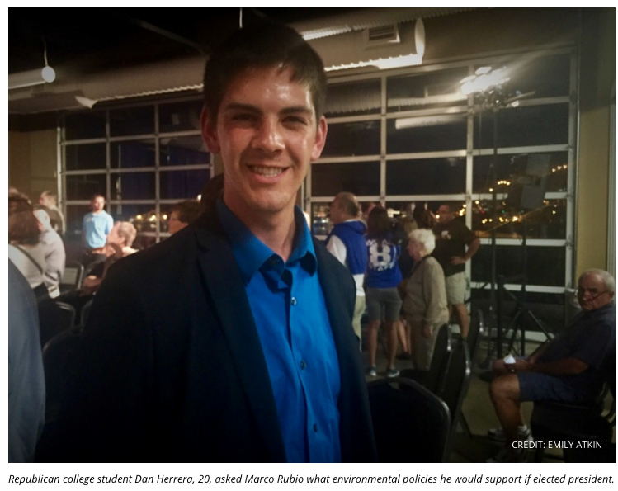

DAVENPORT, IA — When Dan Herrera asked Sen. Marco Rubio (R-FL) about the environment at a town hall meeting in Iowa last week, it almost seemed like a set-up.

After all, environmental groups have been known to plant their advocates among the crowds of Republican candidates’ events across the country, attempting to pressure them on issues like clean air and climate change. And Herrera’s question was framed the way any good environmentalist would ask it — first, an appeal to Rubio’s Catholic faith, and then, a direct question about specific policy.

“Pope Francis in the past couple days said a lot about the environment,” the 20-year-old Herrera said, smiling into the brightly lit stage where Rubio stood. “What environmental policies, if any, will you implement if you’re president?”

As it turned out, Herrera was not a member of 350.org or NextGen Climate Action, but a member of the Augustana College Republicans. Located at Augustana College just across the Missisippi River, the group is dedicated “to promoting the ideals and candidates of their party.”

The Republican party — at least in Washington, D.C. — has been roundly accused of being anti-environment. More than 56 percent of current Congressional Republicans deny climate change, and the chairman of the House Environment committee is a coal-loving climate science denier. Week after week, congressional Republicans hold hearings to decry the EPA’s proposed regulations on smog, coal ash, and drinking water, while calling other hearings to promotefracking, offshore drilling, and crude oil exports.
But among young Republicans like Herrera, the climate tide seems to be changing.

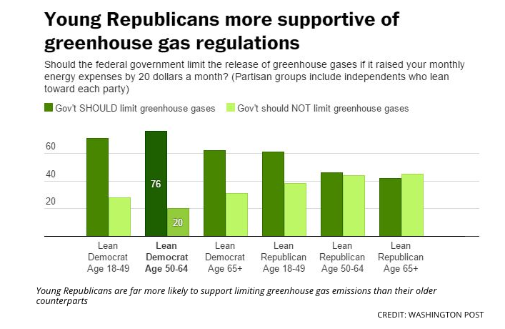

“Look, we all live here,” Herrera told ThinkProgress after the town hall. “I don’t like waking up every morning knowing that I’m wrapping my hands around my nieces’ and nephews’ necks, choking them out with the exhaust that I’m emitting. … I want them to see the same things that I see when I go outside when they’re my age. And I think that in the current pathway we’re at, that’s not going to be a possibility.”

Young Republicans like Herrera are far more likely to support government action on climate and the environment than their older counterparts. A Washington Post-ABC News poll shows that, while fewer than half of Republicans and Republican-leaning independents over age 50 support greenhouse gas regulations, approximately six in 10 of the same group under 50 do support those regulations — even if it means raising energy expenses.

In addition, more groups are forming and organizing to promote conservative clean energy and carbon-reducing policies. Before the first Republican debate, the groups Young Conservatives for Energy Reform and the Ohio Conservative Energy Forum gathered to promote their version of conservative environmentalism — “ending government subsidies for the fossil fuel industry, boosting energy efficiency, advancing renewable sources like wind and solar power and moving away from the idea that ‘drill baby, drill’ is a solution.”

Herrera’s views largely aligned with that version. “Why are we still subsidizing oil? That shouldn’t be subsidized anymore. We should be supporting air and ethanol and solar,” he said.

“The amount of permanent jobs we can come up with in the clean energy industry is phenomenal,” he continued. “When I go to a wind farm, I see actual people working on [turbines] and talk to the designers — I see actual jobs out there. And I think that’s where the Republican solution comes in. It is very possible to stimulate the economy while continuing to produce jobs.”

As for his question for Rubio — what environmental policies would be support as president? — Herrera said he was satisfied with his answer, even though Rubio did not provide many specifics. Instead of saying what policies he would support, Rubio said he was in favor of clean air and water but “Here’s what I don’t support,” before explaining his opposition to EPA regulations.

Later, however, Rubio said he would was in favor of natural gas — which he called a “very clean fuel” — and other renewable sources. “But it has to be driven by markets, and it has to driven by innovation, not by by government mandates that pick winners and losers,” Rubio said.

That was the portion Herrera was impressed with. “The fact that he didn’t just shut it down and immediately say ‘we’re not going to do anything,’ that spoke volumes to me coming from a Republican standpoint,” he said.

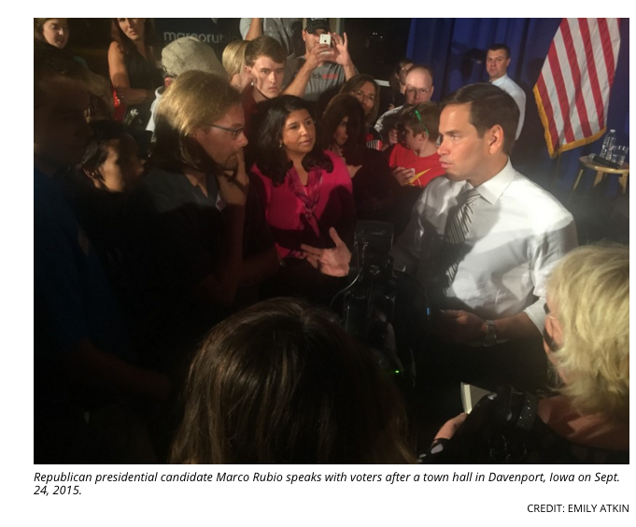

Climate change, as it happened, was the one thing Herrera wanted Rubio to talk about more. In fact, Herrera criticized Rubio for not publicly accepting the science of climate change, which states that the phenomenon is caused by carbon emissions and will be catastrophic if those emissions are not reduced. Rubio has recently said he doesn’t think climate change is a problem.

“In the past he was a climate science supporter, and now he’s publicly a climate science denier,” Herrera said. “I didn’t feel comfortable calling him out on that in front of so many people, but I would love to understand the reason behind his change of views.”

Rubio isn’t the only Republican presidential candidate getting grilled about climate change and the environment on the campaign trail. At one of Carly Fiorina’s town hall events in Dubuque, Iowa, a young woman in red glasses stood up and asked what the former Hewlett-Packard CEO what she would do to help fix the problem. Fiorina, too, said she was opposed to EPA regulation.

Though it was unclear whether the woman was a Republican, Herrera thinks that presidential candidates will continue to face those kinds of questions from GOP Iowans.
“[Iowans] are so very intimately tied with the land, they’re recognizing that the climate is changing and that as a human race … we’ve been awful stewards of the land,” he said. “That should have changed years ago, but it didn’t. And we can’t change the past, so we need to act right now.”

http://thinkprogress.org/climate/2015/09/29/3705448/rubio-fiorina-climate-change-republican-questions/

Young Conservatives Press G.O.P. Presidential Debaters to Wise Up on Energy

By ANDREW C. REVKIN

AUGUST 6, 2015

Not your typical Republican party

A few hundred yards from the Cleveland arena where Fox News has invited the top-ranked Republican presidential candidates to debate tonight, several hundred young conservatives will gather for an unusual party — “an epic Republican evening” celebrating and promoting energy policy reforms that are anathema to most of those who’ll be onstage.
These include ending subsidies for the fossil fuel industry, boosting energy efficiency, advancing renewable sources like wind and solar power and moving away from the idea that “drill baby, drill” is a solution.
The reception and debate-watching party has been organized byYoung Conservatives for Energy Reform, the Christian Coalition of America and the Ohio Conservative Energy Forum.
A prime force behind this push is Michele Combs, a longtime Republican and evangelical organizer who founded the national energy reform group in 2012. Combs says she got involved in energy politics when her doctor advised her to avoid fish during a pregnancy because of mercury levels worsened by power plant pollution and Republican friends said this was not an issue to pursue.
Combs and Scott Rost, from the group’s board of advisers, describe their goals in an opinion piece on Cleveland.com.
I had a Skype conversation with Combs last night that gets across the basics. I hope you’ll listen here. A transcribed snippet is below.

This is an arena rife with hidden agendas, political AstroTurf and the like.
But for the moment, this organization’s only agenda seems to be prodding the party and the candidates to realize that the Republican message of past campaigns is unsustainable — both environmentally and politically.
At the very least, it’s clearly not a pop-up effort.
In 2012, Inside Climate News focused on Combs in this article: “Against the Odds, Young Conservatives Buck the GOP on Energy and Climate Change.” Read this 2013 (Charleston, N.C.) Post & Courier piece for more.

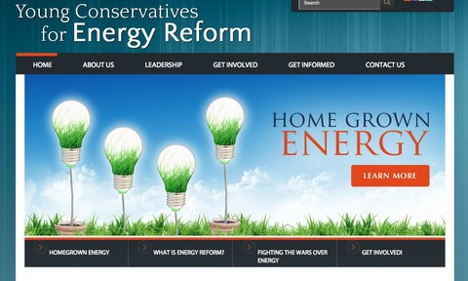
The website of Young Conservatives for Energy Reform.Credit

The group’s website has talking points that could as easily be found over at the Center for American Progress*, like this one:

Right now, subsidies and tax breaks favor old, dirty, entrenched energy sources over emerging clean, high-tech energy sources of the future. These subsidies and tax breaks keep us tied to foreign sources of energy, and discourage us from developing alternatives here at home and leading the world. We need to consider leveling the playing field.
I hope someone on the podium tonight is listening.
Here’s a small excerpt from my chat with Combs:
Q.
What is it like to talk to other Republicans about this.
A.
It’s all about education. You start with energy independence. I think most Republicans want to be energy independent. They don’t like having wars and they don’t like having to buy oil from countries that hate us and want to harm us. And then I think most people want clean air. I’ve never talked to anyone who doesn’t want clean air.
This issue was so polarized for so many years and I think it had the wrong messenger. [Elsewhere she alludes to former Vice President Al Gore and President Obama.]
Getting it back in our court is a slow process, but I haven’t had any negative feedback.
Q.
There’s a lot of name calling — deniers — when it comes to climate change. When I look behind the yelling, I see a lot of the things you were just talking about. I know libertarians who love to not have to rely on a utility for all their electricity. Having a solar panel or some kind of capacity to generate your own electricity, that is a very powerful thing for someone who wants limited control on their lives from the outside…. If you make it all about climate change, you might be alienating people who could be allies. Do you see that kind of thing?
A.
It’s not a litmus test for our group because i think it would alienate. But there’s a process of getting there. I think you start with energy independence and renewables and homegrown energy. Especially with younger conservatives and millennials, they don’t have a problem with climate change. They know it’s out there, and even a lot of the candidates that are running now definitely have acknowledged it.
I see a lot of synchronicity between this partisan approach and the nonpartisan efforts of others seeking climate progress, including the religion-framed discourse of the Texas Tech climate scientist Katharine Hayhoe and the arguments of Kerry Emanuel of the Massachusetts Institute of Technology and Richard Alley at Penn State — both of whom are climate scientists who are registered Republicans.
For more |
“Obama Policy Could Force Robust Climate Discussion From 2016 Candidates” (The New York Times, Aug. 2, 2015)
“The Most (And Least) Extreme Republican Presidential Candidates On Climate Change” (Climate Progress, July 26, 2015)
“The Seven Unexpected Republicans to Watch If You Care About Climate Change” (National Journal, Jan. 5, 2015)
“Religious Conservatives Embrace Pollution Fight” (The New York Times, July 31, 2014)
“Wanted: Republicans for Responsible Oil Policy” (Dot Earth, June 23, 2011)
“‘Republicans for Environmental Protection’ – Endangered Species?” (Dot Earth March 14, 2011)
Clarification, 12:40 p.m. | * I initially included a link to a Think Progress post from the Center of American Progress point above. A reader pointed out on Twitter that the blog has different approach to issues than the nonprofit group.
http://dotearth.blogs.nytimes.com/2015/08/06/young-conservatives-press-g-o-p-presidential-debaters-to-wise-up-on-energy/?smid=tw-share&_r=0
Sample social media hits:

CAMPAIGN 2016:

Enviros, industry rally to put energy, climate in GOP debate
Jennifer Yachnin, E&E reporter | Thursday, August 6, 2015
Environmental activists and energy industry representatives may not agree on the answers, but in the lead-up to tonight's first Republican presidential debate, both sides are clamoring for answers to the same question: What are the candidates' energy platforms?
A total of 17 Republican candidates are set to face off tonight in one of two debates hosted by Fox News, Facebook and the Ohio Republican Party.
A prime-time event will feature the 10 candidates who polled at the top of the five most recent national polls on the race, and an afternoon forum will feature the remaining seven candidates who failed to make the cut.
The 9 p.m. EDT debate will include businessman Donald Trump, former Florida Gov. Jeb Bush, Wisconsin Gov. Scott Walker, former Arkansas Gov. Mike Huckabee, physician Ben Carson, Texas Sen. Ted Cruz, Florida Sen. Marco Rubio, Kentucky Sen. Rand Paul, New Jersey Gov. Chris Christie and Ohio Gov. John Kasich.
The 5 p.m. EDT debate will include former Texas Gov. Rick Perry, former Pennsylvania Sen. Rick Santorum, Louisiana Gov. Bobby Jindal, South Carolina Sen. Lindsey Graham, former New York Gov. George Pataki, former Virginia Gov. Jim Gilmore and former Hewlett-Packard Co. CEO Carly Fiorina.
In recent days, both environmentalists and fossil fuel advocates have called on the Fox News moderators to query the candidates on energy-related issues.
American Petroleum Institute President Jack Gerard said Tuesday that while he expects energy production issues will be included in the debate, he wants to ensure candidates have ample time to focus on the issue.
"I'm not concerned that energy won't be a part of the debate," Gerard said in a teleconference with reporters. He added: "What I want to make sure is that when it comes up, we have a robust discussion around it, and we find out where these candidates are on this historic opportunity."
But environmentalists like California billionaire environmental activist Tom Steyer, who serves as president of NextGen Climate, are also pushing candidates to discuss their views on climate change policy.
"We urge you to ask the Republican candidates for their plan to power our country with more than 50 percent clean energy by 2030 and put us on a path to a completely clean energy economy by 2050," Steyer wrote yesterday in a public memorandum to the Fox News moderators Bret Baier, Megyn Kelly and Chris Wallace. "The American people will be tuning in to hear how the Republican candidates propose to lead our country -- and we urge you to make sure they answer the important questions."
The League of Conservation Voters similarly published an unsigned memorandum urging candidates to discuss the Clean Power Plan and their position on reducing carbon pollution.
Still other activists are working more directly to put energy-related questions before the candidates.
Michele Combs, founder and chairwoman of Young Conservatives for Energy Reform, told E&E Daily that her organization -- along with the Christian Coalition of America and the Ohio Conservative Energy Forum -- has urged its members to submit questions via Facebook. Fox News has said it plans to use submissions from the social media website to formulate some of the debate questions.
"I'm hoping that we'll see a question come out on Thursday night about clean energy. Republicans are really starting to see that they need to embrace this more," Combs said.
She added: "I know they all want to be energy independent and they want to use our resources in this country. ... If you hear most of the candidates talk about it, they all agree, it's just a matter of how we're going to get there."
But advocates for both renewable energy and fossil fuels could be faced with disappointment.
According to a study released by the Winston Group last month, questions about energy policy made up 1.7 percent of all questions asked during a series of 20 GOP presidential primary debates in the 2012 cycle.
The research firm examined 719 questions put to Republican candidates in the 2012 cycle and found 12 related specifically to energy policy. Another six questions, or less than 1 percent of all questions asked during those 20 debates, focused on the environment.
The most-asked-about topics included queries on the economy, which claimed 187 questions, and on foreign policy, which was the focus of 146 questions.
http://www.eenews.net/eedaily/stories/1060023074/search?keyword=Michele+Combs

Parties, Protests Mark First Political Event of 2016 Election
Molly McKitterick
August 06, 2015 8:16 AM
A small group of protesters gathered in front of the TownHall Restaurant in Cleveland, Ohio, Wednesday. Inside, the restaurant staff was making preparations for a rally for Republican presidential hopeful and U.S. Senator Marco Rubio.
But the protesters were not against Rubio. They were taking advantage of the hoopla surrounding Thursday’s Republican debate to demonstrate against the owner of the restaurant, who has been vocal in the movement to legalize marijuana in Ohio.
Ohio’s second-largest city is in the midst of a typical American political free-for-all, in the run-up to the first political event of the 2016 presidential election season, a happening that is being marked with booked hotel rooms, crowded streets, protests and parties.
City officials are busy fielding requests for protest permits, according to local media reports. A group of immigrants plans to march outside the Quicken Loans Arena, where the debate is taking place, to object to the “hate rhetoric” of Republican front-runner Donald Trump.
Another group, Americans United for Change, plans a march to show “how out of touch” all the Republican candidates are. ProgressOhio Education will be protesting Governor John Kasich’s cuts to education. Kasich also is a presidential candidate and will be participating in the debate.
And the parties: Young Conservatives for Energy Reform will be gathering to cheer the debate at the Hard Rock Café, and the American Conservative Union will be at the House of Blues. The Ohio Democratic Party will have a party at the Market Garden Brewery. At this party, more booing than cheering can be expected.
Cleveland: ‘Grit Meets Sophistication’
The unexpected popularity of outspoken billionaire candidate Trump has put the debate in the national spotlight, and it promises to be a great windfall for Cleveland.
“Cleveland has been misunderstood,” says bookseller John Zubal, “and I think, so to speak, an underrated city for a large part of my lifetime. And the Republicans coming here are exposing a side of Cleveland that’s been hidden for a long time.”
On the banks of Lake Erie, the Midwestern city has had a reputation as a rust belt city, whose economic base was manufacturing until both the industry and the city fell on hard times. But recently, Cleveland has diversified its economic base and bounced back.
“World-class experiences without the world-class ego” touts Destination Cleveland, the city’s convention and tourism bureau, which also says Cleveland is where “grit meets sophistication.”
Senior director Emily Lauer says Cleveland has been on a roll since the city’s basketball team, the Cavaliers, hosted the NBA Championship earlier this year. Although the Cavs lost, the event energized the city.
“That level of excitement we saw with the Cavaliers, I think we are seeing that again,” said Lauer.
The basketball championship was also held at the Quicken Loans Arena, known as the Q. With the debate in mind, it may be worth noting that in addition to the Cavs, the Q also is home to the hockey Monsters and Arena football Gladiators.
‘Super Bowl of meetings’
Cleveland was picked for the first debate and it also will host the last and biggest event of the campaign season: the Republican National Convention a year from now.
At the convention, the current field of 17 Republican candidates will have been winnowed down to one, and that person will be officially designated as the Republican nominee.
Lauer calls the convention the “Super Bowl of meetings” and predicts it will bring $200 million into the city.
It is not by accident that Cleveland has been picked to both open and close the Republican presidential nomination process.
The state of Ohio is a swing state that vacillates back and forth between Republican and Democratic candidates. But Ohio also has an eerie track record of picking presidential winners. Since 1964, the state has always voted for the person who won the presidential election.
The Republicans are making their presence known early.
http://www.voanews.com/content/parties-protests-mark-first-political-event-of-2016-election/2903563.html

Young Republicans want GOP to address energy, environment
August 6th, 2015
By Stephanie Carson - Ohio News Connection
Young Republicans want their party to address issues related to energy reform and the environment in tonight’s debate in Cleveland.

CLEVELAND – Ohio is Ground Zero today for the 2016 presidential campaign as Republican candidates for president square off in the campaign season’s first debate.
With a full spectrum of GOP contenders with various priorities, Young Republicans are reminding candidates to pay attention to issues important to them. Michele Combs, founder and chair of Young Conservatives for Energy Reform, says one of those issues is the environment and renewable energy.
“We think it is an American issue, it’s a patriotic issue, it’s a conservative issue to use our homegrown resources,” she says. “We’d like to see more renewables, solar, wind, so we’d like the Republican Party to embrace more of that.”
Tonight the Ohio Conservative Energy Forum, Young Conservatives for Energy Reform and the Christian Coalition of America will host a GOP primary debate watch party in Cleveland to see which presidential candidates will earn the support of Republican voters concerned about clean energy and other key conservative issues.
The debate gets underway tonight at 9 p.m. Eastern time.
According to the Pew Research Center, 50 percent of millennials are Democrats or lean to the Democratic Party, and 34 percent support the GOP. Some experts suggest the Republican Party could see more support from younger voters if they include the protection of the environment in their discussion.
Combs says while the parties may disagree on how to best implement energy reform, protecting the environment is something that appeals to both sides.
“The whole issue, the main issue, they do agree on that,” she says. “Especially among the young people, they get it, they understand it.”
Tonight’s debate is scheduled to run two hours, with three Fox News hosts asking questions of candidates. Donald Trump, Jeb Bush, Scott Walker, Mike Huckabee, Ben Carson, Ted Cruz, Marco Rubio, Rand Paul, Chris Christie and John Kasich will appear in the debate. Former Texas Governor Rick Perry will be among those left out of the mix.
http://morrowcountysentinel.com/news/2057/young-republicans-want-gop-to-address-energy-environment
Also appeared in:

Sample social media hits:

Here's a List of the Republican Debate Watch Parties Happening Tonight

Posted By Eric Sandy Thu, Aug 6, 2015 at 10:47 am
Tickets for the Big Show at the Q tonight went fast, but there are plenty of spots around town to gather and watch the festivities. We can only hope that most of these come with some sort of official in-house drinking game rules.
Did we miss a party listing? Drop a comment below and let us know.
Moncho’s Bar and Grill
2317 Denison Ave.
8 p.m. to 11 p.m.
Pro-immigrant voters, immigrants and allies are gathering for a Ohio’s Voice watch party to respond to the candidates’ comments on immigration reform.
Hard Rock Cafe Cleveland
Tower City Center, 230 W. Huron Road.
6 p.m. to 11 p.m.
Hosted by the Young Conservatives for Energy Reform, the Ohio Conservative Energy Forum, and the Christian Coalition of America to zero in on candidates' stances on clean energy and other environmental issues.
The City Club
850 Euclid Ave.
6:30 p.m.
This event is sold out. Panelists include: John C. Green, Ph.D., Director, Ray C. Bliss Institute of Applied Politics, The University of Akron Karen Beckwith, Ph.D., Chair and Flora Stone Mather Professor, Department of Political Science, Case Western Reserve University Jakiel Sanders, Chair, Governmental Affairs, Cleveland Young Professional Senate.

Speakeasy
1948 W. 25th St. (in the basement of Bier Markt)
8 p.m. to 11:30 p.m.
From the organizers: "Think that all candidates should be talking about increasing the minimum wage to a living wage? Does our nation need an urban agenda? While Thursday's GOP debate may not feature the best candidates for you, meet folks who also want to organize for increased wages and benefits for workers, their families, and their communities."
House of Blues
308 Euclid Ave.
9 p.m. to 1 a.m.
The American Conservative Union
This one costs $10, and it follows what seems to be an all-day thing. "Buckeye Boot Camp" begins at 2 p.m. and will feature appearances from candidates Carly Fiorina, Rick Perry and Rick Santorum.
Market Garden Brewery
1947 W. 25th St.
8 p.m. to 11 p.m.
Ohio Democratic Party and the Cuyahoga County Democratic Party
Hosted by "the other party," this event will contrast Democrats' views on the major social and economic issues with whatever canned speech snippets the GOP candidates provide.
Union Club
1211 Euclid Ave.
The Ohio Chapter of the Frederick Douglass Foundation
Alveda King, the niece of the Rev. Martin Luther King, Jr., will be in attendance for this event. Admittance costs $20 at the door.

http://www.clevescene.com/scene-and-heard/archives/2015/08/06/heres-a-list-of-the-republican-debate-watch-parties-happening-tonight

Debate has big impact on CLE
August 05, 2015

CLEVELAND, OH (WOIO) -
For those of you who weren't around downtown Wednesday, it kind of feels a little like the NBA Finals that were just here back in June. The buzz, the set up and the money, all good things for our city.
The prep work in and around the Q is in high gear. Police starting to barricade off areas around the arena to control traffic and possible protesters.
The people at Destination Cleveland compare this national stage to the NBA Playoffs, with a chance to continue to tell the resurging Cleveland story. National media have taken over Huron in front of the Q, and are setting up in other areas around downtown like East 4th.
Now it's time to talk money. From private jets at Burke LakeFront, to hotels and restaurants. Stop and think for a second when you picture
a debate stage with 10 podiums. All these candidates have large staffs who will be here hoping to get their candidate out front.
Most are staying in downtown hotels which we are told are at capacity. That's close to four thousand rooms. Many restaurants, like the Hard Rock Café will host private watch debate parties for national groups like the Christian Coalition of America.
You can follow the debate coverage online by downloading the 19 Action News app. The free app is available for Blackberry, Android, iPhone and iPad devices. If you don't have a smartphone but would still like to stay informed, just log onto our mobile site at m.woio.com from your phone's browser.

http://www.19actionnews.com/story/29717427/debate-has-big-impact-on-cle

GOP Debate Gives Candidates, Activists a Chance to Campaign in Ohio

Wednesday, August 5, 2015 | Nick Castele
Updated 8/10/15

The Republican debate in Cleveland kicks off Thursday night at Quicken Loans Arena. And there will also be plenty of activity outside the Q.
More than a dozen Republican presidential candidates descend upon Cleveland this week, and several are trying to get in a bit of old-fashioned campaigning while they’re here.
Florida Sen. Marco Rubio held a rally in Cleveland’s Ohio City neighborhood. His host was Ohio Treasurer Josh Mandel, who broke from other major state Republicans this year in endorsing a rival to Gov. John Kasich’s presidential ambitions.
Another 2016 contender, Wisconsin Gov. Scott Walker, scheduled a visit to a Cleveland landmark—Slyman’s Restaurant on St. Clair Avenue. In past years, this eatery famous for its corned-beef has opened its doors to Vice President Joe Biden and then-president George W. Bush.
And Northeast Ohio will play host to a bevy of debate watch parties. There’s one for supporters of immigration reform, for raising the minimum wage, and for the state Democratic and Republican Parties, just to name a few.
Michele Combs is the founder of Young Conservatives for Energy Reform, which advocates using more renewable energy.
She said she traveled to Ohio to host a watch party because of the state's political importance.
"We want to be part of the first debate, and we wanted to show the Republicans that are here in town what we care about."
Ned Ryun is with the political training institute American Majority. He’s running a session in Cleveland with the American Conservative Union training conservative activists to become more effective campaigners.
"Obviously, Ohio’s going to be a very key state in 2016," Ryun said. "And if we can equip the grassroots here in Ohio to do the right things, better our chances to win the state next year."
It’s just one of many times Ohio will be the center of political attention between now and November 2016.
http://www.ideastream.org/news/gop-debate-gives-candidates-activists-chance-campaign-ohio

GOP should embrace clean energy: My Word

August 3, 2015

The 2016 presidential-election cycle is underway, and Florida is smack in the middle of it. An early primary state with a couple of favorite sons in the mix, the Sunshine State can expect a stream of candidates making their cases for why they deserve the nation's top office.

With the first official debate scheduled for Thursday, we hope the candidates' pitches will talk about the importance of promoting homegrown, clean energy. At Young Conservatives for Energy Reform, we encourage all the Republican presidential candidates to embrace policies and practices that are good for the economy, good for our national security, and good for our party at the ballot box. Clean energy checks all these boxes.

Floridians — especially younger voters — recognize that the state will benefit by adopting clean, homegrown energy, such as solar power and biofuels. Why? The clean-energy sector promotes a strong economy, supporting 130,000 jobs across the state.

The Orlando Utilities Commission — looking to install thousands of solar panels just east of the city — is one of a number of utilities in the state investing in large-scale solar as a financially viable energy source. The town of Longwood has adopted programs to promote energy efficiency and sustainable buildings, in order to reduce operating costs and promote a clean environment. We recently held an event there featuring retired Lt. Gen. Richard Zilmer, a member of the CNA Military Advisory Board; CNA is a nonprofit research and analysis group headquartered in Alexandria, Va.

Clean energy also helps bolster national security. At our Longwood event, Zilmer explained that on the battlefield, clean energy helps reduce the number of dangerous fuel conveys. And across the U.S., military bases are prioritizing on-site clean energy and efficiency in order to boost energy security, save money, and ensure reliable power.

We call on GOP presidential hopefuls to embrace clean energy. America should lead global clean-energy innovation efforts, and promote local jobs and a healthy environment. Clean energy should not be a divisive issue. Rather, it is a goal worthy of the support of those who want to be our next president.

At stake is not just control of the White House, but the future of our economy, our environment and our national security.

Michele Combs is founder and chairman of Young Conservatives for Energy Reform (YC4ER). Jennifer Wagner is YC4ER's Orlando chairman.

http://www.orlandosentinel.com/opinion/os-ed-clean-energy-candidates-myword-080315-20150731-story.html

Young conservatives gathering in Cleveland want to hear debaters' clean-energy plans: Michele Combs and Scott Rost (opinion)
August 02, 2015

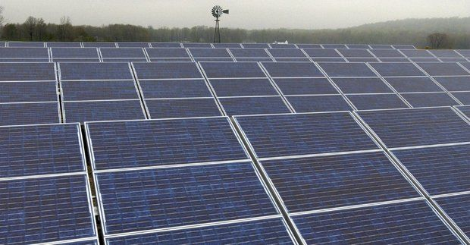
The Fields of Lake Farmpark in Kirtland. (Plain Dealer Photo By C.H.Pete Copeland)

As the Republican presidential hopefuls gather in Cleveland for the first of the primary debates, they seem focused on the personalities of the people sharing the stage instead of the policies they plan to pitch to voters. We would like to see their attention – and the media's – refocused.
The snarky sound bites and "gotcha!" comments coming from the campaign trail aside, our nation faces serious challenges that require strong leadership. Voters deserve to know candidates' detailed plans for addressing real issues. This initial debate provides candidates an opportunity to sell to America a path forward for this country. And for many voters, this debate will provide first impressions that will influence their decisions at the ballot box.
Michele Combs is founder and president of Young Conservatives for Energy Reform in Washington, D.C.

Our country is at a crossroads right now, and the presidential election provides us a perfect opportunity to realign our priorities and vision. Our Grand Old Party needs to reposition itself to appeal to a broader range of voters, including younger ones. They are looking for a candidate who represents their position on all the issues.
But most critically, they care about creating a secure future for the United States by embracing clean energy sources.
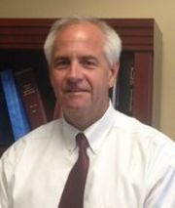
In spite of the vast natural gas resources that lie even beneath the very stage where the candidates will debate, our country remains heavily dependent on foreign oil. This whipsaws our economy and leaves families victim to volatile gas prices. Our addiction to fossil fuels weakens our national security and our energy security and puts a leash on expanding our economic potential. Just imagine: We borrow money from China to buy oil, including from some nations that do not have our best interests at heart.
Scott Rost is a partner at the South Milhausen law firm in Orlando, Florida

Drilling more domestically is not the only answer. No matter how much we produce here at home, oil is a global commodity, and unfortunately, we don't control the spigot. But we do control how we use those God-given renewable resources that are right here in our country. These homegrown energy sources are plentiful — even infinite. Clean energy produced right here at home doesn't require us to remain at the mercy of volatile political situations or unpredictable dictators.
History has demonstrated that when it comes to technological innovation, America's entrepreneurial spirit and dedicated workforce can set a brisk pace for the rest of the world to follow. But this won't happen in the clean energy sector without a detailed energy plan for this nation that includes support for policies that move us closer to true energy independence.
Americans see a crowded Republican primary field, and will quickly winnow it down beginning with this first debate. The public wants and deserves a spirited exchange of high-minded ideas and policy proposals designed to solve pressing problems, not more personal attacks. Our clean, sustainable energy resources provide opportunities for Republican candidates to refocus and re-energize the campaign season with creative, positive approaches worthy of the voters who expect the very best of those who hope to lead our great county. Let's show the voters at home, and people watching beyond our borders, that America can also lead the world, once again, in sound, responsible and sustainable energy policy.
Americans will be tuning into the debate this week not because they are eager to watch the candidates bicker, but because they want to see real solutions put forth on the issues they care about most. It's time we move our party forward by embracing a detailed "all of the above" energy paradigm that is not just a catchy turn of phrase, but a serious commitment reflecting 21st-century values and American ingenuity.
Michele Combs is founder and president of Young Conservatives for Energy Reform in Washington, D.C. Scott Rost is a partner at the South Milhausen law firm in Orlando, Florida, and a member of the board of advisors of Young Conservatives for Energy Reform. Young Conservatives for Energy Reform, the Ohio Conservative Energy Forum and the Christian Coalition are hosting a pre-debate reception and debate watching party at Cleveland's Hard Rock Cafe Thursday from 6 p.m. to 10 p.m. Space is limited so register in advance. For information: tinyurl.com/qa3xoek
http://www.cleveland.com/opinion/index.ssf/2015/08/young_conservatives_want_to_he.html

Sample social media hits:
Sample social media hits from YC4ER’s Debate Watch Party in Cleveland:

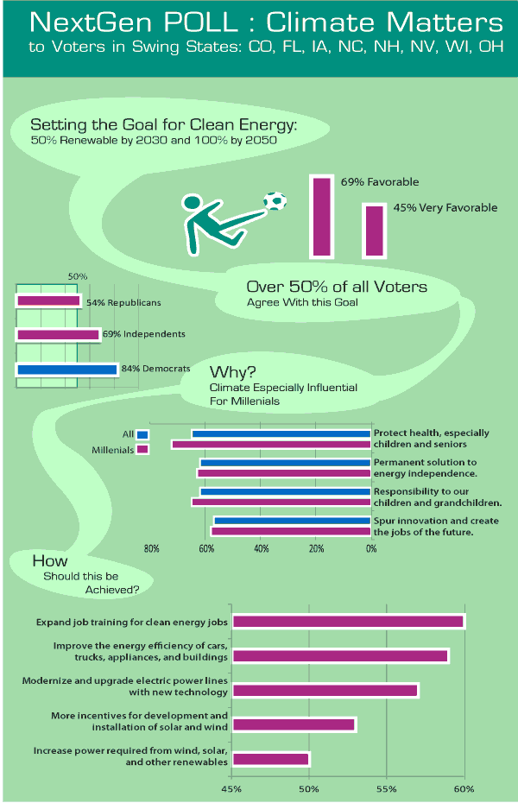
Energy Reform crosses political boundaries, uniting a broad swath of voters in swing states.

July 31, 2015
Two recent events have highlighted the broadening of the energy base:
- Hart Research poll for NextGen Climate that asked voters their opinion on energy policy in 8 swing states: Colorado, Florida, Iowa, North Carolina, New Hampshire, Nevada, Wisconsin and Ohio.
- YC4ER, Young Conservatives for Energy Reform, host an event in Cincinnati, Ohio before the first Republican presidential debate.

NextGen Climate Poll
The Poll showed a strong support for the goal of 50% clean energy by 2030 and the inclusion of a longer-term goal of 100% clean energy by 2050 amongst Republicans, Independents and Democrats.
The Hart report concluded that clean energy has the potential to be an important and persuasive issue in the 2016 presidential campaign. Hart Associates found that voters are overwhelmingly positive toward a candidate who sets a goal of achieving at least 50% clean energy by 2030. Six in 10 (61%) voters say they would be more likely to vote for a candidate for president if they adopted this goal while only 14% say they would be less likely. This could be a mobilizing issue for independents, 62% of whom say they would be more likely to vote for this candidate (compared to just 13% who would be less likely), as well as voters who remain undecided about the 2016 election (46% more likely to vote for a clean energy candidate, 15% less likely). Amongst millennials, a group that the pollsters find are hard to get motivated, 80% found clean energy an inspiring goal, as did 66% of the general electorate polled.

YC4ER
The poll comes as Young Conservatives for Energy Reform and the Christian Coalition will host a reception on August 6 at the Hard Rock Cafe in Cleveland, Ohio prior to the first Republican debate. The group believes energy has been a source of partisan bickering for too long which has weakened the US position as a leader in the energy revolution that is here. They see America’s over-dependence on foreign sources of energy as a drag on the US struggling economy and a threat to national security. They also believe that focusing on a national energy policy and the growth of clean energy means spending more money at home, thus creating jobs and boosting the economy. As they say on their website:
Broadening the base of support for a new energy policy is essential. Conservative and moderate voices must be invited to speak up and help guide a more informed energy dialog, which will produce common sense solutions everyone can agree on. We will build an energy platform that speaks to the values of independence, security, prosperity, family, and stewardship.

Policies that Unite Us
In a time when many policies divide us, such as health care and immigration, the ability of energy policy to cross partisan boundaries is hopeful. As the Hart Associates poll showed, the issues that include:
- Protecting health, especially of children and seniors,
- Ensuring a future for our children and grandchildren,
- Innovation that can lead to jobs of the future along with training for such jobs, and
- Improving the efficiency of cars, trucks, appliances and buildings.
These aren't just laudable goals, but the kind of bread and butter issues that drive elections in surprising directions.
http://tgeink.com/content/energy-policy-can-swing-voters

Young Conservative group weighs in on how to reduce dependence on fossil fuels

July 31, 2015

Remember Sarah Palin’s energy policy? It basically consisted of three words: Drill Baby Drill. During the last presidential election, the GOP party platform included drilling in the Arctic National Wildlife Refuge for oil...and saying no to the Kyoto Protocol, the international treaty on reducing greenhouse gas emissions. But not all Republicans are in lockstep with those policies — including a group called Young Conservatives for Energy Reform (YCER). Some of them will be at this weekend’s Young Republicans National Convention here in Chicago to give people a sense of where they’re coming from on this issue. Michele Combs, founder of YCER, joins us to talk about about what the GOP and the nation need to do to reduce our dependence on fossil fuels and move toward cleaner sources of energy.
http://www.wbez.org/programs/morning-shift/2015-07-31/young-conservative-group-weighs-how-reduce-dependence-fossil-fuels

Sample social media hits from YC4ER’s Event in Chicago:

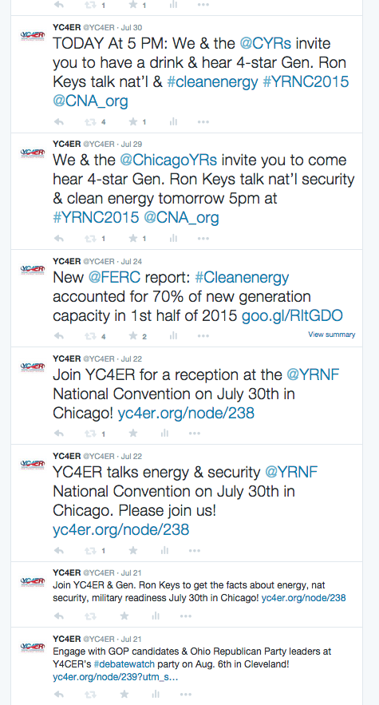

Republican pledges $175 million to push party on climate
A North Carolina executive is pouring his own money into trying to sway people in the GOP to take global warming seriously.

By Darren Goode | June 8, 2015

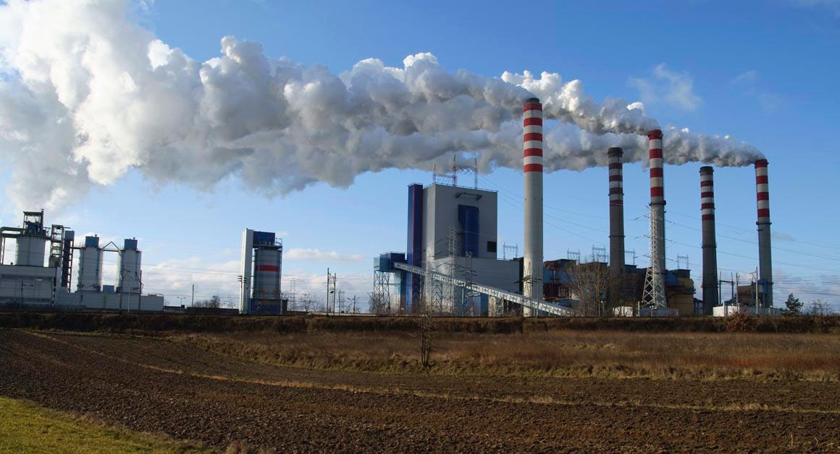

A Republican entrepreneur is putting a whopping $175 million behind a campaign whose message will have some party stalwarts seeing red: The GOP needs to deal with climate change.

North Carolina businessman Jay Faison will launch a social media and online advertising blitz, backed by state and national digital advocacy efforts and a series of strategic grants, as part of a $165 million campaign run through the ClearPath Foundation. The aim is to get the Republican Party to shift its skeptical view of climate change and green energy, topics that usually fall to the bottom of its list of priorities when they don’t generate outright opposition among conservative voters.

In addition to his public education effort, Faison is putting an additional $10 million of his money into a separate political advocacy operation, using the same nonprofit tax status designation as groups like President Barack Obama’s Organizing for Action, Karl Rove’s Crossroads GPS and several tea party groups. He will also try to attract additional outside funds for that operation.

On Tuesday, Faison, who made a fortune from the sale of his Charlotte-based audio-visual equipment company SnapAV, will unveil the first stage of his ClearPath campaign, including spending $40 million through 2016 to persuade moderates and conservatives to join the fight against climate change — but relying on market-based principles rather than government mandates.

“I always felt a little alone out there as a Republican, and so I started ClearPath to create a dialogue around this in a way that hadn’t been done before and sort of be part of the solution,” Faison said in an interview, adding he’d like to see the party’s candidates debate the solutions to climate change, not the science. “We think that there are real Republican solutions to the problem.”

It’s not an issue that tends to sit well with Republican leaders. Among the GOP candidates for president, only long-shot Sen. Lindsey Graham of South Carolina has been consistent in saying that he believed human activity was a cause of climate change. He has vowed to try to persuade Republicans to expand the party’s environmental platform, but he’s currently polling in the low single digits.

Green-minded Republicans may gravitate toward Jeb Bush, who will make his own candidacy official June 15 and has acknowledged climate change as a problem. But he has also echoed conservatives in decrying the “arrogance” of those who say climate science is settled.

The challenge for Faison will be finding a receptive audience inside the party that has focused on fighting Democrats’ climate change policies or rallying voters against what it calls President Barack Obama’s “war on coal.”

“What’s important to remember is that [climate change] doesn’t really register as an issue with many Republican primary voters,” said Eli Lehrer, who helped form the free-market think tank R Street Institute after bolting from the Heartland Institute over its public skepticism of climate science.

“It isn’t that they are denying anything. They just don’t care that much. I don’t care that much. It’s unlikely that I will vote primarily where someone stands on climate change,” he said.

Faison said he’s trying to change that perception — or at least not let Republican apathy about climate change stand in the way of getting the party to join the debate over solutions that has been dominated by Democrats. And that means focusing on solutions in the free market that will appeal to conservatives.

“I think everybody agrees that there’s [climate] risk. And if there is risk then I think we need to move on to solutions which are right in front of our nose,” he said.

A self-described Christian conservative from a prominent Charlotte Republican family, Faison also supports school choice, tort reform and small government, and he has disdain for Obamacare — all positions that put him solidly in the Republican camp and contradict claims that he’s a Republican In Name Only because of his climate outreach.

But as an avid hunter and fisherman, he had long followed climate change issues, and after the sale of his company, Faison decided to turn his attention to the effort.

Tuesday will mark the official rollout of ClearPath.org — a website featuring hundreds of pages of studies and other data including from the National Oceanic and Atmospheric Administration, NASA, Massachusetts Institute of Technology and the corporate consulting firm McKinsey to educate Republicans about climate change. The ClearPath foundation also has an investment portfolio that includes a seven-figure solar energy investment.
There is a wealth of polling suggesting a lot of Republicans do see climate change as a problem that should be addressed through cleaner forms of energy, if not through Environmental Protection Agency and other regulations.

“There’s a lot of center-right Republicans that feel like they don’t have a voice in this issue, and surveys would say they’re eager to share this information to bring other people along with them,” Faison said. “Even in small percentages, that’s in the millions.”

Yet, conservatives remain an outlier. An Earth Day-timed Gallup poll found fewer than 4 in 10 self-identified conservative Republicans — 37 percent — think that climate change will occur in their lifetime, while 19 percent believe it will affect future generations. A plurality — 40 percent — responded that climate change will never happen.
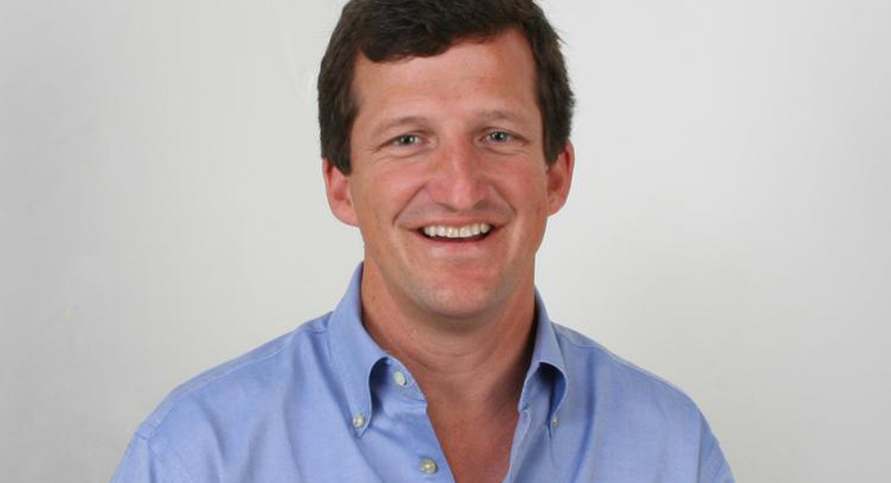
North Carolina businessman Jay Faison will launch a social media and online advertising blitz. | SnapAV

Faison advocates preventing utility monopolies from standing in the way of rooftop solar and other green electricity sources, rather than relying on measures such as the Obama administration’s planned greenhouse gas controls for power plants. Rooftop solar has been championed by tea party groups in Georgia, but it’s an effort that will put Faison in conflict with megadonors like the Koch brothers.

Indeed, the trend among Faison and other green Republicans is to showcase ideas that are or should be pretty well established within the GOP policy framework.

“The problem with Republicans — a lot of Republicans, not all — they just don’t understand the issue,” said Andrew Sabin, owner of a New York-based precious-metal refining business and a longtime GOP donor. “If they saw some of the things they could do that wouldn’t affect the economy and in fact increases jobs and cleans the air, they’re all for it.”

Sabin has pitched GOP presidential candidates on the need to invest in new nuclear plants, wind and solar power, an updated power grid and more research on capturing carbon and storing it — as well as the need to confront the changing climate and rising sea levels.

And though the candidates he’s spoken to have more or less been receptive, Sabin said that doesn’t mean it will translate to anything more.

“You don’t know as a donor whether they really agree or are just patronizing you,” said Sabin, who plans to meet with Carly Fiorina this week.

Faison will target his efforts to local markets and specific demographics, such as Roman Catholics and politically active Floridians, by using advertising, social media and news outlets. And ClearPath will use digital engagement tools to generate feedback from its audience, and put money into grants and think tanks such as the Niskanen Center and R Street.

But breaking through the noise won’t be easy. On the left, Tom Steyer’s NextGen Climate public education campaign has poured money into an operation against Republicans in a bid to elect more green Democrats into office. And the hundreds of millions of dollars flowing from the Koch brothers still attract Republican candidates looking to shore up their conservative street cred.

Only 18 percent of likely Iowa Republican caucus participants believe GOP presidential candidates should “spend a lot of time talking about” climate change, according to a poll conducted late last month by Bloomberg Politics and The Des Moines Register. The next lowest issue polled was income inequality, at 36 percent.

But if a major candidate can put environmental issues on the radar, it could resonate particularly with younger voters in the party, and Sabin is hopeful that Bush can ultimately carve out a Teddy Roosevelt-type position that could broaden the GOP’s base.

“If Jeb Bush comes out with a good environmental policy, he’s going to attract young Republicans for sure, and across the aisle to Democrats and independents it’s going to be a huge help,” Sabin said. “If he’s our candidate, there is no Democrat in this country who would touch him if he had a good environmental plan.”

That emphasis on winning more of the youth vote through a green energy strategy is also the goal of Young Conservatives for Energy Reform, founded by Michele Combs, a veteran Republican operative and daughter of Christian Coalition President Roberta Combs.

“I see the tide turning,” Combs said recently. “The young people and the young generation, they want this issue and they understand this issue.”

Faison has so far has donated $50,000 to Bush’s Right to Rise PAC, and $25,000 to Graham’s campaign. But he hasn’t picked which candidate he intends to back yet.
“This is an issue that … they haven’t clearly articulated yet,” he said.

Bush has acknowledged that the climate is changing, but has said the science is unclear on what is causing it and that the issue isn’t the highest priority for him. He’s been critical of Obama’s regulatory efforts to use the Clean Air Act to tighten emissions.

Sabin, a friend of the Bush family, may be a notable exception among Republicans donors in openly pressing for his environmental priorities, but his efforts may encourage other party funders, who may have been quietly working for greener policies.
“There are a very small handful,” said Rob Sisson, president of ConservAmerica, formerly Republicans for Environmental Protection. “If they decide to come together, it could attract others that we either have not had contact with yet or are not on the radar screen yet.”

http://www.politico.com/story/2015/06/republican-climate-change-jay-faison-118755.html#ixzz3iR993qTB

Keep Michigan energy clean and local

By Blake Edmonds and Michele Combs, Detroit Free Press guest writers
12:14 a.m. EDT March 26, 2015

There have been campaigns calling on Americans to eat locally and shop locally. Now, Michiganders can get on board with a plan to power their lives locally.
That's one of the most interesting elements of Gov. Rick Snyder's vision for a "no-regrets energy future," which focuses on cutting energy waste and prioritizing renewable generation. Instead of wasting energy and relying on coal imported from out of state to generate power, a more efficient Michigan can tap its own plentiful natural gas reserves, and take advantage of the state's tremendous potential for wind, biomass and solar energy, as well.
At Young Conservatives for Energy Reform, we are seeing similarly smart strategies embraced in communities and states across the country. It's becoming a rallying point for conservatives, especially conservatives living far from the partisan wrangling of Washington. We believe embracing clean, efficient energy offers an all-American way to boost Michigan's economy, strengthen national security and promote clean air.
As Snyder has pointed out, each Michigan resident uses about 38% more energy than the average American. There are a lot of ways to cut that number down, by helping families, businesses and organizations to become more efficient and cut their energy bills.
As for where you get the energy you still need, why not go local and stop sending dollars to other states for coal? Harness the wind that's already blowing; catch the sun that's already shining. Turn agricultural waste into fuel, and tap the landfill gas that's just sitting there unused. Grow the economy in Michigan — and along the way, clean the air, as well.
Diversifying our energy supplies also helps with national security. Retired Lt. Gen. Richard Zilmer of the CNA Corporation's Military Advisory Board, spoke to about a hundred West Michigan Young Republicans last year, and shared how our overdependence on oil poses a national security risk. It ties us to regimes that don't always have our best interests at heart, and limits our ability to act on the world stage. Sure, gas prices are low now, but they're controlled by a worldwide market and a cartel we're not part of. Controlling our own energy means controlling our own destiny.
We hope to see Snyder and the Legislature work together to put in place an energy plan that works for all the people who live in the state — and that serves as a model for the rest of the country. Building our energy future on clean, efficient, renewable, homegrown sources is not a Democratic issue or a Republican issue. It's an American issue. And it's the right path forward for the people of Michigan.
Blake Edmonds is the Michigan chairman for Young Conservatives for Energy Reform and the former youth vice-chair of the MI GOP. Michele Combs is the founder and president of Young Conservatives for Energy Reform.
http://www.freep.com/story/opinion/contributors/2015/03/26/snyder-energy-plan/70456288/

Sample Social Media Hits:

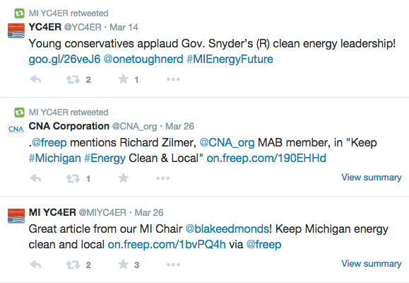

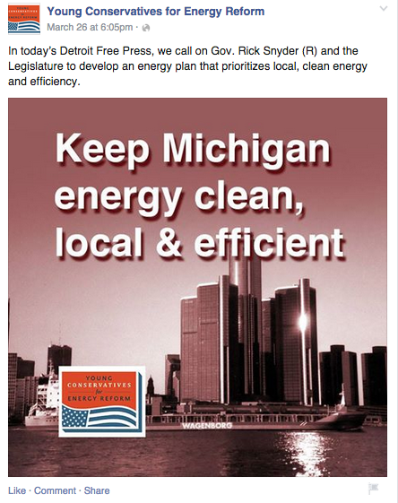

Listen to Grassroots Conservatives: Embrace Energy Reform
By MICHELE COMBS on February 24, 2015 at 2:00 PM
Men and women from across the country are streaming into DC for the Conservative Political Action Conference – the largest gathering of conservatives in the nation – which starts on Wednesday.
These far-flung conservatives bring to our nation’s capital a fresh perspective on a whole range of issues, especially on matters the Washington elite too often pigeonholes as right-versus-left issues. Of course, everyone at CPAC is passionately interested in winning elections. But they also are focused on making a good living, taking care of their families, and building the communities they live in. And the view from the “real America” is often starkly different from the view from Capitol Hill.
Take energy policy. Too often in Washington circles, it is framed as an issue pitting Democrats against Republicans. But it’s not a conservative issue or a liberal issue. It’s an American issue.
As president of Young Conservatives for Energy Reform, I have met with conservatives in state after state. Business owners, parents, community leaders and others from every walk of life see policies that advance clean, efficient energy as essential to the Republican Party’s future – and more importantly, to our country’s.
At YCER, we have seen in our own communities that diversifying energy sources creates local jobs that can’t be exported, and grows the economy. We are seeing cleaner air and healthier communities, which we embrace as being good for families. We are also persuaded by military leaders who see reducing our nation’s over-dependence on oil as a key strategy for strengthening national security. And we embrace the idea that families, businesses and organizations like schools and churches should have the freedom to choose the kind of energy that works best for them.
States are far ahead of Washington on this issue. If you want to see what a clean and efficient energy future looks like, look to the states.
In my state, bright-red South Carolina, Boeing uses solar power to build planes, while BMW uses methane recovered from a landfill to make cars. On the drawing board: utility-scale offshore wind farms. A few months ago, legislators passed a bill expanding financial options and incentives for solar power, beyond our already successful tax credit.
And in the public sector, South Carolina is seeing the money-saving benefits of clean efficient energy, as well. Greenville County Schools put in an energy conservation and management program, and are saving millions of dollars a year. Marines at Parris Island eat in a mess hall partially powered by solar panels, while their children attend a solar-powered child development center.
In terms of cold, hard political calculations, supporting clean and efficient energy is a winning issue. It attracts young people, and it matters more and more for the rest of society, as well. And it’s not just liberals who are interested. As the America Wind Energy Association has pointed out, most of our nation’s wind energy capacity is located in congressional districts represented by Republicans. Look at South Dakota and Iowa, which now get more than one quarter of their electricity from wind power.
Conservative states are benefiting from clean energy. So is the rest of the nation. Now is the time for Republicans to show national leadership on this winning issue. Let’s show the American people that our party has real energy solutions that will help ensure a safer, stronger, and more prosperous nation for generations to come.
A former Chairman of the South Carolina Young Republicans and “Young Republican of the Year,” Michele Combs is the President and Founder of Young Conservatives for Energy Reform.
http://breakingenergy.com/2015/02/24/listen-to-grassroots-conservatives-embrace-energy-reform/

Solar energy’s new best friend is … the Christian Coalition

By Chris Mooney February 20

The politics of solar power keeps getting more and more interesting.
In Indiana, a fight over net metering — basically, whether people with rooftop solar can return their excess power to the grid and thereby lower their utility bills — has drawn out groups ranging from the state chapter of the NAACP to the conservative TUSK (Tell Utilities Solar won’t be Killed) in favor of the practice.
Arrayed on the other side of the issue, meanwhile, are the Indiana Energy Association, a group of utilities, and Republican Rep. Eric Koch, sponsor of abill that would potentially change how net metering works in the state. The legislation, in its current form, would let utility companies ask the Indiana Utility Regulatory Commission to include various “tariffs, rates and charges, and credits” for those customers generating their own energy at home.
Net metering advocates charge that this would reduce how much money rooftop solar installers save on their electricity bills. But the bill’s supporters say it will “level the playing field to ensure that all of those who use the electric grid — whether consuming or generating power — are paying for its upkeep,” in the words of the Indiana Energy Association.
Forty-three states and the District of Columbia currently allow net metering — among them, Indiana. The fight is important because the solar industry in the state, and the number of people installing rooftop solar, is expected to grow in coming years — that is, so long as solar remains a good deal financially.
What’s particularly fascinating is how this debate has mobilized the religious community. Solar panels are going up on church rooftops in Indiana, and on Wednesday, the head of the Christian Coalition of America wrote a blog postfavoring solar and referring specifically to the Indiana fight (although without getting into the technical details of net metering).
Roberta Combs, president of the group, titled her post “For God and Country, Indiana and America Need Better Energy Policies,” writing,
Indiana’s utilities are interested in keeping us reliant on traditional fuel sources that hurt our national security and weaken our economy. We must allow homes, businesses, public organizations, and churches to create local, American power by installing solar.
As conservatives, we stand up for our country’s national security and the health of our economy. And, as Christians, we recognize the biblical mandate to care for God’s creation and protect our children’s future.
This is not the first time that Combs has come out for an initiative that might be described as “green.” She previously supported efforts by Secretary of State John F. Kerry, former senator Joe Lieberman and Sen. Lindsey Graham (R-S.C.) to battle global warming. Her daughter, Michele Combs, is the founder of a group called Young Conservatives for Energy Reform, which stands for“weaning our nation from foreign oil, boosting efficiency, and developing homegrown alternatives from natural gas to biofuels to wind and solar.”
“This whole concept of conservative support for solar has certainly gotten a lot of attention, but this is the most remarkable chapter in the story,” said Bryan Miller, who co-chairs the Alliance for Solar Choice, which advocates in favor of net metering across the country. “We’ve seen a lot of grass-roots activism for sure, but we haven’t seen a major national group, associated with the far right of American politics, coming out on a renewable energy issue.”
The reason this has happened in Indiana, suggests Miller, is that “we’ve had houses of worship who have gone solar, speaking out about this for weeks.” The South Carolina Christian Coalition has also supported solar power in the state.
The Christian Coalition did not immediately return requests for comment.
Energy in the United States is changing so fast, it seems, that politics barely knows how to adapt to it.
http://www.washingtonpost.com/news/energy-environment/wp/2015/02/20/solar-energys-new-best-friend-is-the-christian-coalition/

POLITICS:

Can young Republicans embrace clean energy? A former Marine commander and climate advocate is helping them try

Evan Lehmann, E&E reporter
Published: Friday, February 13, 2015

Correction appended.
Lt. Gen. Richard Zilmer climbed out of an armored vehicle in Kuwait and saw a sky filled with smoke from burning oil rigs. It was 1991, and Iraqi forces had set the wells aflame.
That was an early impression by the Marine officer, now retired, of the price America would pay for its energy supplies. And it would later lead him to advocate for renewable fuels to help save American lives and protect the environment.
"It wasn't lost on anyone that our presence there was about energy, it was about oil, it was about protecting allies in the [Persian] Gulf," Zilmer said last night at an event for young Republicans.
Fifteen years later, in 2006, he would oversee one of the bloodiest provinces in Iraq -- Anbar, where disparate platoons of American troops were refueled by plodding convoys carrying diesel to run their generators. He said every soldier requires 22 gallons of fuel per day to "win the war," an outcome that requires energy-intensive cooling equipment, cameras, radios and other equipment.
That creates a dangerous "exposure" to injury or death from improvised explosive devices, snipers and other attacks, Zilmer said. It also increases the risks of climate change to the military, which is often deployed as an international first responder, he added.
There's a better way, he told the crowd, organized by Young Conservatives for Energy Reform and the American Wind Energy Association. Developing renewable energy domestically can limit military operations in the Middle East that, when factored in, push the real price of gasoline at U.S. filling stations to anywhere between $30 and $200 a gallon, Zilmer said.
"I am not a greenie. I am not a zealot. I am not a tree-hugger," he said, adding that he wants to "make our [military] force better."

A split in the GOP
Corey McCray, a member of the DC Young Republicans, said Zilmer had a "great angle" on energy independence. He grew up hunting in South Carolina and wants to conserve land and wildlife so that when he has kids, they can enjoy the outdoors. He also supports energy efficiency.
But McCray said he's "a little on the fence" about whether humans are causing climate change.
"If it were easy to determine, we would already have a solution," he said.
The meeting last night seemed to embrace the sometimes awkward relationship between conservatives and renewable energy advocates at a time when both chambers of Congress are preparing to embark on comprehensive energy legislation. That hasn't occurred since 2007.
Cleaner sources of energy are widely popular among all types of voters, including those in the GOP. A Gallup poll in 2013 found that 68 percent of Republicans say more emphasis should be put on solar power, and 59 percent of Republicans want more electricity from wind. Conservatives sometimes describe it as a tenet of national security.
Last night's event is meant to underscore that popularity. It's unclear how large a role renewable energy and climate issues will play in this year's energy legislation, but they haven't been emphasized by leaders in either chamber. Instead, things like increased domestic oil and gas production to strengthen trade and diplomacy are high on the list, along with energy efficiency.
Renewable energy's association with taxpayer subsidies sometimes draws Republican opposition. The production tax credit (PTC), which provides wind producers with 2.3 cents per kilowatt-hour for the first 10 years of a project, expired at the end of 2014. It was alive for just two weeks, after the House and the Senate rekindled it to grant producers the credit retroactively for 2014. It's no longer operative.
Republicans showed their skepticism toward the credit in a recent debate over the Keystone XL pipeline by defeating an amendment that expressed support for a five-year extension of the PTC. Just three Republicans supported the measure.
It's a different story outside of the Capitol.

Wind power popular in red states
A poll last month by The New York Times, Stanford University and Resources for the Future found that 80 percent of respondents supported tax breaks that encourage the production of electricity from sources like the wind and sun to address global warming.
It was the most popular policy offered in the poll for reducing greenhouse gas emissions. Other options included raising taxes on gasoline (36 percent approved) or electricity (25 percent), and offering tax breaks to encourage the construction of nuclear power plants (36 percent). A popular policy included giving tax breaks to the operators of coal-fired power plants for reducing their pollution. Sixty-eight percent of respondents favored that idea.
The nation now has nearly 66,000 megawatts of installed wind power capacity, up from just 4,100 MW in 2001. Turbines tend to go up in states with windy conditions, whatever the political mood might be. Texas produces almost a quarter of the nation's wind power, and Oklahoma and Kansas are in the top 10.
Sen. Rob Portman (R-Ohio) told the crowd of perhaps 100 people that he plans to file a broad energy efficiency bill in about three weeks. A slimmed-down version of the measure, which is co-sponsored by Sen. Jeanne Shaheen (D-N.H.), sailed through the Senate last month as an amendment to a bill authorizing the Keystone XL pipeline. That KXL measure is expected to be vetoed by President Obama soon.
Zilmer sits on the Military Advisory Board of CNA Corp., a collection of three- and four-star generals and admirals that has warned that climate change is a "threat multiplier" and a "catalyst for conflict."
"The nature and pace of observed climate changes -- and an emerging scientific consensus on their projected consequences -- pose severe risks for our national security," the board said last year in a report named "National Security and the Accelerating Risks of Climate Change."
Zilmer urged the group last night to educate themselves about things like flooding from sea-level rise and melting sea ice in the Arctic.
"I am not here to convince anyone -- anyone at all -- about climate change," he said. "Do your own homework."
Correction: An earlier version of this story incorrectly said an unsuccessful Keystone XL amendment would have extended the production tax credit permanently. The amendment offered a five-year extension of the tax credit.

http://www.eenews.net/climatewire/2015/02/13/stories/1060013444

Congress Needs to Follow the People on Clean Energy | Commentary

By Michele Combs and Tom Kiernan
Feb. 11, 2015, 12:39 p.m.

Harvesting power from the wind is about investing in long-term energy solutions that can benefit our families, communities and economy for generations to come.

However, there are some inside the Beltway who talk about renewable energy as if it were merely a pet cause of the left.

Clean, homegrown energy is not a liberal issue or a conservative issue. It’s an American issue. And as Congress moves past the Keystone XL pipeline debate and begins to look at the broader energy picture, it’s time for our elected leaders to move beyond scoring partisan political points and get on with the business of real energy reform.

Diversifying our nation’s energy portfolio to include homegrown renewable energy that can never run out is essential — it will grow the economy, strengthen national security and build a better future for our country.

Poll after poll shows a majority of Americans across the political spectrum and across the nation support renewable energy. For them, clean homegrown energy is not some strange, futuristic concept. It’s something they rely on every day.

The U.S. is blessed with abundant wind energy resources. Wind power now generates more than a quarter of the electricity in Iowa and South Dakota. The U.S. is also No. 1 in the world in wind energy production, with enough to power 18 million American homes.

Harvesting energy from the wind provides value to consumers. Wind power’s costs have dropped by more than half in just five years and wind energy is the lowest cost option for utilities in several parts of the U.S. Wind even saved consumers $1 billion over just two days across the Great Lakes and Mid-Atlantic states during the 2014 “polar vortex.”

By building wind farms, American workers are making more of our own energy right here at home. With more than 500 factories in 43 states, American wind power has built a brand new domestic manufacturing sector and the wind energy industry supports more than 50,000 well-paying jobs. With policy certainty wind can support hundreds of thousands well-paying jobs by 2030.

Many homes, universities, churches and synagogues are powered by clean, homegrown energy. Farmers and ranchers call wind power their new “drought-resistant” cash crop. Businesses from Starbucks to DHL to the National Hockey League are running, in part, on renewables. Clean energy is one thing even Microsoft and Apple can agree on.

The military gets it, too. Our organizations are co-hosting an event at which Gen. Richard Zilmer — who served as the U.S. commander in al Anbar province during the “Anbar Awakening” — will talk about the importance of diversifying our energy portfolio on the battlefield and here at home, in order to build a stronger and more secure nation. In Iraq, Zilmer saw firsthand how over-reliance on fuel convoys turned his troops into targets.

We are also excited to hear an update on Congress’s plans from Sen. Lindsey Graham, R-S.C., whose conservative state is home to more than 18 factories that manufacture parts for the wind industry, and Sen. Rob Portman, R-Ohio, whose state houses 63 such factories supporting thousands of jobs.

http://www.rollcall.com/news/congress_needs_to_follow_the_people_on_clean_energy_commentary-240022-1.html

Sample Social Media Hits:

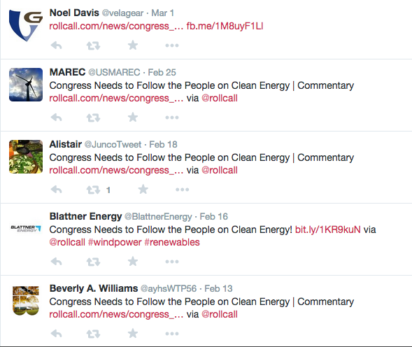

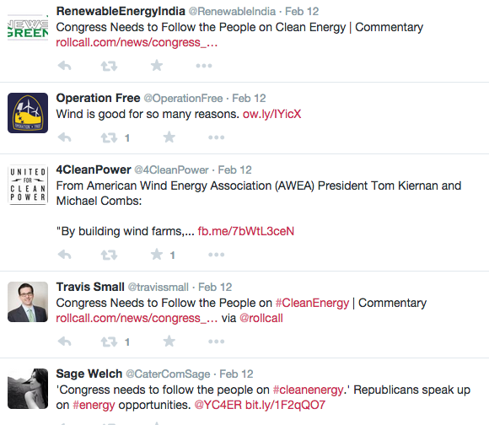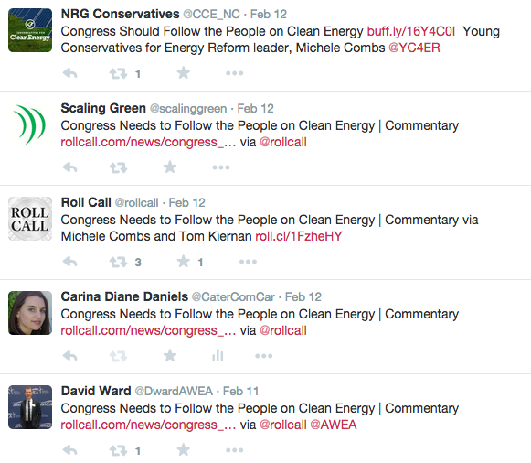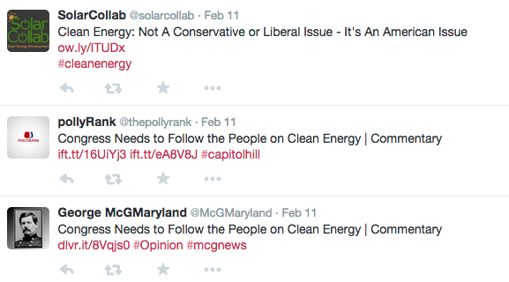

January 21, 2015, 05:00 pm

Let’s get past Keystone and get on with energy reform

By Michele Combs

Once again, the debate over the Keystone XL pipeline is sucking up all the air in the room when it comes to energy policy. But the heated debate is something of a distraction from more substantive energy issues. Whether the pipeline gets built or not, the oil it’s supposed to transport will get used somewhere in the world if market conditions warrant.
I hope the issue is finally resolved soon, so that Congress can turn its attention to the real solution to our energy problems: Developing a bipartisan, comprehensive, “all of the above” energy strategy. That’s what the American people want. And it’s what we at Young Conservatives for Energy Reform (YCER) are counting on the newly Republican-controlled Congress to deliver.

Republicans have the chance to build our nation’s energy future on a new footing that puts America’s interests first. The U.S. needs an energy policy that grows the economy, strengthens our national security and our standing in the world, and minimizes unhealthy pollution. Republicans are in the driver’s seat, and must not waste this opportunity.
As conservatives, we at YCER see energy efficiency as the starting point and bedrock of sensible energy policy. Again this session, Sen. Rob Portman (R-Ohio) and Sen. Jeanne Shaheen (D-N.H.) are joining forces on energy efficiency legislation that has broad support, including from young conservatives across the country. A slimmed-down version of their bill has been introduced as an amendment to the Keystone measure the Senate is considering, and the senators also plan on reintroducing a more comprehensive energy efficiency bill later this year.
Efficiency, the continuing development of domestic fossil fuels, and a ramp-up of renewable energy should all be part of a comprehensive energy bill, which is being discussed for later this year. Some see that third element – clean energy – as a partisan issue, but it’s not: it’s an American issue.
Homegrown energy that can never run out creates American jobs, and gives us a piece of a growing international market. It boosts energy independence, and makes us less reliant on foreign sources of energy whose interests are not always aligned with our own. It also means cleaner air and water, and a healthier future for our families.
Renewable energy is a political winner, as well. Poll after poll shows broad-based support for developing alternative sources of energy. And for younger people—a demographic Republicans need to court – support is especially strong.
So let’s get the battle over the Keystone XL pipeline over with, and move onto a comprehensive energy bill that reinvigorates America’s energy policy. It’s what voters want. It’s what our country needs. And if Republicans are the ones who finally deliver real energy reform, it will be good for our party, as well.
Combs is the president of Young Conservatives for Energy Reform and a former “Young Republican of the Year.”
http://thehill.com/blogs/congress-blog/energy-environment/230101-lets-get-past-keystone-and-get-on-with-energy-reform

Facebook
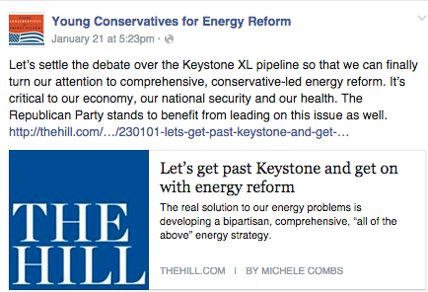

Twitter

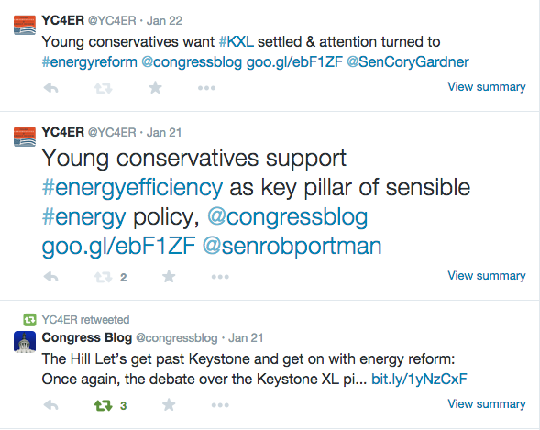

Young conservatives and retired general team up to preach alternative energy reforms

By Jim Harger | jharger@mlive.com
on November 18, 2014 at 6:30 AM, updated November 18, 2014 at 6:36 AM

GRAND RAPIDS, MI – Michele Combs and Lt. Gen. Richard Zilmer (Ret.) seem like an unlikely couple to promote alternative energy and clean energy policies – especially to the West Michigan Young Republicans.
Combs, a former "Young Republican of the Year," is president of Young Conservatives for Energy Reform, a group she created two years ago.
Zilmer is a former commander of Operation Iraqi Freedom who serves on the eight-year-old Military Advisory Board for the CNA Corp., a non-profit think tank based in Washington, D.C.
Both were in Grand Rapids on Monday, Nov. 17, to address the West Michigan Young Republicans.
Though clean energy is a cause trumpeted primarily in progressive environmental groups, Combs said it’s also a message that is being well-received by young conservatives.
“They want something done about energy efficiency and saving the planet,” Combs said during a taping of “West Michigan Week,” a weekly news program on WGVU-TV. “This is not a Republican issue or a Democratic issue. This is a family issue.”
Combs said her group is bypassing the Republican establishment with its message of alternative energy.
“This is an issue the Republicans have not wanted to address. But we’re hearing it from the grass roots,” she said.
Zilmer has been pushing for alternative energy sources for the military for more than two years. He argues that the military needs to reduce its dependency on foreign oil and fossil-based fuel to remain militarily effective.
The U.S. military spends more than $15 billion on petroleum fuel products a year, Zilmer said. The average soldier consumes 22 gallons of fuel per day compared to World War II, when a soldier consumed only about one gallon per day.
Zilmer and Combs acknowledged that cheaper crude oil prices and cheaper gasoline at the pump made their message more difficult to sell in the past two years.
“At the end of the day, this is not about being an environmentalist, a green or a zealot,” Zilmer said. “It’s about being faster, lighter and more lethal on modern the battle field.”
http://www.mlive.com/business/west-michigan/index.ssf/2014/11/young_conservatives_and_retire.html

During their visit to Michigan in November 2014, Michele Combs & Lt. Gen. Zilmer also interviewed with the following outlets:

Taped TV interview with Michele & Gen. Zilmer

(Michele Combs Only)

(Michele Combs Only)

(Michele Combs Only)

(Lt. Gen. Zilmer Only)

Lt. Gen. Zilmer’s interview: http://frontlinesoffreedom.com/2014/11/29/show-362-2nd-hour/

Retired military officer discusses climate change’s national security implications

By Lindsay Carbonell Published 05/29/14 4:38pm
Lt. General Richard Zilmer is not a climate scientist, but he knows how to prepare for a risky situation — and climate change, he says, is looming.
“Energy is a national security issue,” Zilmer said. “This is not just an issue that will go away tomorrow.”
Zilmer and Michele Combs, chairwoman of Young Conservatives for Energy Reform, a grassroots group advocating for renewable energy, met with North Carolina political, community and business leaders in Raleigh last week about energy reform.
“We’re trying to show young people and young Republicans, young professionals out there that this issue should not be a partisan issue,” Combs said. “This issue should be an American issue.”
Combs said climate change has national security and economic concerns that have not been emphasized in the environmental discussion. She said she tries to focus on clean air, energy independence and homegrown energy — making the environmental issue one with patriotic significance.
“For so many years, this has been a left-leaning, liberal issue,” she said. “I think it has had the wrong messengers in the past.”
Where Combs' focus is in the political realm, Zilmer’s is in national security.
Zilmer is a member of the Military Advisory Board, a think tank at the Center for Naval Analyses, a federally-funded research and development center. The board has produced two reports, one earlier this month and one in 2007, on climate change.
While climate change is not a direct cause of military conflict, Zilmer said, it is a threat multiplier to stressors that already exist, such as unemployment and food and water scarcity.
“Climate change suddenly plays a part in that puzzle,” he said.

Honor America’s fallen by lowering risks to troops caused by oil dependence

By RICHARD ZILMER | The News & Observer | May 25, 2014
This Memorial Day, we honor those who have died while serving in our nation’s armed forces. I have personally witnessed too many of our brave men and women put at risk on the battlefield while protecting fuel convoys.

In recent conflicts, fuel convoys have been among our enemies’ favorite targets. Transporting fuel to bases and troops in war zones has become an especially dangerous job.

As a commander in Iraq, I witnessed firsthand the toll in casualties imposed by our battlefield dependence on oil. And with other members of the CNA’s Military Advisory Board, a panel of retired three- and four-star generals and admirals, I have studied the intersection of energy and national security on a wider scale.

CNA’s Military Advisory Board has found that America’s over-dependence on fossil fuels makes us vulnerable on the battlefield. It is a national security threat – economically, militarily and diplomatically. Our oil dependence weakens us, constraining our options for action on the world stage and causing us to send money to regimes whose interests don’t always dovetail with ours.

There are also financial penalties attached to our armed forces’ dependence on fossil fuels. Every $10 increase in the price of a barrel of oil means a $1.3 billion increase in operating costs for the Pentagon. And the military allocates a tremendous amount of resources to ensuring the freedom of movement of oil shipments – an estimated $8 trillion protecting oil cargoes in the Persian Gulf since 1976, a 2010 study found.

So it is no wonder that America’s armed forces are embracing energy efficiency and alternative energy sources. In Iraq, I called for more use of wind and solar resources and increased energy efficiency because finding ways to use less oil in war zones saves lives. Over the last several years, every branch of the military has set ambitious clean energy and efficiency targets, in a broad effort to boost energy security and cut operating costs.

If our men and women in uniform can incorporate efficiency and renewable energy into their dangerous jobs, surely the rest of us can do our part on the homefront. And as I learned during a visit to Raleigh recently, North Carolina is embracing the opportunity that clean energy represents.

At one event I spoke at, Chambers for Innovation and Clean Energy joined the Greater Raleigh Chamber of Commerce and the Research Triangle Regional Partnership, bringing together business leaders to talk about national security, energy and economics.

At another meeting, the Wake County Young Republicans and Young Conservatives for Energy Reform gathered to consider clean, efficient energy through a conservative lens, as an economic and national security imperative.

Since North Carolina’s Renewable Energy and Energy Efficiency Portfolio Standard was introduced in 2007, about $2.7 billion has been invested in clean energy and efficiency, according to the N.C. Sustainable Energy Association.

That investment has supported more than 36,000 jobs. The state is staking out a leadership position in the growing renewable energy field, ranking second among all states in new solar installations last year.

In North Carolina and across America, our energy landscape is changing. We have the chance to create a future in which our nation’s energy is made here at home and can never run out and where our economy and national security are stronger and more resilient than ever. This Memorial Day, that is a good way to honor the fallen.

Energy consumption and climate change as national security threats

WILL MICHAELS & FRANK STASIO|North Carolina Public Radio | May 21, 2014
Climate change and the way we use energy are threats to national security, according to group of U.S. military generals at the nonprofit CNA Corporation.
Their research shows stronger storms will likely divert more troops to humanitarian missions and American dependence on fossil fuels forces convoys to routinely transport fuel through dangerous areas.
Host Frank Stasio talks with retired Lt. Gen. Richard Zilmer, a member of the Military Advisory Board at CNA Corporation.
Gen. Zilmer speaks at 6 p.m. tonight at Bolt Bistro in Raleigh at an event co-hosted by the Wake County Young Republicans and Young Conservatives for Energy Reform.

http://wunc.org/post/energy-consumption-and-climate-change-national-security-threats

April 29, 2014, 12:00 pm
Efficient energy made in America: a winning issue for Republicans
By Michele Combs and Angel Garcia
As the Young Republican Leadership Conference brings young professionals from across the country to Washington, Young Conservatives for Energy Reform is on hand to talk about a crucial issue—and a winning issue-- for our party and our nation: energy reform.
Advancing homegrown energy and embracing efficiency boosts economic growth, increases national security, and protects clean air and clean water. This dovetails with conservative values. It’s time for conservatives to lead the way on energy reform.

Our nation is dependent on foreign oil, which limits our ability to act on the world stage and makes us weaker. Stepped-up domestic production doesn’t completely solve the problem, because we remain vulnerable to price gyrations on the international oil market, which whipsaw our economy and leave businesses and families struggling to balance the books and plan for the future.
Using energy more efficiently and beefing up our cleaner, made-in-America energy options makes us more energy independent and less vulnerable on the world stage. It also means cleaner air and water, which translates into healthier families and lower healthcare costs.
It’s also an economic opportunity. Across the country, entrepreneurs and manufacturers are hard at work on innovative energy technologies and services. They are creating American jobs in every state in the country.
Clean energy is no longer a fringe issue. Consider wind energy, for example. Every single state has a wind power facility, a wind-related manufacturing facility, or both. And Republicans, take note: over 81 percent of all U.S. wind power capacity is in House districts that were represented by Republicans during the 112th Congress, according to the American Wind Energy Association.
Now solar power is coming on strong. Last year, almost 22 percent of the new electric generating capacity installed in the U.S. was solar. The only source to top it was natural gas, which is a key domestic energy option, as well.
And Americans want options. A Zogby Analytics poll found 69 percent of homeowners want more choices in how their homes are powered. And the vast majority of Americans—including 80 percent of Republicans surveyed—say they do not want utilities blocking homeowners’ effort to install solar power panels on their own property. This is a growing issue as prices for solar generating technology continue to drop.
Of course, the cheapest energy of all is the energy you never use. Efficiency is an energy resource, as businesses, families, and institutions across our nation are finding out. This is another area where new technologies and services continue to develop, and new business opportunities continue to crop up.
As long as we’re in D.C., we’ll point out that energy efficiency is also a front on which Congress can act, by passing the Energy Savings and Industrial Competitiveness Act. The bipartisan bill, sponsored by Sen. Rob Portman (R-Ohio) and Sen. Jeanne Shaheen (D-New Hampshire), is a common-sense approach to cutting government waste by saving energy, and helping businesses and families across the country save money through efficiency. During previous efforts to pass it, the bill earned support from the U.S. Chamber of Commerce, the National Association of Manufacturers, and other business groups, and it should become law.
There’s often a disconnect between the way energy issues are discussed inside the Beltway and outside the Beltway. In state after state, we at Young Conservatives for Energy Reform are hearing from the rising generation of conservatives that energy reform—including a serious commitment to efficiency and homegrown clean energy—is an issue of critical importance. And they want Republicans to lead the charge. Embracing energy reform will make our party-- and our country-- stronger.
Combs is the president of Young Conservatives for Energy Reform (YCER) and a former “Young Republican of the Year.” Garcia is president of the Chicago Young Republicans and Midwestern Regional Director for the Young Republican National Federation. He is representing YCER at the Young Republican Leadership Conference this week.

A Call to Action: Conservatives and Climate | Commentary
By Michele Combs, Beau Allen and James Dozier
March 13, 2014, 5 a.m.
As Republicans, we know that our party’s foundation — built on fiscal conservatism, strong national security and family values — brings together Americans from diverse backgrounds. So it’s no surprise that we don’t always agree on every issue.
But combating climate change can and should bring fiscal, social and national security conservatives together. Why? Because protecting our environment and building a secure future for America is our greatest obligation — and our greatest opportunity. Whether you are convinced by climate science or not, promoting energy efficiency and clean, homegrown energy is good for the Republican Party and good for the country.
We are among the many conservatives who accept the scientific facts that show us the Earth is getting warmer, but we also understand that many of our fellow conservatives are uncertain about the impact humans are having on the climate. If we want to appeal to younger generations of voters and independents, we must stop fighting over the science of climate change and start focusing on the things that unite us as conservatives. We need to focus our political energy on advancing conservative, small-government solutions that will enhance our economic, national and environmental security. And as conservatives we owe it to ourselves, and to future generations, to be good stewards of God’s creation
If conservatives don’t start offering solutions and leading on domestic clean energy production, President Barack Obama and his liberal friends will push forward ineffective policies that wrap the environment in red tape, raise taxes, kill jobs and punish companies.
So let’s draw on our conservative values and come together to offer market-driven solutions to protect our climate and grow our economy. We can promote policies that create high-paying American jobs, give companies the opportunity to innovate and lead on bringing new clean energy technologies to market that reduces our need for oil from hostile nations.
We should look for ways to build on the momentum generated by Republicans such as Rep. Cory Gardner of Colorado and Sen. Rob Portman of Ohio, who are proving that our party can lead on common-sense energy solutions. Portman co-sponsored the practical and bipartisan Energy Savings and Industrial Competitiveness Act, designed to help families, businesses and the federal government become more energy efficient. Gardner’s bipartisan energy efficiency bill would encourage federal agencies to enter into energy savings performance contracts that specify how much energy the agency will save. These common-sense solutions rely on public-private partnerships, encourage innovation, won’t add to the deficit and will save taxpayers an estimated $1 billion.
Clean and efficient energy matters to voters. In a recent survey commissioned by Citizens for Responsible Energy Solutions, 76 percent of voters said that pursuing a comprehensive approach to energy is a priority. Further, 60 percent of voters believe we should place more emphasis on diversifying our energy sources to include renewables like wind, solar and hydro.
We believe it is smart for conservative leaders to support policies that will encourage the production of cheap, reliable and clean energy. We can do this by crafting targeted incentives and investments in research, and by changing regulations to reduce the burdens on the private sector in bringing new technologies to market.
Republicans who care about fiscal conservatism, national security and strong families can lead the way forward on a real “all of the above” approach to energy development. Such a comprehensive approach will ensure that America continues to lead the world in natural gas exploration, and that the free market drives clean energy development. It will keep high-paying wind and solar manufacturing jobs at home, rather than sending these jobs to China. And a common-sense, conservative approach to clean energy production will ensure our country has greater energy independence and security.
As we head toward another election, we encourage our fellow Republicans to engage in a meaningful conversation about a forward-thinking conservative vision for our country and our party. We owe it to ourselves and to the next generation to secure continued American prosperity through good stewardship of our economy and our environment.
Michele Combs is president of Young Conservatives for Energy Reform. Beau Allen is a member of the Concord 51 board of directors. James Dozier is the executive director of Citizens for Responsible Energy Solutions.

Young Conservatives Support Energy Efficiency
By Michele Combs on March 11, 2014 at 10:00 AM

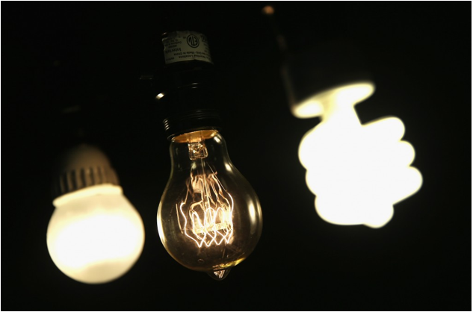
Boosting energy efficiency helps strengthen our economy, and leads to a better and healthier future for all Americans. So we at Young Conservatives for Energy Reform are excited about the possibility of Congress passing common-sense energy efficiency legislation for the first time since the George W. Bush administration.
The Energy Efficiency Improvement Act, sponsored by Rep. Peter Welch (D-Vermont) and Rep. David McKinley (R-West Virginia), has passed the House of Representatives with overwhelming bipartisan support. Now it’s the Senate’s turn to consider similar legislation: the bipartisan Energy Savings and Industrial Competitiveness Act, sponsored by Sen. Rob Portman (R-Ohio) and Jeanne Shaheen (D-New Hampshire).
Both bills cover commercial buildings. Businesses taking advantage of energy efficiency improvements would reduce costs, boosting their bottom lines and strengthening the economy. And some of those savings would likely be passed onto customers, saving families money. Energy efficiency legislation would also create badly needed jobs. And in these rocky economic times, we need all the new jobs we can get.
Energy efficiency legislation would also prod the government to adopt energy-saving practices, curbing energy waste and saving taxpayer money. That is especially important because the federal government is the single biggest guzzler of energy in the United States. Every year, the government spends $7 billion on building-related energy costs alone, and much of that energy gets wasted through inefficiency. One estimate suggests improving government buildings’ energy systems could result in savings of more than $1 billion every year.
During previous efforts to pass it, the Shaheen-Portman bill has attracted endorsements from a wide variety of organizations, from the Chamber of Commerce and the National Association of Manufacturers to public interest groups. It is the kind of common-sense effort that Young Conservatives for Energy Reform supports: energy action that is rooted in our values.
I’m a mother, and when I was pregnant I was stunned to be told not to eat fish because of mercury pollution. I began to learn about the way burning fossil fuels pollutes our water and our air. And it led me to wonder why America is not leading the world in cleaner energy innovation, including becoming more energy efficient so we don’t need to burn as much polluting fuel in the first place.
As President Reagan put it, “Preservation of our environment is not a partisan challenge. It’s common sense.” I believe every American of every political stripe wants clean air and water.
The Energy Savings and Industrial Competitiveness Act is good for families and the economy. Here’s hoping that this sensible energy efficiency legislation becomes law.
A former “Young Republican of the Year,” Michele Combs is the President and Founder of Young Conservatives for Energy Reform.

A conservative view on energy reform

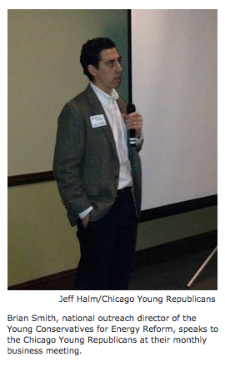
by Kevin Clifford
Feb 11, 2014
With midterm elections looming and 2016 presidential elections in sight, some conservative advocacy groups are working to get their red party behind green energy reform.
Young Conservatives for Energy Reform hosted an event Monday with Chicago Young Republicans to discuss what energy reform looks like from a conservative perspective.
“The energy issue should not be left to the Democrats,” said Angel Garcia, president of Chicago Young Republicans. “We need to take it back from the left.”
Brian Smith, national outreach director of the Young Conservatives for Energy Reform, addressed a full room at the University Club of Chicago. He spoke about the national security risks posed by fossil fuel supplied by countries that “do not like us.”
“Most of the state budgets of Iran, Saudi Arabia, Venezuela, and Russia are heavily financed by oil,” Smith said. “Every time we fill up at the pump, we’re essentially sending them money.”
Framing energy reform as a national security issue is one of the ways Young Conservatives for Energy Reform appeals to voters and legislators on the right. The group’s website also stresses the economic viability of alternative energy, including a statistic that global investments in clean energy reached a new record of $260 billion in 2011, a 5 percent increase from 2010.
“Right now, the best solution seems to be electric cars, wind and solar, in order to get job growth, energy security and clean air,” said Smith, an MBA candidate at Northwestern’s Kellogg School of Management.
In Illinois, Smith said, streamlining solar permitting could cut costs for homeowners who want to install panels. He said the state could follow California’s example and offer tax exemptions for solar panels as well.
“When it comes to solar, there are, like, five to 10 policy levers that you can pull in order to make it really cost effective. Probably four or five of those would be really palpable for conservatives,” Smith said. “I would say, let’s pull those levers.”
For some conservatives in the audience however, the palpability of energy reform boils down to whether it feels like a choice or a mandate: the difference between earning tax credits for buying a clean energy vehicle and levying carbon taxes to restrict emissions.
“We [the right] look at it as a choice to do the right thing,” said Brian Sitter, one of the young conservatives at the event. “Whereas the left tries to ram restrictions down your throat.”
http://news.medill.northwestern.edu/chicago/news.aspx?id=227829

Morning Shift: Conservative group targets clean energy as a key issue

February 10, 2014

WBEZ

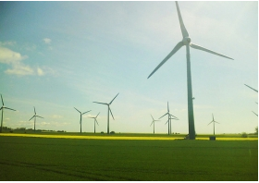
Young GOP leaders want to get in front of clean energy - Clean energy is not typically thought of as a key conservative issue but a group of young Republicans want to make energy reform a priority. National Outreach Director of Young Conservatives for Energy Reform Brian Smith explains why they've targeted this issue and what reform looks like for them.

http://www.wbez.org/programs/morning-shift-tony-sarabia/2014-02-10/morning-shift-conservative-group-targets-clean-energy

Michele Combs a conservative voice for energy reform
David Quick
Friday, November 8, 2013
Conservatives, for the most part, haven’t been keen on alternative energy sources, particularly solar and wind, over the past three decades.

When President Ronald Reagan took office in 1981, one of his first orders was to remove the solar panels that Jimmy Carter had placed on the White House roof.
Conservative radio talk show host Rush Limbaugh routinely derides solar, wind and electric cars.
And who can forget Republican vice presidential candidate Sarah Palin’s energy mantra: “Drill, baby, drill.”
But one longtime, local, pedigreed conservative hopes to change that reputation and sees clean energy and air as a “family value” that has no place in partisanship.
Michele Combs, a Republican organizer since her college days in the late 1980s and daughter of Christian Coalition of America President Roberta Combs, formed Young Conservatives for Energy Reform in the spring of 2012.
Since then, the Hanahan resident has been using her background and skills in creating a grass-roots network to grow support among young conservatives, notably Young Republican clubs, across the United States to support energy reforms.
“Of any issue in the past 20 years, I think this one should be a bipartisan issue,” says Combs. “We really need to come together as a country on it.”
All-American themes
Her strategy is to appeal to what she views as conservative common sense: that alternative energy is good for national security, that it provides economic opportunities through jobs and energy cost savings, and that because its sources are home-grown, alternative energy is ultimately patriotic.
Combs is working with retired generals and admirals to spread the message that alternative energy is good for national security.
On Saturday from 6-9 p.m., her group and South Carolina Young Republicans will be hosting Ret. Marine Corps Lt. General Richard Zilmer to speak at The Citadel Alumni House.
Zilmer says cutting our nation’s dependence on fossil fuels will reduce our economic vulnerability.
“Some say that fully exploiting our domestic energy resources is the solution to all of our energy problems. It’s not. It may be a part of the solution, but it is emphatically not the solution,” says Zilmer, who is among 12 military leaders who worked on the Center for Naval Analysis’ report, “Ensuring America’s Freedom of Movement: A National Security Imperative to Reduce U.S. Oil Dependence.”
Zilmer adds, “Even if we fully exploited our domestic fossil fuel resources, we’d still be tethered to an international market that leaves us vulnerable to price swings and spikes.”
His appearance at The Citadel will mark the first official event for Young Conservatives for Energy Reform in South Carolina.
A wake-up call
Combs, 46, says her first brush with the nation’s environmental issues came when she was pregnant with her son, Logan, more than 13 years ago. She was warned not to eat fish because of the risks of mercury to her developing fetus.
“As I researched it, I found out about all the mercury from coal-fired plants and I couldn’t believe we (conservatives) weren’t talking about this. I asked why aren’t we talking about mercury and clean air and I was told it was a Democratic or liberal issue. I thought to myself, ‘No, it’s not. It’s a family issue. Everyone wants clean air.’ ”
She didn’t really act on that sentiment, however, until about four years ago.
At one point, Combs found herself among a cross-section of political people at an event in Colorado to talk about environmental issues.
“When I opened the door, who was the very first person I meet? ... Al Gore. Talk about being thrown in the environmental fire. But there were conservatives there, too, and the Gores were very nice to me.”
Combs came away realizing that conservatives needed to learn why energy reform, and even protecting the environment, is or should be a value they embrace.
The wrong messengers
She blamed the “messengers” of energy reform, including Gore himself and President Barack Obama, for turning off many conservatives, particularly “low information voters who don’t go beyond” listening to Limbaugh on radio.
Combs hopes to rally conservative messengers with a conservation-minded cause and make it OK to support alternatives to fossil fuel.
“No one can say that I’m not a dire hard, pro-life, pro-family conservative. When they see someone like me, it’s a relief,” says Combs.
She also notes that Obama, for all his promises for energy reform, has failed to deliver by getting bogged down other issues, such as health care, immigration reform and gun control.
“I think this administration has done a lot of things to hurt this issue,” says Combs. “I have no love for (Obama) because I was a Romney supporter, but I think that Obama could’ve done a lot more on energy reform and he’s done nothing but make a lot of people upset on his side.”
In her travels, Combs also reminds people that conservation used to be a platform that the Republican party owned, citing President Theodore Roosevelt’s creation of the national parks, President Richard Nixon’s array of environmental protection acts (creating the Environmental Protection Agency and Endangered Species Act), and President George H.W. Bush’s bipartisan support for protections against acid rain.
As for climate change, aka “global warming,” Combs has found a range of beliefs among conservatives from those who think it is occurring to those who adamantly disagree.
But her argument transcends climate change. Rather, she zeroes in on finding alternatives to fossil fuels simply as a means to simply having cleaner air and a healthier environment.
Her mother has joined her in championing the cause and helped persuade Sen. Lindsay Graham, R-S.C., to be a part of climate change legislation in 2010. His support, however, has rubbed many South Carolina conservatives the wrong way.
Glimmers of hope
Combs’ hope for conservative change lies primarily in the young.
“I think young people get it and understand it. Most of them have young families and want a cleaner environment for their families. I think we start there because I just think they seem to be a little more open-minded,” says Combs.
And while progress in Washington has stagnated during the political impasses of recent years, Combs says she continues to meet conservative leaders on local and state levels who have taken on energy reforms.
For example, staunch Republican Mayor Greg Ballard of Indianapolis has led the charge to convert the city’s vehicle fleet to plug-in hybrid cars and compressed natural gas trucks.
Closer to home, Combs sites Republican Gov. Nikki Haley’s support for energy efficiency in state buildings and Republican Sen. Paul Campbell’s leadership in supporting clean energy in South Carolina.
The Berkeley County senator, who is the former president of the American Institute of Mining, Metallurgical and Petroleum Engineers, echoes many of Combs’ sentiments.
“It’s not in America’s best interest to send money overseas to pay for energy from nations that don’t like us. For the sake of our economy and national security, we should pursue true energy independence, “ says Campbell.

Michele Combs also interviewed with the following radio shows in advance of the YCER event in Charleston, SC:

Mornings with Kelly Golden on WSC-FM in Charleston, SC
November 8, 2013

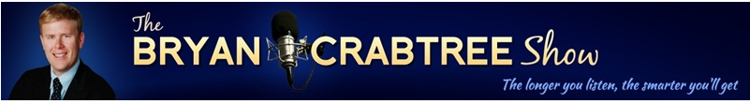

The Bryan Crabtree Show on WQSC-FM in Charleston, SC
November 8, 2013

On energy: Following the lead of the U.S. military

November 7, 2013

By Michele Combs, Joe M. Garavaglia and Linda Ragsdale
When it comes to energy policy, we can learn a lot from the U.S. military.
That might seem like a strange assertion, since the Department of Defense is among the biggest consumers of energy in the world. But as conservative organizations in St. Louis learned recently, our armed forces are changing the way they power their mission — making the military more efficient and effective, saving money, and even saving lives. “More fight, less fuel” is not an empty buzz phrase.
In the entire history of the U.S. Air Force, there have been only 203 four-star generals, and Ronald Keys — now retired — is one of them. At two recent events — one co-sponsored by the St. Louis Young Republicans and the national organization Young Conservatives for Energy Reform, and another hosted by the St. Louis County Pachyderms, Gen. Keys talked about the high cost of traditional energy on the battlefield. An Army evaluation found one American killed for every 24 fuel convoys in Afghanistan, while the Marines found one in 10 casualties were hit while working on fuel and water convoys. Imagine if trips to the gas station were a matter of life and death, and you can imagine how seriously you’d take conservation and alternative energy sources.
Looking at the bigger picture, safeguarding the free flow of oil stretches our military thin. And reliance on oil limits our actions on the world stage, and ties us to countries that do not always share our values. It also exposes American families and businesses to dramatic swings in world energy prices, which whipsaw our economy and weaken our country.
Gen. Keys pointed out that the Department of Defense has improved its energy productivity by 13.3 percent since 2003 — twice as fast as the economy as a whole. The Pentagon is cutting back on wasted energy, becoming more and more efficient. It is adopting renewables such as solar, wind, geothermal, and biofuels, resulting in a more diversified energy portfolio. And it is changing its culture, figuring the cost of fuel in everything it does, and planning accordingly.
As conservatives, we see promise in similar approaches for the nation as a whole. Cleaner, more efficient energy is vital to our economic and national security. It is also a family-values concern. Cutting back on the use of dirty sources of energy promotes clean air and water, which helps ensure a healthier future for our children. As President Reagan put it, “Preservation of our environment is not a partisan challenge. It’s common sense.”
Developing clean-energy technology and capacity taps into a huge and expanding worldwide market that offers chances for long-term economic growth. Last year alone, investment in renewables was $268.7 billion worldwide, according to Bloomberg New Energy Finance.
That economic opportunity is something Missouri is well-placed to take advantage of. The Show-Me State has strong potential in wind energy and biofuels, and policies in place that encourage renewable energy generation. It’s no surprise that Missouri was ranked as the seventh-best state for clean-energy job creation in the second quarter of this year.
Boosting energy efficiency and developing a full portfolio of cleaner, made-in-America energy options makes for a stronger state economy. It also makes for a stronger, safer, and more secure nation.
Michele Combs is president of Young Conservatives for Energy Reform. Joe M. Garavaglia is president of the St. Louis Young Republicans. Linda Ragsdale is involved with the St. Louis Young Republicans and is vice president of programs for the St. Louis County Pachyderms.

General Ronald Keys

St. Louis Young Republicans host U.S. Air Force general who speaks on need to end dependence on fossil fuels. "We need to encourage renewables. We need to consider cap and trade and a carbon tax to recover the indirect costs of relying on fossil fuels."
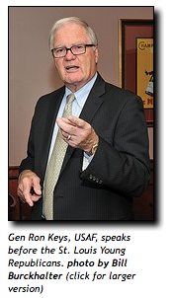
October 25, 2013

Democrats in "Drinking Liberally," a group that meets at JP's Corner and the Jefferson Grill in Kirkwood, may now have to make room for Republicans in a new pack of pachyderms, "Young Conservatives for Energy Reform."
Earlier this month, the St. Louis Young Republicans heard from Gen. Ron Keys, USAF, on the need to end dependence on fossil fuels. His talk at Jefferson Grill was sponsored, in part, by Young Conservatives for Energy Reform, which hopes to start chapters across Missouri.
"My pitch is that we have to end our dependency on fossil fuels for energy security reasons and because the world is going to become more and more unstable with the effects of climate change," said Keys. "I am with the CNA Military Advisory Board, a group that is very concerned about what's ahead for America
if we don't change our energy policies.
"It's a real problem that we have to depend on oil from countries that are not our friends, which compromises our foreign policy," said Keys. "The other bookend on this is the effects of climate change. The effects are going to cause instability in countries that already are problem areas for us."
Keys said these countries will become desperate as rising sea levels from climate change cause mass migrations. He said the U.S. military will be called upon to help with humanitarian relief, but also will be battling to keep terrorists from gaining a foothold in desperate, troubled countries.
Linda Ragsdale, a member of the St. Louis Young Republicans and a past chair of the organization, described the Keys' presentation in Kirkwood as a real eye-opener.
"His topic about fossil fuel dependency is not one usually considered by conservatives," said Ragsdale. "Being green and having clean energy are issues that have kind of been ceded to Democrats, but he did a good job posing it as a national security issue.
"In 2008, I was persuaded by the 'drill, baby, drill' chant," continued Ragsdale. "But Gen. Keys made the point that the well is going to run dry. And no matter how much we drill, it all ends up on the world market. So the additional drilling is not going to help us with security or with making oil cheaper for us."
Joe Garavaglia, president of the St Louis Young Republicans, gave this take on the Kirkwood meeting: "As a conservative, two of my top issues are national security and the economy. Hearing from a four-star general about national security and economic impacts of our oil dependence convinced me, that conservatives must have a voice in moving our nation's energy profile forward."

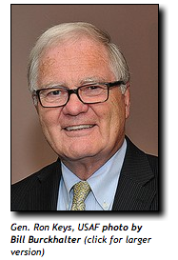
Bipartisan Imbibing
Paul Cartier, proprietor of JP's Corner and Jefferson Grill, said he is happy to host and raise a toast to both the liberals and conservatives who come to roost at his restaurant and bar facilities.
"Drinking Liberally is closer to my heart, because they drink more," said Cartier. "They're more casually dressed and a little more boisterous. The Young Republicans look like they come here straight from work and they order less beer and drink more water.
"But I like both groups," said Cartier. "I'd like to get them in the same room together and see what would happen. I am sure they would do better getting along than Congress."
Ragsdale said it may be only a matter of time before St. Louis Young Republicans and a new chapter of the Young Conservatives for Energy Reform start meeting together on policy issues in Kirkwood.
"There's talk of starting several energy chapters in Missouri," said Ragsdale. "My understanding is that Gen. Keys will be coming to Jefferson City to deliver his message soon."
Michele Combs, founder and president of Young Conservatives for Energy Reform, said there will be an event in the state capital after the first of the year and Keys hopes to speak with conservative state legislators.
"We've been to 30 states with our message and I was very impressed with the meeting in Kirkwood," said Combs. "Conservatives will embrace green energy, if the message is about energy independence and efficiency.
"It's time for Republicans to get rid of their knee-jerk reaction that if you support clean energy, you are with the environmental wackos and Al Gore," added Combs. "We also have to stop blindly supporting the big oil companies and fighting in other countries over control of oil.
"Now, this is just my personal opinion, but I think the Iraq War was all about oil," said Combs. "And I think Republicans have had enough of going to war over oil. We need to get out of the Middle East."
General's Warning
At the Kirkwood meeting and at other appearances on his St. Louis visit, Keys reiterated the mounting evidence that global warming is real. Heat waves are intensifying. Wild fires are increasing. Sea levels are rising. Glaciers and permafrost are melting.
"The science is very clear on this," said Keys. "We can't keep pumping all this CO2 into the atmosphere and just pretend that it has no effect. The impacts are underway and the world is going to be a very different place in three decades.
"The science is in, and we need to start reacting and planning in a strategic way right now," added Keys. "We need to encourage renewables. We need to consider cap and trade and a carbon tax to recover the indirect costs of relying on fossil fuels."
Keys said his usual audiences are mayors, green businesses and "renewable energy folks." He said he has increasingly found himself speaking to Republican groups, whom he said respond favorably when energy issues are seen in the context of national security.
"However, people need to realize that the effects of global warming are not in some faraway country overseas," said Keys. "It is here in the U.S. right now, whether it's areas of intense drought, abnormal heat waves or unusual flooding in certain locations."

Young Republicans Tackle Energy Reform
October 22, 2013

Imagine launching a climate change initiative in a state like Missouri where the politicians loathe talk of global warming and carbon footprints. Well, that's just what our academic friends on Forsyth did this fall semester.
Washington University launched an education program for students to be led by Peter Raven, president emeritus of the Missouri Botanical Garden. In announcing the program, Raven said:
"Students graduating this year will live and work in a vastly different world from the one in which we live now. The warmer and less dependable climate of the future and the accompanying rise in sea level, difficulties in feeding a rapidly growing population, spreading diseases, and more need for strong cooperation between nations will pose novel challenges to every aspect of their lives."
One can almost hear all the groans from the pachyderm pack that meets under the Capitol Dome in Jefferson City. Missouri's GOP climate skeptics have no patience for such pronouncements as those by Dr. Raven.
Except — get this — there is a new, younger breed of Republican now willing to listen to the concerns of educators, scientists and strategic planners on climate change issues. The St. Louis Young Republicans gathered earlier this month in Kirkwood to hear from Gen. Ron Keys, USAF, on the need to end dependence on fossil fuels. Keys' talk was sponsored, in part, by Young Conservatives for Energy Reform, which hopes to start chapters across Missouri.
"My pitch is that we have to end our dependency on fossil fuels for energy security reasons and because the world is going to become more and more unstable with the effects of climate change," said Keys. "I am with the CNA Military Advisory Board, a group that is very concerned about what's ahead for America if we don't change our energy policies.
"It's a real problem that we have to depend on oil from countries that are not our friends, which compromises our foreign policy," said Keys. "The other bookend on this is the effects of climate change. The effects are going to cause instability in countries that already are problem areas for us."
Linda Ragsdale, a member of the St. Louis Young Republicans and a past chair of the organization, described the Keys' talk as a real eye-opener.
"His topic about fossil fuel dependency is not one usually considered by conservatives," said Ragsdale. "Being green and having clean energy are issues that have kind of been ceded to Democrats, but he did a good job posing it as a national security issue."
Ellinger On Public Policy
Perhaps the young Republicans can persuade older elephants in Jefferson City, who've grown long in the tusk, to consider some sensible public policies on energy and CO2 pollution.
Rory Ellinger, D-University City, has been speaking out about the need for some good public policy since the legislative veto session in August. Like so many of us, Ellinger is mystified that his colleagues focus on ending any and all restrictions on guns, while neglecting health care needs and education issues in the state.
"What I feel legislators are sent to do is to make good public policy," said Ellinger. "For example, shouldn't we consider making it, at the very least, a misdemeanor to leave a fully-loaded gun unattended in a public place?"
Ellinger was referring to the incident in which a legislative assistant for House Speaker Tim Jones, R-Eureka, left a semiautomatic handgun with a bullet in the chamber on a toilet roll dispenser in a capitol bathroom. Because students frequent the capitol building on tours, Ellinger thinks it might be good public policy to discourage such negligence.
"We also have the technology now to make guns only operable by their owners," said Ellinger. "No one else could fire them. Only the right finger print would activate a gun. That to me would be good public policy. It's not a restriction, but a way to make everybody feel safer and more free from violence."
Ellinger points out examples of public policy that have made for longer and safer lives, from seat belts in cars to limits on contaminants in the air we breathe and the water we drink.
Some good public policy on energy issues and global warming might also be appreciated. As Gen. Keys told the Young Republicans this month: "The science is in, and we need to start reacting and planning in a strategic way. We need to encourage renewables. We need to consider cap and trade and a carbon tax to recover indirect costs of relying on fossil fuels.
"People need to realize that the effects of global warming are not in some faraway country overseas. It is here in the U.S. right now, whether it's areas of intense drought, abnormal heat waves or unusual flooding in certain locations."
My Word: Energy reform: Beyond party politics
July 8, 2013|By Brian T. Empric and Michele Combs
While Republican Party strategists ponder how to win the next election, they're naturally thinking about ways to inspire more young people to vote. The post-Boomer generations are a powerful constituency — yet one that proved fickle last fall.
As young Republicans who care about our party, and — even more — our country, we have a suggestion for how to win back the hearts and minds of young voters. It boils down to two words: energy reform.
It's only natural for young people to care about energy policy. We'll inherit an America shaped by decisions made today. And it's increasingly clear that diversifying our nation's energy portfolio is in our best interest.
This message was underscored recently by retired U.S. Marine Corps Lt. Gen. Richard Zilmer of CNA's Military Advisory Board, who spoke at an event co-hosted by our respective organizations, the Orange County Young Republicans and Young Conservatives for Energy Reform.
As Zilmer told us, he witnessed first-hand the risks posed by America's over-dependence on fossil fuels. While serving as commanding general of multinational forces in Al Anbar province in Iraq, he called for greater deployment of renewable energy on the battlefield to reduce the number of troop casualties resulting from dangerous fuel convoys often targeted by the enemy.
America's dependence on oil also affects our domestic economy. Even though we've reduced our reliance on imports, we're still tied to a volatile international market manipulated by a cartel that leaves us vulnerable to dramatic swings in price. And historically, purchasing foreign oil from unstable parts of the world has constrained foreign-policy options and placed us in the position of funding both sides of the fight against terrorism.
By pursuing a strategy that prioritizes efficiency first, we can make our nation stronger by attracting investment, creating jobs and having more control over our energy future. America must lead the global competition for clean-energy technologies and promote free-market forces to pick economically viable solutions without needing taxpayer-funded subsidies.
Zilmer's message is that a cleaner and more diverse energy future is in every American's interest, meaning it's our duty to keep debates over energy reform outside the realm of partisan politics.
As young conservatives who want the best for our country — and our party — we salute him.
Brian T. Empric is vice president of the Orange County Young Republicans. Michele Combs is president of Young Conservatives for Energy Reform.

Republicans, seeking clean energy, often embrace it outside the Beltway
By EVAN LEHMANN | July 24, 2013

Clean energy may still be fighting words in Congress, but conservative and liberal states are often talking the same language, according to a report that finds support for using less fossil fuel in some unlikely places.

It asserts that an energy "transformation" is underway in disparate states, including Republican ones, as public officials, businesses and city leaders pursue efforts to increase energy efficiency and renewable energy use. This is contrary to the "stereotypes" that describe clean energy progress as being stalled by partisan impasses, it says.

"When it comes to clean energy, it's happening. It's happening in places you wouldn't expect, and it's happening with people you might not expect," said Stewart Hudson, president of the Tremaine Foundation, which provides clean energy grants to cities and states and commissioned the report.

"It's not being led, always, by progressives and liberals," he added. "There are people of Republican bent who are leading the charge."

The report examines policies in three states with different energy profiles: South Carolina, Pennsylvania and Connecticut.

Among them, it found three drivers that cross political lines to reduce fossil fuel use. Climate change isn't one of them. The action is rooted, instead, in politically benign areas, like schools, the military and new technologies.

South Carolina Gov. Nikki Haley, a Republican elected in 2010, encouraged efficiency by requiring state buildings and public schools to reduce their energy use 20 percent by 2020. The report also points to a law approved by the state Legislature in 2010 allowing "on-bill financing" for energy efficiency improvements. It means homeowners don't have to find upfront cash to pay for retrofits. About 20 states have similar programs.

The Electric Cooperatives of South Carolina helped launch a similar on-bill financing program for weatherization projects, which can save homeowners up to $1,200 a year, according to the report.

"Rural energy co-ops, which I don't think have ever been accused of being lefty, are doing some real important work on energy efficiency, not necessarily because they're concerned about climate, though some are, but really because of the economic benefits that are so obvious," Hudson said.

'Come together' on energy?

The 84-page report highlights conservative leaders such as George Shultz, who served as secretary of state under President Reagan and who has recently promoted a carbon tax as a way to lower rates on income and corporations.

It also cites Gov. Sam Brownback as promoting wind-rich Kansas as "the Renewable State" and Arizona Gov. Jan Brewer for calling her state "our nation's solar capital." Both are Republicans. Roberta Combs, president of the Christian Coalition, is held up for her belief that climate change is a family issue.

Michele Combs, her daughter, who's active in South Carolina politics and who recently founded the Young Conservatives for Energy Reform, will speak at an event on Capitol Hill today releasing the report.

"I think more and more we're seeing this as truly a nonpartisan, or bipartisan, issue," Michele Combs said yesterday of clean energy. "The Democrats like it because of the environmental reasons, and the Republicans like it because we can save money. I think if we can come together with those two areas, I think we do a lot nationwide."

Among the reasons for state leadership is the control that those officials have over electric utilities -- and the impacts that rising rates can have on their political careers. So they often turn to energy efficiency, which can save consumers money by "eliminating waste," the report says.

Another reason could be related to lobbying. It suggests that state and local politicians are more insulated from the influence of the fossil fuel industry than members of Congress, who saw the industry spend $139 million on lobbying in 2012.

At least 24 states have efficiency standards that require utilities to meet annual targets for saving electricity. Many of them are Democratic strongholds, like California, Illinois and New York. But others don't fit the typical profile, like Texas, North Carolina and Ohio.

"The nation's opinion media often frames clean energy policies as caught in the partisan divide," the report says. "Outside the Beltway, however, and largely ignored by politicized and mainstream media alike, Americans know that energy efficiency really isn't about politics -- it's about common sense."

Rhetoric stays heated on Capitol Hill
The report also highlights the northeast U.S. cap-and-trade program called the Regional Greenhouse Gas Initiative, saying it's had "clear economic benefits -- including pumping money into the nine states' economies without raising taxes."

It doesn't mention that New Jersey Gov. Chris Christie, a Republican, withdrew his state from the program.
The report was released amid characteristic partisanship on Capitol Hill. As its supporters were arguing that federal impasses on energy policy capture the headlines over local progress, members of Congress were doing their best to get in the news.

Sen. John Hoeven (R-N.D.), who supports the proposed Keystone XL pipeline, promised yesterday to offer an amendment mandating its approval to a key energy efficiency bill sponsored by Sens. Rob Portman (R-Ohio) and Jeanne Shaheen (D-N.H.). The move could complicate Senate efforts to pass the legislation before the August recess.

A House panel controlled by Republicans, meanwhile, advanced a spending bill for Interior and environmental programs that seeks to cut $5.5 billion from U.S. EPA, a 33 percent reduction. The measure also would prohibit the agency from using money to develop greenhouse gas regulations on power plants, announced last month by President Obama.

While the report strikes an optimistic tone, it acknowledges that climate change won't be fixed with the current policies.

"To be sure, the world will need a lot more of an energy revolution than we've documented here to ensure a stable climate and cleaner air and water," it says. "Yet we believe the progress represents the beginning of a movement that will grow quickly, and be hard, if not impossible, to stop."

http://www.eenews.net/climatewire/2013/07/24/stories/1059984923

The Coming GOP Civil War Over Climate Change

Science, storms, and demographics are starting to change minds among the rank and file.

By Coral Davenport

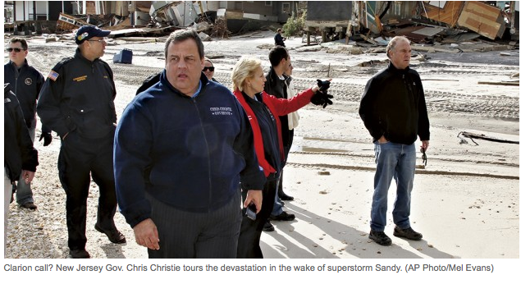
Kerry Emanuel registered as a Republican as soon he turned 18, in 1973. The aspiring scientist was turned off by what he saw as the Left’s blind ideology. “I had friends who denied Pol Pot was killing people in Cambodia,” he says. “I reacted very badly to the triumph of ideology over reason.”
Back then, Emanuel saw the Republican Party as the political fit for a data-driven scientist. Today, the professor of atmospheric science at the Massachusetts Institute of Technology is considered one of the United States’ foremost authorities on climate change—particularly on how rising carbon pollution will increase the intensity of hurricanes.
In January 2012, just before South Carolina’s Republican presidential primary, the Charleston-based Christian Coalition of America, one of the most influential advocacy groups in conservative politics, flew Emanuel down to meet with the GOP presidential candidates. Perhaps an unlikely prophet of doom where global warming is concerned, the coalition has begun to push Republicans to take action on climate change, out of worry that coming catastrophes could hit the next generation hard, especially the world’s poor.
The meetings didn’t take. “[Newt] Gingrich and [Mitt] Romney understood, … and I think they even believed the evidence and understood the risk,” Emanuel says. “But they were so terrified by the extremists in their party that in the primaries they felt compelled to deny it. Which is not good leadership, good integrity. I got a low impression of them as leaders.” Throughout the Republican presidential primaries, every candidate but one—former Utah Gov. Jon Huntsman, who was knocked out of the race at the start—questioned, denied, or outright mocked the science of climate change.
Soon after his experience in South Carolina, Emanuel changed his lifelong Republican Party registration to independent. “The idea that you could look a huge amount of evidence straight in the face and, for purely ideological reasons, deny it, is anathema to me,” he says.
Emanuel predicts that many more voters like him, people who think of themselves as conservative or independent but are turned off by what they see as a willful denial of science and facts, will also abandon the GOP, unless the party comes to an honest reckoning about global warming.
And a quiet, but growing, number of other Republicans fear the same thing. Already, deep fissures are emerging between, on one side, a base of ideological voters and lawmakers with strong ties to powerful tea-party groups and super PACs funded by the fossil-fuel industry who see climate change as a false threat concocted by liberals to justify greater government control; and on the other side, a quiet group of moderates, younger voters, and leading conservative intellectuals who fear that if Republicans continue to dismiss or deny climate change, the party will become irrelevant.
“There is a divide within the party,” says Samuel Thernstrom, who served on President George W. Bush’s Council on Environmental Quality and is now a scholar of environmental policy at the American Enterprise Institute, a conservative think tank. “The position that climate change is a hoax is untenable.”
A concerted push has begun within the party—in conservative think tanks and grassroots groups, and even in backroom, off-the-record conversations on Capitol Hill—to persuade Republicans to acknowledge and address climate change in their own terms. The effort will surely add heat to the deep internal conflict in the years ahead.
Republicans have been struggling with an identity crisis since the 2012 presidential election. In particular, the nation’s rapid demographic changes are forcing the GOP to come to terms with the newly powerful influence of Hispanic voters and to confront the issue of immigration. For now, climate change isn’t getting anywhere close to that kind of urgent scrutiny from Republicans, at least not in public. GOP strategists say that Republican candidates hoping to win primary races, where the electorate tends to be older and more ideologically driven, are still best served to deny, ignore, or dismiss climate change.
Today, a Republican candidate “wouldn’t be able to win a primary with a Jon Huntsman position on this,” says strategist Glen Bolger.
The problem is, as polling data and the changing demographics of the American electorate show, it’s likely that the position that can win voters in a primary will lose voters in a general election. Some day, though, the facts—both scientific and demographic—will force GOP candidates to confront climate change whether they want to or not. And that day will come sooner than they think.
Already, the numbers tell the story. Polls show that a majority of Americans, and a plurality of Republicans, believe global warming is a problem. Concern about the issue is higher among younger voters and independents, who Republicans will need to attract if they want to win elections.
According to a pair of Gallup Polls in April, 58 percent of all Americans are worried about global warming, and 57 percent believe it is caused by human activities. Not surprisingly, responses reflect a partisan divide on the issue, but among Republicans, concern about global warming is rising. Gallup found that 75 percent of Democrats worry about climate change, compared with 59 percent of independent voters (up from 51 percent in 2010) and 40 percent of Republicans (up from 32 percent from that year).
A January poll of Republicans and Republican-leading independents conducted by George Mason University’s Center for Climate Change Communication said that a majority (52 percent) think climate change is happening; 62 percent favor taking action to combat climate change, such as taxing carbon pollution. Only 35 percent of the Republican respondents said they agree with the Republican Party’s position on climate change. (The party’s 2012 platform opposed any limits on greenhouse-gas emissions and suggested the science underlying projections of a warming climate is “uncertain.”)
Meanwhile, a March poll by the Pew Research Center for the People and the Press found that 69 percent of Americans believe the climate is already changing. On the more contentious question of whether fossil-fuel pollution is causing that change, the poll uncovered a generation gap: Only 28 percent of voters over age 65 accept the scientific consensus that such emissions are warming the Earth, while close to 50 percent of those under 50 accept it.
“These polls show that there are a lot of people who are inclined to vote Republican—and believe America should respond to climate change,” says Edward Maibach, director of the George Mason program. “Republicans aren’t inclined to respond to it right now, but in the future, if they don’t take these issues seriously, they’re inclined to alienate a lot of Republican voters.”

CHRISTIAN SOLDIERS
Mother and daughter Roberta and Michele Combs are pillars of the Religious Right. Roberta, president and CEO of the Christian Coalition America, got her start in Republican politics working with celebrated strategist Lee Atwater. Michele, who was named Young Republican of the Year in 1989 and worked as a planner for events such as George W. Bush’s inauguration, is the coalition’s communications director. With their white-blond bouffant hair, penchant for fuchsia lipstick, soft South Carolina accents, and sterling conservative bona fides, the Combses are familiar presences in the ruby-red heart of the GOP establishment.
That’s why it’s so surprising to many that they are tackling climate change. But both women see global warming, and clean air and environmental protection more broadly, as issues that tie into their core conservative mission of protecting family values.
“This is an important issue for the Republican Party,” Roberta Combs says. “At one point in time, this was a Republican issue, but Democrats took it over.”
In 2010, Roberta led a Christian Coalition push for her friend Sen. Lindsey Graham of South Carolina to sign on to a Senate climate-change bill, as the measure’s sole GOP sponsor. Graham eventually pulled his support, but thanks in part to Roberta’s pressure, he’s remained one of the few Republicans to openly acknowledge climate change and to call on his party to look for a solution. He is sticking with his position even as he prepares to face South Carolina voters for reelection next year.
“I think the Republican Party needs to embrace an environmental agenda,” Graham says. “When you ask a Republican candidate for president, what’s your environmental platform, what do they say? We need to be able to speak to this just as quickly as to do to reforming the tax code. Younger people, people under 30, this is a huge issue for them.”
Roberta was the Christian Coalition official who persuaded Emanuel, the MIT scientist, to speak with the GOP presidential candidates in January 2012. And she continues to employ her group’s grassroots muscle to muster conservative support for Republicans like Graham who support action to combat climate change, with the hope that eventually one will sponsor a bill that can pass.
“I think the Republican Party has got to move to the center. We should never leave our base, but we’ve got to be more open-minded and look at issues more American families care about,” Roberta says. “As the electorate changes, we’re not going to win as much. It’s a different generation, and the Republican Party has got to look at all of this and broaden its agenda if they want to continue to win elections.”
Last summer, Michele launched a new group, Young Conservatives for Energy Reform, aimed at amassing grassroots support for lawmakers and legislation addressing clean energy and climate change. She is channeling her network of connections among the Christian Coalition and the Young Republicans.
She works closely with Brian Smith, a 32-year-old Air Force veteran and the chairman of the Midwest chapter, who is also a former cochairman of the Young Republicans National Federation, a training ground for party leaders founded in 1931. The energy group is structured like the Young Republicans, with volunteers staffing city, state, and regional chapters. So far, the group has state chairs in Florida, Georgia, Indiana, New Hampshire, Ohio, South Carolina, and Texas—all of which have Republican governors.
Over the past year, the group has held a dozen events in those and other states. In October 2012, it sponsored a get-together in Washington for GOP congressional staff. The gatherings—mostly of young professionals in their 20s, 30s, and 40s—feature hors d’oeuvres, cocktails, and a talk from retired Marine Gen. Richard Zilmer, who makes the case that both climate change and U.S. oil dependence are matters of national security, and that policies to cut fossil-fuel use are consistent with conservative values. Emanuel has also spoken at some of the events.
The goal, Michele says, is to build a database of voters who will, at some point, come forward to back Republican candidates who support cutting carbon pollution. “We are building a grassroots army of young conservatives around the country,” she says. “When the time comes, we’ll have the grassroots to organize around candidates or legislation, and we can activate them.”

PAYING THE PRICE
What Michele and Roberta want to do, in other words, is protect lawmakers such as Bob Inglis. Today, Republicans point to the former House member from South Carolina as the textbook tale of what happens when a red-state conservative dares to acknowledge climate change.
Inglis, who left Congress in 2011, recalls the challenge his son, Rob, threw down to him a decade ago before he was to vote in his first election. He said, “I’ll vote for you, Dad, but you’ve got to clean up your act on the environment.’ ”
Inglis had never given much thought to the issue of climate change. As a by-the-books conservative, he says, “I accepted that if Al Gore was for it, I was against it, until my son challenged my ignorance on the subject.” Inglis spent the next few years educating himself on climate issues. He joined the House Science Committee and accompanied climate scientists on research trips to Antarctica and the Great Barrier Reef, where he saw firsthand the damages wrought by rising carbon pollution and warming temperatures. “I got convinced of the science,” he says, and, in 2009, Inglis cosponsored climate-change legislation with Republican Rep. Jeff Flake of Arizona. The bill proposed an idea that had strong backing from environmentalists, including Gore, as well as prominent conservative economists. It would create a tax on carbon pollution but use the revenue to cut payroll or income taxes.
Inglis would pay dearly for his support of the so-called carbon-tax swap. The following year, he lost his primary election to a tea-party candidate, Trey Gowdy. And Inglis knows his position on the climate was the reason. “The most enduring heresy was saying, ‘Climate change is real and we should do something about it.’ That was seen as a statement against the tribal orthodoxy.”
“But,” he says, “these heresies and orthodoxies change so quickly. Back in 2010, I was voting for immigration reform; look how that’s changed. It’s going to be like that with climate change.”
Along with the evolving politics of immigration reform, Bob and Rob Inglis also see in their situation a kinship with Sen. Rob Portman of Ohio, who jolted the party earlier this year when he came out in support of gay marriage. Portman changed his stance after conversations with his 21-year-old son, Will, who is gay.
“I hope there’s a parallel,” Bob Inglis says. “Rob [Portman] is a hero of mine. He loves his son. He’s willing to take risks for his son.” Unlike Inglis, Portman hasn’t yet had to face voters in a primary—and won’t until 2016. Given the rapid shift in public attitudes toward gay marriage, he may in fact suffer no repercussions. It wasn’t long ago that gay marriage served as a valuable wedge issue for the party (think George W. Bush in 2004)—much like placing limits on carbon is today.
For the moment, however, Inglis has taken on the arduous task of bringing his party back to him. Last summer, he founded the Energy and Enterprise Initiative, a nonprofit organization based at George Mason University, focused on convincing conservatives, particularly young ones, that climate change, caused by carbon pollution, is a serious threat—and on pushing for the carbon-tax swap as a fundamentally conservative economic solution. Since last fall, Inglis and a cohort of conservative economists have made their case at a dozen events, including talks at colleges and universities in Florida, Illinois, Kansas, Kentucky, and Mississippi.
Last month, 21-year-old Republican Kevin Croswhite, a senior at Carthage College in Kenosha, Wis., who grew up in nearby Salem (both towns lie within in the district of Rep. Paul Ryan, the 2012 GOP vice presidential candidate) attended one of Inglis’s events—and was sold.
Croswhite has considered himself a conservative Republican since high school. As an economics major, he is a big believer in data: scientific, economic, and demographic. He is persuaded that his party’s rejection of the data on climate change will damage it politically.
“The country’s going to become more educated, and that’s not going to break our way, as a party, if we are denying what 90 out of 100 scientists say,” Croswhite argues. “If the scientific community is generally accepting of something, you need to trust that.”
While Combs’s and Inglis’s groups try to appeal to conservative Christians and young Republicans, another organization—the National Audubon Society—is reaching out to red-state conservatives in the West, linking the threat of climate change to the ideal of Theodore Roosevelt’s Republican conservatism, in a bid to appeal to hunters, fishers, ranchers, and other lovers of the outdoors. The venerable nonpartisan group has teamed with the Washington organization ConservAmerica to ask red-state voters to sign an “American Eagle Compact” calling for lawmakers to act on conservation policies, including climate change. The effort, which Audubon says is funded by a Texas Republican who has asked to remain anonymous, has so far garnered 55,000 signatures.
“We’re trying to figure out how to partner with those people, so they can turn out in communities across the country, to activate them for support,” says Audubon President and CEO David Yarnold. “We want to make sure that when Republican legislators who support conservation and climate policy go home, they’re not just getting hollered at. We want to make sure they’re hearing from reasonable conservationists who say this is not a partisan issue.”

LIGHTING THE WAY
While those groups work from the bottom up to help push Washington to move on climate issues, a constellation of prominent conservative economists is bolstering the cause. These conservatives include such intellectuals as Art Laffer, the former senior adviser to President Reagan; George Shultz, Reagan’s secretary of State; Gregory Mankiw, who was an economic adviser to the Romney campaign and the former chief economist for George W. Bush’s Council of Economic Advisers; Douglas Holtz-Eakin, the president of the influential conservative think tank American Action Forum, a former head of Bush’s Council on Economic Advisers, and an economic adviser to Sen. John McCain’s 2008 presidential campaign; and a host of other well-respected conservative economic thinkers.
Laffer spoke to National Journal by phone from his home in Tennessee, where he lives next door to Gore. The Reagan economist and the liberal global-warming crusader disagree on many issues but are united on the wisdom of a carbon-tax swap as good environmental and economic policy. “Al is a dear friend, and I think he’s a damned good public servant,” Laffer says. “I am ignorant-squared on climate change, but what I do believe is that the risks of reducing carbon in the environment are less than the risks of putting more carbon into the environment.”
Last year, Laffer wrote a detailed paper on how best to structure a carbon-tax swap, presumably as part of the broader tax-reform effort Congress appears to be moving toward. “What I believe in, and Al Gore believes in, is if you’re going to do a carbon tax, you need to offset it dollar-for-dollar with marginal tax reduction on income or employment,” he says. “Anyone who goes through what I just went through, they’ll agree with me. I’ve had more experience than anyone in the financial thinking on this.”
At the beginning of this Congress, a group of Republican lawmakers, along with a few coal-state Democrats, sponsored a measure that vowed they would never back a carbon tax, and given the antitax mood in Washington, prospects for such a tax appear dim. Still, both opponents and proponents concede that the idea will certainly be on the table if Congress makes a serious attempt at tax reform in the coming years.
Laffer said that as with so many of the policies he’s proposed before, the time will ripen for a carbon tax as it moves from impossible to inevitable. “My policies are always the North Star,” he says. “Right now, this is viewed as a third-order problem. But if we take over in 2016, this will have huge traction.”
Laffer spent last year promoting the idea on college campuses. The climate-change advocacy group Clean Air-Cool Planet flew Holtz-Eakin to New Hampshire to participate in living-room chats with voters about the economic costs of climate change and the economic benefits of addressing the problem.
In March, Schultz went to Capitol Hill to talk about climate change and push the carbon tax to congressional aides. In a standing-room-only gathering in the Rayburn House Office Building, he argued, “Good work on conservation and the environment is in the Republican genes; we’ve been the guys who did it.… My proposal is to have a revenue-neutral carbon tax.” Schultz got a standing ovation. Among the audience were staffers from the offices of Republican Reps. Phil Roe of Tennessee, Billy Long of Missouri, and Randy Neugebauer of Texas—ranked as the most conservative member of the House in a 2011 NJ survey.

A SLEEPING GIANT
It’s long been taken as a truism that the powerful oil lobby is the reason nothing happens on climate change in Washington. For many years, that was indeed true. In particular, Exxon Mobil, the nation’s largest oil company and a major contributor to Republican candidates, was associated with a campaign to fuel skepticism about climate science. From 1998 to 2006, Exxon Mobil contributed more than $600,000 to the Heartland Institute, a well-known nonprofit group that holds conferences and publishes books aimed at debunking the science of climate change. Exxon Mobil’s support of Heartland made sense. The oil company stood to take a financial hit from “cap-and-trade” climate-change proposals that would have priced carbon pollution from oil.
For a number of reasons, that equation is changing. Exxon Mobil has ended its support of Heartland’s agenda. It’s not that the oil giant has had a green awakening; it’s just that a series of internal changes have positioned the company to profit from at least some policies that price carbon emissions.
In 2010, Exxon Mobil bought the natural-gas company XTO Energy, which transformed the venerable oil producer into the world’s largest natural-gas producer. Around the same time, the company began making a noticeable shift in its climate policy. The reason: Natural gas, which is used to generate electricity, is the lowest-polluting fossil fuel, emitting just half of the greenhouse gases as coal, the world’s top electricity source. In the event of a tax on carbon pollution, demand for coal-fired electricity would freeze, while markets for natural gas would explode.
Every year, Exxon Mobil puts out a widely read report with projections on the global state of energy development. The most recent one included the assumption of a future price on carbon and a corresponding surge in natural-gas consumption. “We assume there’s going to be a price on carbon in the future, and that assumption drives our investment strategy,” says company spokesman Alan Jeffers.
And the position on climate change at Exxon Mobil that once helped fund the Heartland conferences? “We have the same concerns about climate change as everyone. The risk of climate change exists; it’s caused by more carbon in the atmosphere; the risk is growing; and there’s broad scientific and policy consensus on this,” Jeffers says.
In 2010, during Senate negotiations on the cap-and-trade bill, Exxon Mobil told the White House that it wouldn’t back that bill, but it would support legislation with a straight carbon tax, ideally, a carbon-tax swap along the lines of what Inglis and Laffer propose. Ultimately, of course, all of those attempts failed. And, today, Exxon Mobil is not actively lobbying for the tax. The company’s position remains the same, though, Jeffers says. “Our approach has been, if public policymakers have decided they want to put a price on carbon, we see a revenue-neutral carbon tax as the most efficient way to do that.”
In the 2012 campaign, Exxon Mobil gave $2.7 million in political contributions, with 88 percent going to Republicans. One of the world’s biggest and most profitable oil companies—a lobbying powerhouse and major influence in GOP politics, particularly in deep-red oil states—has accepted the science of climate change and figured out how to profit from a carbon-price policy. While Exxon Mobil won’t be leading the green revolution, its shift could make a difference in the way many Republicans approach the issue.

HEADING FOR THE HILLS
For now, however, no prominent Republican running for office in the next few years will want to get anywhere near a carbon-tax proposal, or even talk about climate change. While the rift in the party over global warming is becoming increasingly evident, most Republicans feel much more secure on the side that denies the problem.
That was made abundantly plain during the Conservative Political Action Conference in March, the annual Washington gathering that the GOP base uses to anoint its future leaders. Two leading speakers this year were Sen. Marco Rubio and former Gov. Jeb Bush, both of Florida, the state that scientists such as Kerry Emanuel warn is the most vulnerable to devastation from intensified hurricanes in the coming years.
Rubio was the undisputed star attraction, and his keynote speech sparked some of the loudest cheers when he denounced climate science in the context of condemning abortion.
“The people who are actually closed-minded in American politics are the people who love to preach about the certainty of science with regards to our climate but ignore the absolute fact that science has proven that life begins at conception,” Rubio said. A month earlier, in his response to President Obama’s State of the Union, Rubio had said, “When we point out that no matter how many job-killing laws we pass, our government can’t control the weather, [Obama] accuses us of wanting dirty water and dirty air.”
Bush’s CPAC speech had a decidedly different tone. He castigated his party for espousing hard-right views. “Way too many people believe Republicans are anti-immigrant, antiwoman, antiscience, antigay, anti-worker … and the list goes on,” he said. “Many voters are simply unwilling to choose our candidates, because those voters feel unloved, unwanted, and unwelcome in our party.”
Bush did not specifically mention climate change, although many on both sides of the aisle interpreted his remark about science as a signal that he’d be open to addressing the issue. Pundits praised the speech, but it was not a hit with his party. Bush spoke to a quiet room with a fair number of empty seats. Many in the audience members were checking their mobile devices. When he finished, Bush was met with a polite, modest smattering of applause. (Another Republican who has signaled support for climate-change legislation, New Jersey Gov. Chris Christie, wasn’t even invited to CPAC.)
At 41, Rubio personifies the next generation of Republican leadership, while Bush represents an older, perhaps out-of-date moderate mind-set—which means the party may very well be heading in the wrong direction when it comes to embracing climate science. Rubio’s view is likely to remain the mainstream one in the party in the short term, thanks to tea-party groups such as Americans for Prosperity, a super PAC founded by David and Charles Koch, the principal owners of Koch Industries, a major U.S. oil conglomerate.
Over the last several years, Americans for Prosperity has spearheaded an all-fronts campaign using advertising, social media, and cross-country events aimed at electing lawmakers who will ensure that the fossil-fuel industry won’t have to worry about any new regulations. The group spent $36 million to influence the 2012 elections.
“We’ve been having this debate with the Left for 10 years, and we welcome having the debate with these new groups. If there are groups who want to do a niche effort with the Republican electorate, we’ll win that debate,” says the group’s president, Tim Phillips. He’s not worried that organizations such as Combs’s Christian Coalition or economists such as Laffer will influence lawmakers—because AFP would hit any such candidate with an all-out negative campaign. “Let them bring a carbon tax on. They know it’s political death for them to bring this forward on their own.”
There’s no denying the political power of groups like Americans for Prosperity. Still, despite its massive wealth, the super PAC failed to achieve either of its two chief political goals of 2012—unseating President Obama and claiming the Senate majority for Republicans.
The goal of grassroots efforts is to persuade Republicans that they’ll be rewarded if they take a stand in support of climate action—and that they could doom their party to minority status if they don’t. Advocates in the GOP realize that it’s too early and too fraught for Republicans seeking reelection to sound the alarm over the changing climate.
But out of sight on Capitol Hill, staffers say, conversations are taking place about how to go about doing that—eventually. “Most Republicans say the same thing behind closed doors: ‘Of course, I get that the climate is changing, of course I get that we need to do something—but I need to get reelected.’ Somehow they’re going to have to find a safe place on this,” says the Audubon Society’s Yarnold.
“We’re trying to get them to come out of the climate closet,” he says. “There’s no question they’re leaving votes on the table because of this. And they know it.”
This article appears in the May 11, 2013, edition of National Journal as Getting Warmer.

Young conservative groups stand up for energy reform: Robert Dintaman, Michele Combs and Brian Smith
May 25, 2013 at 1:35 PM

Inside Washington, D.C., in recent years, energy issues have been tangled up in partisan politics, discouraging many of our fellow conservatives from joining the calls for reform.
We wish some of them could have been here in Cleveland recently, when former Marine Corps Lt. Gen. Richard Zilmer, of the Military Advisory Board of CNA, a research and analysis organization, met with our respective groups, the Greater Cleveland Young Republicans and Young Conservatives for Energy Reform. He spoke from firsthand experience about the national security risks created by America's long dependence on fossil fuels. We believe that this issue is far too important to "belong" to a single political party.
It was during Zilmer's fighting in Kuwait, in Operation Desert Storm, that he first realized how what former President George W. Bush would eventually call our "addiction to oil" was drawing the nation into conflict in the oil-rich Middle East. On the battlefield, as Zilmer warns, that thirst for oil has also put our troops' lives in immediate danger. Transporting and protecting fuel sources not only diverts valuable time and resources from the military mission, it also places soldiers in the line of fire. In fact, one Army study found that during the early years of our presence in Afghanistan, one in every 24 fuel convoys resulted in the death of an American fighter.
Because we care deeply about the safety of our troops and the future security and strength of our nation, we take Zilmer's message very seriously. Together with him, we believe it's time to leave the dangerous path of continuing to rely on imported oil, in particular, and instead develop our own homegrown energy sources. And by these we mean not just fossil fuels -- oil, coal and natural gas -- but also wind, solar and geothermal energy, which don't dirty the air and which never run out.
The U.S. military has been leading the way to a more secure energy future by proactively developing renewable energy sources, testing cutting-edge energy technologies and reducing energy waste at twice the rate of the rest of the national economy.
And hearteningly, many U.S. cities are following suit. Right here in Cleveland, for example, the Case Western Reserve University Great Lakes Energy Institute has quadrupled its energy research in the past four years, increasing the chances that American innovations will attract some of the estimated $268 billion in global private funds invested last year in the global clean-energy market. And in 2012, clean-tech entrepreneurs in Northeast Ohio, with support from public-private partnerships like JumpStart, raised a sizeable portion of the $212 million that startups in the area attracted from venture capitalists and other investors.
Thanks to the leadership of another Ohio citizen, Republican Sen. Rob Portman, a potentially more sweeping reform is also under way. Together with Sen. Jeanne Shaheen, a Democrat from New Hampshire, Portman has sponsored the Energy Savings and Industrial Competitiveness Act (ESIC), a major energy-efficiency bill now working its way through the Senate. ESIC will save consumers and businesses money -- which they can spend on local goods and services that help grow the economy.
We hope to see more bipartisan action on energy issues. The three of us represent young conservatives -- a vital constituency for Republicans focused on figuring out how to win the next election, and poll after poll shows that Americans of all political persuasions are interested in weaning our nation from foreign oil by embracing energy efficiency and developing clean, renewable power.
As President Ronald Reagan said, several years before "green" energy began to seem so Blue, "Preservation of our environment is not a liberal or conservative challenge; it's common sense."
Indeed, policies supporting cleaner energy speak to core conservative values -- including strengthening the economy, boosting national defense and leaving our children a better world. Outside the Beltway -- right here in Cleveland and in states throughout the country -- young conservatives understand that national security and jobs are on the line if we don't start making energy reform a priority. Let's take Zilmer's warnings seriously -- and start today with a pledge to end the partisanship over this crucial national issue.
Robert Dintaman, of Cleveland, is chairman of the Greater Cleveland Young Republicans. Michele Combs, of Charleston, S.C., is president of Young Conservatives for Energy Reform. Brian Smith, of Chicago, is the Midwest chairman of Young Conservatives for Energy Reform.

Retired Marine warns of security risks posed by energy dependence

JOSEPH DIEBOLD, WEB EDITOR
February 12, 2013
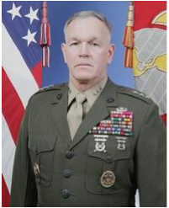
A speech Tuesday at the Donald P. Jacobs Center featured two rarities in the world of environmental activism: a conservative advocacy group and a military officer.
Former Marine Corps Lt. Gen. Richard Zilmer spoke to about 75 students from the Kellogg School of Management about the national security risks posed by oil dependency and climate change. Zilmer, who retired in 2011 after 36 years of active duty, serves on the research nonprofit CNA’s Military Advisory Board, a group of retired military officers working on issues of national security. CNA is a not-for-profit research and analysis organization.
Zilmer wove stories from his time in the military into his half-hour long talk, including a “twilight zone” midday journey from Saudi Arabia into Kuwait during Operation Desert Storm in 1991, during which he realized the importance of oil in American foreign policy.
“It struck me,” Zilmer said. “You couldn’t escape the reflection that part of the reason we were there was ensuring that lines of communication, petroleum fuel, petroleum, remained open because this is how our global economy works.”
He emphasized during the speech how the board was providing military experience to a field normally dominated by science and economics, while reiterating the importance of a multifaceted approach where nobody has a monopoly on the best ideas.
“There’s a sweet spot between the Department of Energy and the Department of Defense that we’re trying to find right now,” he said. “Anything that’s promoting efficiency and reducing that impact of petroleum, we get behind.”
Zilmer came to Kellogg through the board’s partnership with Young Conservatives for Energy Reform. Brian Smith, the Midwest director and a co-founder of the group, said the group’s broader goal in partnering with the Military Advisory Board is to “inform grassroots conservatives about the risks posed by climate change and oil dependency.” Smith, though, said he hoped Zilmer appealed to an audience of young professionals with a wide scope of political views, while demonstrating the importance of linking the military and business worlds.
“The military continues to talk to the business community and the political community about the security risks that this poses,” the first-year Kellogg student said. “It’s about finding the right balance between economic security and national security.”
Zilmer also offered a call-to-arms to the business school students in front of him, noting the country is “sitting at a crossroads with climate change,” which will shape “the future you’re going to inherit.” Near the end of his speech, he returned to economics.
“If the price of gas drops 50 cents tomorrow, people like us won’t be invited to talk anymore.”
Rubab Bhangu Mavi, a first-year Kellogg student, said Zilmer was “preaching to the choir” because she has worked on environmental policy before, but she said it was good to see the military paying attention to the environment.
“I’m glad the military is getting behind everyone and educating them on the need to get this to happen because I think the U.S. really cares about what the Army thinks and the Air Force thinks,” she said.
Zilmer’s talk was preceded by words from several other speakers, including Christian Burgsmueller, head of the Transport, Energy, Environment and Nuclear Matters section of the European Union’s Washington Delegation. Burgsmueller had some veiled critiques of America’s handling of energy policy, referencing “your fossil fuel bonanza” and the persistence of climate change dissenters.
“In Europe, this is settled science,” Burgsmueller said. “There’s no debate raging in Europe on climate change.”
Still, he noted “the trans-Atlantic flavor of the whole story,” explaining that Europe was once as dependent on Russia for its oil as the United States is on the Middle East before a push for clean energy in the last two decades.
Zilmer was firm in his concern that America needed to improve its energy policy — and quickly.
“The rest of the world has gotten it,” he said. “If we’re not smart, we’re going to find ourselves behind … in the future.”

ADVOCACY:

Climate skeptics, seeing rising prospects for a carbon tax, vow to make it ‘toxic’
Evan Lehmann, E&E reporter
Published: Friday, October 26, 2012
Climate skeptics concerned about the rise of conservative groups favoring a carbon tax are preparing a response that seeks to make the policy politically "toxic" for Republicans who might consider it.
The pre-emptive effort, still in its early stages, is designed to discredit the idea that taxing carbon emissions is a good trade-off for lower corporate and individual tax rates, as the nation lurches toward, perhaps, a wide-ranging overhaul to its tax system.
Particularly worrisome is the influence that Mitt Romney's key economic advisers, three of whom support taxing carbon, might exert on the Republican Party as lawmakers weigh difficult choices to avert sunsetting tax cuts and to reduce the $16 trillion deficit. Other prominent economists, like Arthur Laffer, who advised President Reagan, also advocate taxing carbon over income.
"And those people, like Glenn Hubbard and Greg Mankiw and Art Laffer, those people are very influential once you get behind closed doors and they start putting a deal together," said Myron Ebell, who oversees global warming initiatives at the Competitive Enterprise Institute (CEI). "And so we have to make the idea of a carbon tax toxic."
He indicated that the effort would proceed whether Romney wins or loses the election. Hubbard, the dean of Columbia University Graduate School of Business, and Mankiw, a Harvard economist, are advising Romney on economic issues. Both are former chairmen of the Council of Economic Advisers under President George W. Bush.
Mankiw declined to comment by email about CEI's campaign. But he pointed to a 2009 journal article as a source of his "most complete views" on taxing carbon. In the article, Mankiw attempts to convince people who are "skeptical of higher gasoline and energy taxes" that they're economically beneficial -- exactly the kind of message that concerns Ebell.
The fear is that these assertions by prominent GOP economists, and a growing number of conservative groups, will resonate with Republicans in a rare political moment when they might actually have a chance of passing. The acceptance of a carbon tax as a stand-alone initiative is remote. But if it's one piece within a huge collection of provisions meant to reduce the deficit and simplify the tax code, it might fly, some analysts say. Ebell also believes it's possible.
"We see that as definitely a plausible scenario that the promoters of carbon tax could come forward and say, 'Well, we know how to make this deal work; all you need to do is trade this for that and give us a carbon tax,'" Ebell said.
"It's really what the conservative movement decides" that's important, he added. "So we think that that's where the battle will be waged within the movement -- and that we have every expectation that it will be a difficult battle, but it's one that we should win, or it's one that we can win."

Motives that are 'not pure'
One element of CEI's strategy was on display yesterday. Marlo Lewis Jr., a CEI scholar and a member of Ebell's climate team, wrote an op-ed for Forbes that described a carbon tax as "political poison for the GOP."
"The only thing Republicans would gain from destroying their bona fides as the anti-tax, pro-energy party is faint and fleeting praise from cocktail party 'progressives' and the liberal media," he warned. "If Republicans consider that a good bargain, they deserve to be called the stupid party."
The effort is reminiscent of the attacks on cap-and-trade legislation in 2009 and 2010, when opponents reframed the debate to emphasize rising energy prices. Ebell, who says climate change is hyped by scientists and advocates, proudly speaks of his contribution to the collapse of "cap-n-tax."
The pre-emptive effort to discolor carbon taxes might do that and more. Ebell is taking aim at emerging conservative groups that have sometimes waded into discussions about swapping income taxes for one that discourages emissions. He sees a threat in letting conservative groups portray a carbon tax as an economic issue. So he plans to link them to environmental organizations to reduce their credibility as conservative messengers.
"So there will be these efforts to get into the inside of the conservative movement in the debate over the carbon tax," Ebell said of these "front groups," which he named. "And I think those people will be defeated when people on our side point out that these people have motives that are not pure from a conservative or free-market standpoint, that they're being funded by the left, by the environmental left."
Several conservative leaders of those groups reacted sharply to Ebell's characterizations.
Former Rep. Bob Inglis (R-S.C.), who advocates for a carbon tax in exchange for lower income rates and zero energy subsidies at George Mason University's Energy and Enterprise Initiative, said: "If he wants to shut us down, I've got some news for him: I knew what it would cost me when I was in Congress. I didn't back down then, and I'm certainly not going to back down now."

'Character assassinations'?
Eli Lehrer, who is the president of R Street Institute and has worked at both CEI and the Heartland Institute, said his group is largely funded by insurance companies and other non-environmental donors -- often the same contributors that funded him at CEI.
"I know this since I raised the money at both places," Lehrer said. "So if my funding stream makes me a front group, then by that logic, CEI is, too. It's just ridiculous."
Lehrer works with some green groups on insurance issues, like reducing subsidies in the National Flood Insurance Program. And he or his staff attended two private meetings this summer with conservatives and liberals to discuss ways to advance a carbon tax, which he says can be "pro-growth" if it's done correctly.
"I find it quite disappointing that Myron is resorting to character assassinations and attacks on individuals," Lehrer said. "I'm just disappointed that he doesn't seem to have an argument against us on the facts and instead wants to attack us for who we work with."
Michele Combs, founder of Young Conservatives for Energy Reform, said of Ebell's claim that her group is an environmental mouthpiece: "That's just not true. I am as conservative as they come.
"We're not even commenting on the carbon tax," she added. "We haven't even gotten to the point. We're in an organizational mode. We're not even talking policy. We're just talking about a broad energy independence [goal] ... all sorts of renewables, biofuels and stuff like that."

A warning of 'peril' to Republicans
Ebell, who rejects the scientific evidence and political arguments for addressing global warming, said his effort against carbon taxes is still being formulated. Apart from op-eds, he indicated that his group will use routine meetings with conservatives to warn them away from the policy.
"We'll fight it," said Ebell, who believes that a carbon tax would continue to grow for years or decades. "I have every expectation we'll win, but I think it'll be a real fight once tax reform becomes a -- once the leadership in Congress on both sides say, 'We're gonna make tax reform a big deal and we're gonna get it done this Congress.' Then I think the carbon tax will be part of the mix and we'll have to fight it."
He won't be alone. Tim Phillips, president of Americans for Prosperity, a group that casts doubt on climate change and has connections to the Koch brothers, said his group is already meeting with Republicans to warn them away from any deal that lowers income taxes in return for a tax on carbon.
"It's a potent issue when you say, 'Hey, in case you're not paying enough for utility bills and gas prices, these guys want to ... rifle up a new revenue stream and pursue this global warming ideology, or in support of supposed tax reform,'" said Phillips, whose group attacked lawmakers in 2010 for supporting cap and trade.
"Those who support this, I don't think it's a free ride," he said of a carbon tax. "They do it at their peril. I mean Democrats and Republicans."
Some advocates warn that the debate could collapse before it begins if opponents are able to define a carbon tax as an environmental initiative. That would lose resonance among Republicans, a contingent of whom is crucial for a successful outcome.
The focus must be on the economic benefits of lowering income or corporate tax rates, says Paul Bledsoe, an independent consultant who served as communications director of the Senate Finance Committee when Vice President Al Gore proposed a stand-alone British thermal unit tax in 1993. Its failure continues to haunt lawmakers.
"The issue to be effective has to be taken up on, and justified on, economic and tax reform grounds," Bledsoe said. "The environmentalists' views are really beside the point."

October 24, 2012, 12:00 pm

Rethinking and reforming our energy policy
By Michele Combs and Brian Smith, Young Conservatives for Energy Reform
As Election Day gets closer, a growing number of young conservatives are urging political leaders to make energy reform a national priority.
That’s why Young Conservatives for Energy Reform recently co-sponsored a reception in Washington, D.C. We want Republicans inside the Beltway to know what we are hearing outside the Beltway. At meetings and events we’ve held across the country over the past several months, young conservatives have told us that we need a new approach to energy in this country. To us, it’s not a partisan issue. It’s an American issue.
As Lt. General Richard Zilmer (Ret.) of CNA’s Military Advisory Board put it at our D.C. event, our over-dependence on oil makes our nation weaker. We send nearly a billion dollars a day overseas to pay for oil. Some of that money ends up in the hands of people who wish to do us harm. This puts us in the position of funding both sides of the war against terrorism. And that’s a position we can’t afford to be in.
Our oil addiction also comes at great cost to our military - both in blood and in treasure. Every $10 increase in the price of a barrel of oil costs the Department of Defense over $1 billion dollars, leaving taxpayers to foot the bill. And on the battlefield, the need for oil puts our troops’ lives in greater danger, because our enemies often target fuel convoys. In fact, an Army study found that 1 in 24 fuel convoys results in an American casualty in Afghanistan.
For young conservatives, these costs are unacceptable. And we believe adopting an “all-of-the-above” and “Made in America” approach to energy is the solution. That means reducing our over-dependence on oil, becoming more energy efficient, and developing homegrown energy sources such as natural gas, solar, wind, and biofuels.
We also support moving to homegrown energy for economic reasons. Last year, investment in the global renewable energy market reached a record $260 billion. Similarly, the market for electrified vehicles is expected to experience a Compounded Annual Growth Rate of almost 20%, compared to just 3.7% for the overall vehicle market. America must help these fast-growing businesses by keeping taxes and regulation low, and investing in current and future scientists and engineers. Doing so will help reinvigorate our economy, and keep more American jobs and dollars here at home. We want to own the cutting-edge energy technologies of the future—and not continue to rely heavily on other countries to fuel our energy needs.
One of us is a veteran of the war in Iraq. The other is a mother. And we both- along with many other young conservatives - also support homegrown energy for the sake of cleaner air.
We believe that protecting our air and water is an important family-values issue. In 1970, Senator Barry Goldwater wrote, “While I am a great believer in the free enterprise system and all that it entails, I am an even stronger believer in the right of our people to live in a clean and pollution-free environment." We agree. Renewable energy will cut down on pollution, and help ensure a healthier future for American families and future generations.
When it comes to energy reform, there’s a growing disconnect between the way the issue is discussed inside the Beltway and outside the Beltway. Across the country, in state after state, young conservatives want greater energy efficiency and homegrown energy. They know this approach will make America safer, stronger and cleaner. We brought this message to our recent event in Washington, D.C. And we intend to continue to share this message with our nation’s elected officials after Election Day.
Combs is the president of Young Conservatives for Energy Reform (YCER) and a former “Young Republican of the Year.” Smith, an Air Force veteran, is YCER’s Midwest chair.

Young, green conservatives aim to break ‘tree-hugger’ stereotype
12:42 AM 10/13/2012
Jacob Fiscler and Linya Zhang

WASHINGTON — Conservatism and conservation don’t have to be mutually exclusive.
That’s the message of Young Conservatives for Energy Reform, a new advocacy group aimed at influencing Republicans and getting conservatives to pay attention to the need for new energy policies — a topic former Gov. Mitt Romney hasn’t seemed eager to touch.
“Conservatives are all about conservation,” said Michele Combs, the organization’s founder. Combs cited Teddy Roosevelt, who established the first U.S. national parks, and Richard Nixon, who signed the Clean Air Act, as examples of Republican environmental leaders.
“I don’t consider myself an environmentalist,” she said emphatically. “I just consider myself an American who cares about energy and cares about the environment and cares about the future of this country.”
To get support from more Republicans, Combs and her group have reframed environmental and renewable-energy advocacy as national security issues, and hopes it can earn bipartisan backing.
“To get energy legislation [passed], we’re going to have to have Republican support,” Combs, a 25-year veteran Republican activist, said.
Keya Chatterjee, director of international climate policy at the World Wildlife Fund, agrees that backing for energy reform has to come from across the political spectrum.
“I think the more the merrier,” she said. “We need all kinds of slices of America talking about this issue in their own way, in a way that resonates with their audience and in a way that helps people understand that there are lots and lots of solutions to this problem, and also lots of reasons that you should care about it.”
“Probably many of the things I would say would be wildly applauded by the environmental constituencies, [but] that’s not what it’s about,” said retired Marine Corps Gen. Richard Zilmer, who supports the use of green energy to help the armed forces become smarter, leaner and more lethal in the battlefield.
A report released by CNA Analysis & Solutions, a nonpartisan research group Zilmer advises, showed that a 15 to 20 percent reduction in oil consumption would lessen the impact of oil supply “shock” to the U.S. economy. The report calls for a 30 percent cut in oil use.
But for Combs and the young Republicans, bipartisanship will have to wait until after the election. Combs supports Mitt Romney for president even though he has promised to increase domestic oil and gas production in order to make America more energy independent.
Romney’s first step is a good start, Combs said.

Lt. General Richard Zilmer (Ret.) & Michele Combs also interviewed with the following reporters in Washington, DC:

Keith Johnson of The Wall Street Journal
[October 9, 2012]

David Kashi of Medill News Service
[October 9, 2012]
Monday, October 8, 2012
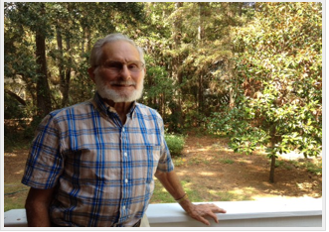

REMEMBERING ROOSEVELT
Bob Pitsch is 92 years old, and he's been fascinated by politics ever since he heard the voice of Franklin Delano Roosevelt on his aunt's radio. Bob's family had lost everything in the Depression, they were living in a house with no electricity, or plumbing. But still, Bob was caught up in the hope for change.

GOING AGAINST THE GRAIN
Also today, two stories of people going against the grain of their party platforms. Brian Smith is a young conservative who's pushing for energy reform. And Mark Sandlin is a liberal Christian minister trying to make space to the left of the right.
Music in this show: "Happy Days are Here Again" by Jack Hylton and His Band; "The One O'Clock Jump" by Count Basie; "The Democratic Circus" by David Byrne/Talking Heads; "Parchman Blues" by Tangle Eye.

POLITICS:

Climate change goes missing in first debate
Evan Lehmann, E&E reporter
Published: Thursday, October 4, 2012
Climate change was not mentioned in the first presidential debate, a striking omission for environmentalists and clean-tech advocates who view it as a lost chance to highlight an issue that is central to the nation's economy and ecology.
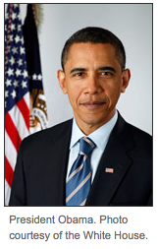
The interlinked topic of energy was also overshadowed by the dominant issues of taxes, education and health care in a debate themed around domestic policy. Practiced lines that routinely appear in stump speeches by both candidates received light treatment or were absent altogether, like President Obama's well-worn brags about the toughened fuel economy standards imposed by his administration.
Yet it was the disappearance of climate change that symbolized how much the issue has been disinvited to presidential politics, four years after Obama campaigned on cutting carbon emissions.
"It's just a real shame. What it says about the issue is that it's not a serious political issue," Manik Roy, vice president of strategic outreach with the Center for Climate and Energy Solutions, said before the debate, when asked about the possible omission of climate.
"How would we ever explain to our kids and grandkids 20 years from now that we had a presidential debate this night and did not talk about one of the most important issues facing their world by that time?" he added. "It would be just remarkable if it didn't come up."
From the beginning, the debate's design was violated. The candidates repeatedly surpassed their two-minute allotment of time to answer questions, derailing moderator Jim Lehrer's plan to sweep through consecutive "segments" related to domestic policy. It's unknown if questions about climate change or energy were bumped as time expired on the 90-minute debate.
The debate will be a disappointment for climate advocates, many of whom believe Obama could benefit electorally by rebuking Romney for his shifting assertions about rising temperatures. They viewed the candidates' first face-to-face meeting as a plum opportunity for Obama to set the record straight: Romney saw climate dangers in the past but is now unwilling to tackle them.
"I think if the president brings this up and says, 'I believe in the science and we have an obligation -- moral and, frankly, economic -- to figure out how to deal with this issue,' and questions whether Romney does the same, I think that's advantage Obama," said Roger Ballentine, who chaired the White House Climate Change Task Force under President Clinton.
"And you also play into a serious Romney weakness, which is inconsistency, flip-flopping and political opportunism," he added.
Others had hoped for probing questions from Lehrer. Both campaigns have been setting their own terms for months, appearing before friendly crowds on the trail and dictating when and where to participate in television broadcasts. The debate marked the first opportunity in the race to test the candidates in an unpredictable setting.

Rehash of old attacks
But the event failed to yield new information about the candidates' positions on climate, like what steps Obama would take in his second term to drive down greenhouse gas emissions, if he would follow through with a clean energy standard, and whether he would advance efforts to cut carbon in the transportation sector.
Romney might have been asked if it's contradictory to say climate change has negative consequences while pledging to pursue only passive policies to reduce emissions, or why his energy blueprint, which emphasizes expanded fossil fuel production, doesn't mention climate change. Still others anticipated that Lehrer might ask him why he appeared to minimize sea-level rise at his nominating convention, only to acknowledge days later that humans are affecting the climate.
"I could see an interesting question to Governor Romney about some of the evolution of his position on the issue, even very recently," Roy said.
Of Obama, who has been largely silent on climate change, Roy said, "I'd like to know his plans."
The debate didn't reveal those plans. But it did rehash long-standing attacks by both candidates, from Romney's jabs on Solyndra and the Keystone XL oil pipeline to Obama's championing of renewable energy.
"Gasoline prices have doubled under the president," Romney said, pointing out a condition that is driven by market forces more than federal policies. "And by the way, I like coal. I'm going to make sure we can continue to burn clean coal. People in the coal industry feel like it's getting crushed by your policies."
Romney's campaign and his conservative surrogates have aggressively accused Obama of waging a "war on coal." Those messages are being aired in crucial swing states like Ohio and Virginia. Other portions of the nation's coal patch are solidly Republican, raising questions about whether those attacks will harm Obama at the polls.
"It seems like [Obama has] taken a pounding on energy issues in Appalachia," said Kyle Kondik, an analyst at the University of Virginia's Center for Politics. "But he didn't do very well in those places anyway -- southeast Ohio, western PA, West Virginia, western Virginia. There's billboards all over that part of the country with 'Obama's war on coal' and all this other stuff."

Coal fight joined, but offstage
Obama, who was halting early in the debate, didn't respond to Romney's coal jab. But his campaign has sought to turn the tables. It released a television ad this week accusing Romney of using coal miners as props during an event in Ohio at a Murray Energy Corp. mine in August (Greenwire, Oct. 3). Miners filled the area behind Romney, a mandatory appearance that forced the company to shut down mining operations.
"Their mine was closed, lost the pay they needed, all to be props in Romney's commercial," the Obama ad says.
There were signs early in the debate that energy issues might rise to the top. Both candidates mentioned it as a top priority in their opening remarks.
Romney acknowledged that oil and natural gas production is growing in the United States -- a claim often made by Obama -- but he credited private producers for the increase, while blaming Obama for limiting energy development on public lands. He proposes expanding production by giving states permitting influence on public tracts, a move that Romney claims can create 4 million jobs.
"I want to get America and North America energy independent so we can create those jobs," he said.
In that respect, analysts say there is only marginal difference in how the candidates envision expanding domestic energy production. But the debate, there, too, failed to uncover details about their plans.
"I would like to see them say more about how we can become more energy independent," Michele Combs, president of Young Conservatives for Energy Reform, said before the debate.
She launched the organization recently to give the conservative movement a voice advocating for renewable energy, strengthened national security and "clean air." She says Romney's energy independence plan is a good "first step" toward using less foreign oil, and she hopes it could lead to legislation in the future that reduces emissions.
The Denver debate might have also missed an opportunity to address sportsmen, a slice of the electorate that tends to be conservative but is concerned about the impact of climate on hunting and angling.
"They've come to recognize for the most part that, yeah, there is something to this," said Eric Washburn, who worked on energy issues under Senate Democrats and is now helping the Bipartisan Policy Center with a project focused on sportsmen. "Now there's not a consensus, I think, around what's causing [climate change]. But I think there's close to a consensus on that the climate is changing, and we're seeing nature shift in ways we didn't see in the past."
Outdoor Life, a popular magazine for sportsmen, issued a voters guide this month that says, "The potential affects of climate change on hunting and fishing have been documented, and the studies aren't coming from enviro-freaks, either."
Two more presidential debates will take place this month. If climate change is absent from those, advocates worry about the prospects of elevating the issue in the national discussion.
"It's certainly a negative for the issue if it doesn't come up. There's no other way to spin that," Ballentine said.

Sunday, September 30, 2012

Zilmer: US must break away from its overreliance on oil

By RICHARD C. ZILMER
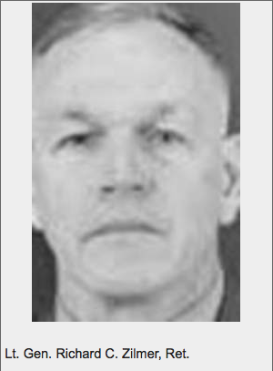
America’s overdependence on oil represents a significant threat to our national security.
That’s the message I recently shared at the Young Conservatives for Energy Reform’s launch event in New Hampshire. And I learned it’s an issue that many of New Hampshire’s leading young conservatives are concerned about and want to address.
While serving for 36 years in the Marine Corps, I saw America’s current approach to energy risks undermining our military’s effectiveness and compromising its ability to ensure the safety and security of our nation.
The bottom line: Our overdependence on oil takes a toll on and off the battlefield. It comes with high costs – in dollars and in lives.
All too often the need for oil turns our troops into targets. A Marine Corps evaluation found that convoy operations account for 10 percent of casualties in Iraq and Afghanistan. I witnessed the dangers firsthand while serving in the Anbar Province during the “Anbar Awakening.” Fuel convoys were frequent targets of attacks.
Oil comes with an expensive price tag. And the military’s demand for oil has grown significantly over time. The Army uses an average of 22 gallons of fuel per soldier per day in Afghanistan. That’s 20 more gallons than the average soldier used in World War II. The costs are considerable. The Pentagon spent more than $17 billion on fuel in 2011.
Today, I serve on CNA’s Military Advisory Board, a panel of retired admirals and generals who collectively have more than 400 years of military experience. The board studies issues critical to our national security – and our energy posture is a top concern.
The advisory board’s latest report, “Ensuring America’s Freedom of Movement: A National Security Imperative to Reduce U.S. Oil Dependence,” found that a 30 percent reduction in American oil consumption is necessary to enhance national security and ensure our ability to move goods and people freely about the nation in the event of a major disruption to our oil supply.
This goal is ambitious, but achievable. The keys include using energy more efficiently and moving to alternative sources of energy.
The U.S. military is already taking action, and renewable energy and efficiency are having tangible benefits on the battlefield. For example, forward operating bases are embracing efficiency and deploying clean energy sources, and Marines in Afghanistan are using lightweight, solar-powered equipment. This means fewer convoys for diesel fuel to run generators – and fewer Americans at risk.
In the longer term, each of America’s armed services is embracing clean energy goals. The Army plans to get 25 percent of its energy from renewable sources by 2025. The Marine Corps’ main expeditionary energy goal is to increase operational energy efficiency on the battlefield by 50 percent. This is expected to reduce the amount of fuel each Marine uses by 50 percent per day.
New Hampshire has a role to play in addressing our nation’s energy challenges and in helping secure a safer and more prosperous future for its residents and for the nation as a whole.
Clean energy policies like the state’s Renewable Portfolio Standard have the potential to attract new companies into the state, foster innovation and cut down on the need for fossil fuels that are subject to volatile price shocks.
Energy efficiency also can help New Hampshire companies improve their bottom lines and become more competitive. For example, energy efficiency upgrades are helping EMD Millipore’s factory in Jaffrey save more than $160,000 each year.
At the inaugural event for the New Hampshire chapter of the Young Conservatives for Energy Reform, I learned that many conservatives in New Hampshire don’t see the need to address our nation’s energy challenges as a Republican or a Democratic issue. They see it as an American issue.
Having spent my career in the military, I believe this is an issue that rises above partisan politics. And I agree that taking steps to strengthen our nation’s security and economy for generations to come is a goal all Americans can get behind.
Retired Lt. Gen. Richard C. Zilmer was deputy commandant for manpower and reserve affairs at Headquarters Marine Corps. He serves on CNA’s Military Advisory Board and was the featured speaker at the recent Young Conservatives for Energy Reform’s New Hampshire launch event.

POLITICS

Conservative Group Plans to Push Republicans Toward Action on Climate, Cleaner Energy
By Coral Davenport
Updated: August 20, 2012 | 8:03 a.m.

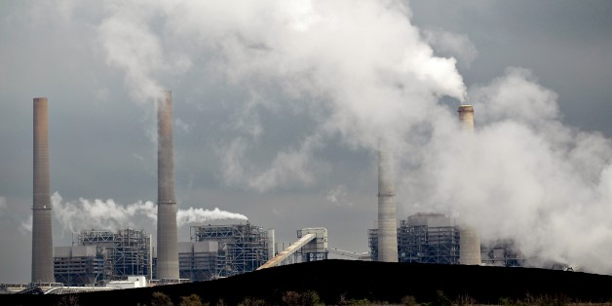
In a campaign season where energy and climate change have become partisan lightning rods, a small but growing group of Republicans are pushing back against their party’s orthodoxy on both issues.
Leading members of the Christian Coalition and the Young Republicans on Monday will launch nationwide the Young Conservatives for Energy Reform, a grassroots group aimed at engaging Republicans on the goals of cutting oil use, backing alternative energy and clean-air regulations, and fighting climate change.
The announcement comes less than a month after the rollout of a new conservative-run campaign and think tank, the Energy and Enterprise Institute, aimed at winning Republicans over to the idea of using the tax code to cut carbon pollution and fossil fuel use.
Both groups have an uphill battle. Over the past two years, the Republican Party has galvanized around the fossil fuel industry, drifting far away from its position in 2004 when presidential nominee Sen. John McCain of Arizona actually campaigned on the promise to address climate change.
The 2010 congressional races saw a slew of super PAC attack ads against lawmakers who backed climate change policy. This year, the presidential primaries saw moderate Republicans, including presumptive GOP nominee Mitt Romney—who had once pushed for climate and clean-energy policies—abandoning those positions and walking back his former acceptance of the science that says human activities cause climate change.
This year’s campaign has been marked by GOP attacks on President Obama’s clean-energy policies, as exemplified by the failed solar company Solyndra, and a fierce partisan fight over what Republicans call Obama’s “war on coal,” including efforts by his Environmental Protection Agency to tighten regulations on pollution from coal-fired power plants.
The fossil fuel industry is spending mightily to keep the GOP on its side: Of the $30 million the oil, coal, and gas industries have spent so far to influence the 2012 election cycle, 88 percent has gone to Republican candidates, according to the Center for Responsive Politics.
It’s in that atmosphere that the two cofounders of Young Conservatives for Energy Reform, Michele Combs and Brian Smith, hope to make a difference in their party’s approach to energy. Both have rock-solid conservative bona fides.
Combs is communications director for the Christian Coalition of America, which calls itself the nation’s largest conservative grassroots organization. Her mother, Roberta Combs, is the coalition’s president. Growing up, Combs was a leader in the Young Republicans—she was elected “Young Republican of the Year” in 1989. Before working for the Christian Coalition, she ran a special-events company that produced events for Republican campaigns, conventions, and the George W. Bush inauguration.
Roberta Combs led a 2010 lobbying push by the Christian Coalition to push GOP lawmakers to act on climate change; Michele Combs says she was inspired to engage on clean-energy issues when she was pregnant and told she couldn’t eat fish because they may be tainted with mercury, which is emitted from coal-fired power plants.
Smith, an Iraq and Afghanistan war veteran and former cochair of the Young Republican National Federation Policy Committee, is pursuing a joint degree in business administration and engineering at Northwestern University, and worked on energy technology and security issues at Pentagon labs.
The pair wants to harness the resources and networks of the Christian Coalition and Young Republicans at events across the country to make the case to conservatives that they should back clean-energy and climate policies. Combs and Smith said they’ll press the case by presenting alternative energy, climate change, and clean air as nonpartisan issues affecting families and national security.
The group intends to replicate the organizational model of the Young Republicans, creating city, regional, and state chairmen.
“We want to take this issue and make it not so partisan,” Combs told National Journal last week. “We believe this is a family issue. I’m optimistic that we can make young conservatives comfortable talking about this. I think it’s possible to talk about this and not be labeled a heretic. For younger conservatives, this is a lot more acceptable to talk about.”
Added Smith: “We want to make it safe for Republicans to debate climate change.”
The group has already held events in Florida, Ohio, and South Carolina, and plans further events—rallies, speeches, roundtables, and town halls—in New Hampshire and other 2012 battleground states.
Juan Lopez, a Florida employment lawyer, is the group’s Florida chairman and a lifelong Republican. He acknowledged that within the Republican Party, the new group represents a lone voice—one with a message that’s sometimes at odds with the Romney-Ryan presidential campaign, which is pushing an aggressive expansion of oil drilling. The ticket’s vice presidential nominee and the chairman of the House Budget Committee, Rep. Paul Ryan, R-Wis., proposed dramatic cuts to clean-energy spending in his budget proposal.
“The leaders of the party are reasonable people,” Lopez said. “They listen to the voices of reason. Ryan is an outdoorsman, he’s in favor of clean air. He listens to all voices…. Republican Party leaders are reasonable, and we’ll get the message across by having our voices heard.”
The group hopes to work closely with Sen. Lindsey Graham, R-S.C., who has strong ties to the Christian Coalition and who in 2010 teamed with Sens. John Kerry, D-Mass., and Joe Lieberman, ID-Conn., on a sweeping climate-change bill. But although Graham has frequently expressed the need to tackle energy and climate-change issues, he pulled his support from the bill before it was introduced. And it’s likely to be tougher for him to go out on a limb on issues that inflame his party as he looks toward a Senate primary race in 2014.
Smith said he doesn’t expect the group to present specific climate and energy legislative proposals, at least at the outset, but rather to try to simply fire up young conservatives on the issues. “We want to help conservatives feel comfortable taking tough votes and not getting shot down if they support clean-energy technology.”
It remains to be seen whether the new handful of groups can make an impact in a party where fossil fuel interests, including powerhouse lobbying groups like the American Petroleum Institute and the American Coalition for Clean Coal Electricity, have an outsized impact on legislation and campaign media spending.
Paul Bledsoe, a former Clinton White House energy official who is now a senior strategist at the Bipartisan Policy Center, noted that the growth of pro-climate voices in the GOP could signal a cyclical return of the party to the issue. “It was just four years ago that John McCain was the nominee and you had dozens of Republicans sponsoring climate change legislation,” he said. “It’s due for a rebound at some point.”

http://www.nationaljournal.com/energy/conservative-group-plans-to-push-republicans-toward-action-on-climate-cleaner-energy-20120819

This article was also picked up by:
http://news.yahoo.com/conservative-group-plans-push-republicans-toward-action-climate-080357232.html

http://politico.biz/conservative-group-plans-to-push-republicans-toward-action-on-climate-cleaner-energy

http://weather.top10-digest.com/conservative-group-plans-to-push-republicans-toward-action-on-climate-cleaner-energy/

http://www.airpollutionnews.com/conservative-group-plans-to-push-republicans-toward-action-on-climate-cleaner-energy/

http://dailyclimate.org/

ENERGY POLICY:

'Gen X' group joins push from the right for action on renewables, efficiency
Nick Juliano, E&E reporter
Published: Monday, August 20, 2012
The growing clutch of conservative elder statesmen who have been calling for their ideological allies to take seriously the threat of climate change gained new support today from a group planning to organize younger Republicans in an effort to promote clean sources of energy and reduce reliance on fossil fuels.
The new group, Young Conservatives for Energy Reform, launched today amid a presidential election season that has featured disputes over whether to worry about rising greenhouse gas emissions and how much government support should go to alternative energy sources like wind and solar. The group, whose founders boast links to the powerful Christian Coalition and Young Republican National Federation, hope to reverse the GOP's embrace of climate change skepticism and convince the party that there are conservative ways to wean the country off foreign oil and clean up its air and water.
Michele Combs, the new group's president, has worked for the Christian Coalition of America, of which her mother, Roberta Combs, is president. The coalition, a key pillar on the "religious right," has lobbied in favor of cap-and-trade legislation in the past and has said promoting renewable energy development and energy efficiency efforts are part of a "responsibility to care for God's creation."
Young Conservatives for Energy Reform points to calls from former President George W. Bush to address America's "addiction" to oil. The group bills itself as a network of "Generation X professionals" and plans to promote efficiency and domestically sourced alternative energy to boost national security and the economy while cleaning up the environment.
Michele Combs, 45, said the group is not weighing in on specific policies at this point, instead focusing on grass-roots efforts to educate activists and remove some of the stigma that can surround climate and clean energy issues in conservative circles.
While the group's focus tends more toward promoting new energy sources than combating climate change for its own sake, the issue should be able to garner more attention from Republicans, said Brian Smith, an Air Force veteran and the group's Midwest chairman. Smith personally endorsed the scientific consensus that climate change is real and its risks should be addressed.
"We want to talk about those risks and be able to do so without it being a litmus test on conservatism," Smith, 32, said on a conference call this morning.
The group aims to follow the Young Republicans model by establishing chapters in all 50 states and organizing grass-roots support for clean energy policies. Specific advocacy will come in the coming months, Smith said, as group members evaluate state-level efforts with an eye toward building on what has worked and eliminating what has not.
Combs said the group has held events in eight states so far, including Florida, South Carolina, Ohio and New Hampshire.
A number of prominent conservatives have recently come out in favor of doing something to address climate change, with the most prominent suggestion being a tax on carbon dioxide emissions that would be offset by reductions in income or payroll taxes.
Supporters of some variation of such a scheme include former Rep. Bob Inglis (R-S.C.), who launched a new center to promote the idea at George Mason University, and George Shultz, who served as secretary of state in the Reagan administration. The American Enterprise Institute, a free-market think tank, also recently convened a meeting of groups on both sides of the political spectrum to consider how such ideas could be turned into policy (E&E Daily, July 12).
While the novelty of conservatives caring about climate change has attracted quite a bit of attention during the past several weeks, the efforts still have something of a voice-in-the-wilderness feel to them. Denying the link between human activity and climate change has become the de facto position among a broad swath Republican lawmakers -- a shift from the days before 2008 when it was possible to find Republicans like Sen. John McCain (R-Ariz.) or former Sen. John Warner (R-Va.) backing cap-and-trade legislation.
Sen. Lindsey Graham (R-S.C.) also worked on a climate bill in 2009 and 2010 alongside Sens. John Kerry (D-Mass.) and Joseph Lieberman (I-Conn.), although he abandoned the effort before a bill was introduced, and the legislation never came to the Senate floor.

ADVOCACY:

Conservative Republicans launch a new group to promote clean energy
Evan Lehmann, E&E reporter
Published: Monday, August 20, 2012
A new conservative organization is being unveiled this morning to promote renewable energy and increased efficiency, issues that the Republican Party has de-emphasized as it pursues increased domestic fossil fuel production.
The group, Young Conservatives for Energy Reform, is led by Michele Combs, the former chairwoman of South Carolina Young Republicans and the daughter of Roberta Combs, president of the Christian Coalition of America.
The new organization aims to wean the country from its oil dependency in order to increase national security and protect the environment. Its definition of energy reform promotes "a more prosperous, safe, secure, and healthy America, and a better future for our nation's families."
"We are a group of young professionals who are concerned about America's addiction to foreign oil and energy independence," Michele Combs said in a statement today. "Every American is concerned about our troops who are risking their lives to protect oil convoys in dangerous foreign lands. Every American is frustrated with gas price spikes. And every American wants clean air and water."
The group is unveiling itself during the hyper-political presidential campaign, in which Republican Mitt Romney rarely addresses renewable energy and increased efficiency. He promotes environmentalism even less.
That has led some Republicans, like Sen. Lindsey Graham (R-S.C.), to encourage the GOP to speak more positively about clean energy sources, in part to retain younger voters. Polls show strong support for renewable energy, regardless of political party. They also point to a marginally stronger belief in man-made climate change among younger generations, compared to retirement-age Americans.
Young Conservatives for Energy Reform seeks to represent Generation X, one of the best science-educated generations to ever come of age in America. That demographic slice of the nation is composed of people in their 30s and 40s; they are reliable voters with rising incomes who stand to be the future of their party.

'Voice of the future'?
Religious voters form a clear cross section of conservatives, many of whom see it as a moral imperative to protect the Earth. The new group appears to be close to the idea of creation care, though a spokeswoman said it's not affiliated with the Christian Coalition, which expanded its platform in recent years to include environmentalism and clean energy.
Roberta Combs has teamed up with Larry Schweiger, president of the National Wildlife Federation, to promote a "clean energy revolution" to protect the country from expensive power, foreign hostilities and pollution. Together, they endorsed Senate legislation in 2010 to cap carbon emissions.
"I think there's an appetite for this kind of organization," Schweiger said of the new group in an interview. "They know a lot about the conservative community, a lot about the church community, and certainly [they] have a keen interest in working with young people. I think it has a pretty good shot at getting traction."
Other conservatives have used the spotlight of the election year to endorse climate-related efforts that are out of fashion in Republican circles. Former Secretary of State George Shultz, who served under Ronald Reagan, is pressing for a carbon tax. So is former U.S. Rep. Bob Inglis (R-S.C.). And a variety of conservative economists say taxing carbon dioxide could be beneficial, financially and environmentally, if it results in lower income taxes.
But those viewpoints represent the outlier conservative community. That's one reason the Rev. Joel Hunter, who heads an evangelical congregation of 15,000 people near Orlando, Fla., declined to lead the Christian Coalition in 2006. The organization was then too strictly conservative on a number of issues, including on its positions around climate change, he said in an interview. He surrendered the presidency before formally ascending to the position. Three years later, in 2009, he left the Republican Party to become an independent.
Now he hopes the emergence of Young Conservatives for Energy Reform reflects a turning point for the conservative movement. Michele Combs calls it a "bold new direction for our nation."
"I'm really glad to see someone of that generation, from somebody of that place on the political spectrum, be able to speak up for this cause," Hunter said on Friday. "To me, it's hopefully not a white buffalo [or] a voice crying in the wilderness -- it's the voice of the future. Because I do think that the next generation, as they continue to voice their priorities, it will be very clear in their mind, in fact it already is for many of them, that [climate change] is something that has to be addressed as a national priority."

Young Conservatives Discover Climate Change
by Justin Green | Aug 20, 2012 2:30 PM EDT
As recently as 2010, major Republican leaders such as Lindsey Graham were comfortable proposing (although not passing) market-based solutions to climate change. That was largely swept away with the Tea Party, but the hints of a comeback are emerging. From National Journal, the tale of two young conservatives attempting to create safer conditions for GOP politicians to vote on climate-change issues:
It’s in that atmosphere that the two cofounders of Young Conservatives for Energy Reform, Michele Combs and Brian Smith, hope to make a difference in their party’s approach to energy. Both have rock-solid conservative bona fides. ...
The group hopes to work closely with Sen. Lindsey Graham, R-S.C., who has strong ties to the Christian Coalition and who in 2010 teamed with Sens. John Kerry, D-Mass., and Joe Lieberman, ID-Conn., on a sweeping climate-change bill. But although Graham has frequently expressed the need to tackle energy and climate-change issues, he pulled his support from the bill before it was introduced. And it’s likely to be tougher for him to go out on a limb on issues that inflame his party as he looks toward a Senate primary race in 2014.
Smith said he doesn’t expect the group to present specific climate and energy legislative proposals, at least at the outset, but rather to try to simply fire up young conservatives on the issues. “We want to help conservatives feel comfortable taking tough votes and not getting shot down if they support clean-energy technology.”
http://www.thedailybeast.com/articles/2012/08/20/young-conservatives-climate-change.html

Young Conservatives for Energy Reform

Conservatives are championing approaches to energy that tackle what George W. Bush called, “America’s oil ‘addiction’”.
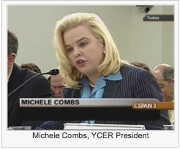
Taking a clear-eyed look at the nation’s energy needs, Young Conservatives for Energy Reform (YCER) is advocating a “Made in America” approach, using US technology, skills, and resourcefulness.
Starting with local receptions and rallies — eight so far and five planned for the coming months — YCER was founded on a belief in the power of grass roots organizations. YCER President, Michele Combs, who is also active in the Christian Coalition, wants YCER to both listen and engage. The group is starting with chairs in Florida and the Midwest, and planning to expand from there.
- Florida State YCER Chairperson Juan C. Lopez-Campillo, Attorney with the Orlando office of Jackson Lewis, LLP
- Midwest YCER Chairperson Brian Smith, Former investment banker and graduate student at the Kellogg School of Management at Northwestern University.
Ms. Combs, a former ‘Young Republican of the Year’ from South Carolina, is an articulate and personable spokesperson for YCER. She became concerned when, as a mother-to-be, she found that there were some fish she shouldn’t eat due to pollutants in the water. Energy production uses — and then discharges into rivers, streams and oceans — 27% of the water used in the US, according to Electric Power and Research Institute (EPRI). Energy production also emits over 40% of the CO2 — affecting our air and water quality, according to US Energy Information Administration (EIA). “We all want clean air and water,” she said.
For Ms. Combs, fair and free markets are the fastest route to reducing oil dependence. She noted that some of the policies that could be advocated by YCER are sometimes thought of as “kind of left wing,” but likened the future of energy reform to the bans on tobacco, which are now broadly accepted in spite of a rocky start.
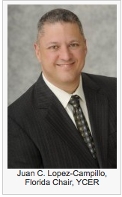
Juan Lopez, the Florida state chair, echoed Ms. Combs’ thoughts. He is troubled by foreign oil, which is still imported to the tune of around $1 billion per day.
“Some say drilling here is the answer, but that won’t solve the long term problem,” he said. He supports an approach to energy based on alternative resources ‘in our own back yard’. “Invest here, locally,” he said. “I believe we need to work across the aisle because that’s what Americans want.”
Brian Smith’s passion was literally forged in fire while at an Air Force Research Lab, where he focused on energy-related technologies. He found himself on special assignment to the Army in the Middle East, addressing urgent battle-field problems. Young soldiers were dying on roads mined with improvised explosive devices (IEDs). Mr. Smith’s group was looking not at how to better armor trucks, but to “protect men from dying by keeping them off the road in the first place.”
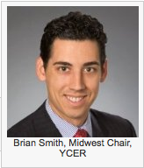
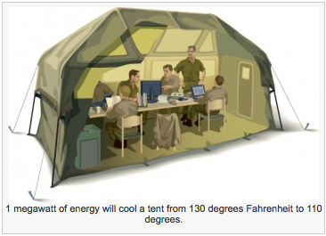
The low-hanging fruit was the over two million gallons of fuel traveling daily to equip forward bases with energy for cooling, transportation and other vital needs. Since simply sending less fuel would compromise the task, Mr. Smith’s team looked at US based technologies that could deliver energy deployed locally, which would significantly reduce the fuel traveling on trucks along dangerous roads. While researching and implementing new strategies, he got a crash course in energy production and management.
He came back to the United States and joined Arsenal Venture Partners, the venture capital arm of the Army. While there he became knowledgeable about the renewable industry, seeing some sectors — such as solar — that he believes are ready to scale. Scale in renewables means they can produce a significant amount of energy at a price that is competitive with fossil fuels.
“On energy independence there is broad consensus,” he said. “On the climate change front, I believe there is sufficient evidence to have that [climate change] conversation.”
As for YCER plans, they are talking with local communities about energy reform and how people are affected on a daily basis. YCER plans to identify the people who care about this issue, energizing them to expand their numbers.
As Ms. Combs explained, YCER can “Show those inside the beltway what people outside the beltway are really thinking.”
Like Brian Smith, who has been politically active most of his life — working on Presidential candidate John McCain’s campaign as an advisor — Ms. Combs worked with Lindsay Graham, from whom she learned a lot. “He tried to break that divide,” she said. “He’s a hero for our side.”
The long term goal will be to develop policies and to advocate for them on Capitol Hill. However, the next six months will be focused on understanding what people really want and which state policies could be brought to the national congressional level.
Mr. Smith concluded our conversation by saying, “I’m just trying to make a difference.”
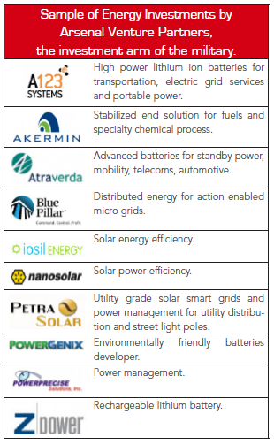

Young Conservatives Move Beyond “Drill, Baby, Drill”, According to The Green Economy
Young Conservatives for Energy Reform (YCER) is breaking out of traditional conservative roles to partner with a network of grassroots organizations and champion domestic energy reform.
New York, NY (PRWEB) October 16, 2012
Young Conservatives for Energy Reform (YCER) is breaking out of traditional conservative roles to partner with a network of grassroots organizations and champion domestic energy reform. YCER advocates American-made alternatives to foreign oil, calling for a fair and free market approach to energy alternatives such as solar power that end America’s oil addiction.
“Some say drilling here is the answer, but that won’t solve the long term problem,” said Juan Lopez, chairperson for YCER’s Florida chapter. “We need to work across the aisle because that’s what Americans want.”
YCER is talking with local communities nationwide about how energy policies affect them. The organization plans to grow using energetic people to champion renewable sources of energy for the American market.
THE GREEN ECONOMY provides news, analysis and ideas for business leaders who are creating a new world economy through strategies that acknowledge, calculate for and take advantage of a resource-constrained environment. To read more about young conservatives or other articles, go to http://www.thegreeneconomy.com.

This press release was also picked up by:

http://www.fox19.com/story/19830009/young-conservatives-move-beyond-drill-baby-drill-according-to-the-green-economy

Against the Odds, Young Conservatives Buck the GOP on Energy and Climate Change

A group of young Republicans is out to persuade their party to pursue a path toward a future free of fossil fuels.

By Maria Gallucci, InsideClimate News Sep 5, 2012
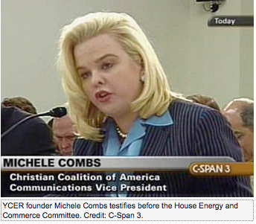
A group of young Republicans has set out to achieve what some might say is an impossible goal: Over the next two years they'll try to persuade their party to craft and support legislation that would reform the nation’s energy system and set a path toward a future free of fossil fuels.
"We want to show conservatives that this truly is an issue that affects us, affects our families and our businesses," said Michele Combs, a 45-year-old legislative consultant who founded the group. (Paragraph includes correction, 09/05/2012).
The organization—Young Conservatives for Energy Reform, or YCER—joins a small but growing number of like-minded groups and individuals who hope to revive a voice that has been lost in the Republican Party, one that's focused on curbing, not expanding, fossil fuel production. (Paragraph includes correction, 09/05/2012).
At last week's GOP convention in Florida, the Evangelical Environment Network teamed with the Florida Wildlife Federation to buy billboard ads touting prominent Republicans' concerns about climate change, including Ohio Governor John Kasich. In July, a group called the Energy and Enterprise Initiative was formed to bring Republicans and libertarians together to find free-market solutions to the climate change problem. Former Rep. Bob Inglis, a South Carolina Republican, is heading the initiative out of George Mason University’s Center for Climate Change Communication.
"A lot of conservatives don't believe that there are climactic costs" to burning fossil fuels, said Alex Bozmoski, the initiative's director of strategy and operations. "It's only prudent to acknowledge that the continued, unabated emission of greenhouse gases poses a risk for current and especially future generations."
YCER's leaders have deep roots in the Republican Party. Combs, the group's president, was a 1989 national "Young Republican of the Year," and Brian Smith, a 32-year-old Air Force Veteran and chair of the Midwest chapter, is a former co-chair of the Young Republicans National Federation, a training ground for party leaders since 1931. Both support Mitt Romney's presidential bid, even though his energy platform favors more fossil fuels and less environmental regulation. (Paragraph includes correction, 09/05/2012).
Combs said YCER won't take individual Republican politicians to task for their climate change skepticism or push for specific policy solutions—at least not immediately. They also won't make climate change science a key part of their agenda.
"Our position on climate change is that it really shouldn't be a litmus test for Republicans," said Smith on a call with reporters last month. "We want it to be an issue that Republicans can talk about." (Paragraph includes correction, 09/05/2012).
The group also won't go against the grain of the Republican leadership when it comes to scaling up domestic oil and natural gas drilling. Romney made both a key part of his recently unveiled plan for U.S. energy independence by 2020.
Combs called the ramp-up strategy "a good first step" on the path toward energy reform. But Juan Lopez-Campillo, an Orlando-based attorney and chair of the group's Florida chapter, said YCER hopes to move Republicans beyond the "drill here, drill now" mentality that now pervades the party. He said he supports shifting government subsidies from oil companies to the burgeoning clean-energy sector, a position usually favored by Democrats. "I think there should be a leveling of the playing field," he said.
One of YCER's first steps will be to address what Combs calls the "lack of education" among conservative Americans who may have tuned out the energy debate because they see it as a strictly liberal agenda.
"Some of them don't even realize what energy reform entails, and they don't realize how much it really controls their lives," she said.
YCER plans to host local receptions and rallies where energy experts and Republicans interested in energy reform can meet with the public to discuss topics that aren't often talked about in conservative circles.
They'll stress why it is important to gradually phase out fossil fuels in favor of cleaner alternatives like wind and solar energy, emphasize the national security benefits of scaling back oil imports and underscore the reality that America’s own oil and natural gas resources will eventually run out. They will also highlight the health benefits of keeping toxic pollutants out of the air and waterways, and try to drive home the message that spurring growth in the renewables sector can create jobs and economic gains.
"Irrespective of whether you support the science behind climate change or whether you don't, all of us can agree that renewable, clean energy resources are the way to go to stabilize our [energy] future," Lopez-Campillo said.
Shifting the Focus from Climate Change
Katharine Hayhoe, an atmospheric scientist at Texas Tech University, said that treading lightly on the topic of climate change could prove a smart strategy for groups like YCER. Hayhoe, an evangelical Christian who describes herself as a conservative, gained national attention last year when then-GOP presidential contender Newt Gingrich rejected a chapter she had written on man-made global warming from his book on environmental issues, which is set to come out after the November elections.
Because climate change "has been cast as an ideological issue," Hayhoe said young conservatives might break through to their peers more easily by appealing to common values, like the desire for cleaner air and water, healthier families, and strong local economies.
"What matters is not what we say, but what we do," she said. "If it does get things done, then it's better than a hundred campaigns that focus on climate change and are not able to get anything done."
YCER will be run like the Young Republicans, with city, state and regional chapters staffed by volunteers. So far, the group has state chairs in Florida, Georgia, Indiana, New Hampshire, Ohio, South Carolina and Texas—all states with Republican governors. Target members are young professionals in their 20s, 30s and 40s.
At YCER's first event in June, about 100 people gathered in Winter Park, Fla. to hear Richard Zilmer, a retired three-star Marine Corps general, discuss the need to break America's dependence on foreign oil and to use the nation’s energy resources more efficiently.
Zilmer has advocated for stricter fuel economy standards in cars and trucks, like those finalized last week by the Obama administration. The new rules, which passed with support from the country’s biggest car companies, will require automakers to get a fleet average of 54.5 miles per gallon by 2025, nearly double today's average. GOP presidential candidate Mitt Romney would consider rolling the standards back if he’s elected, according to his June interview with The Detroit News.
YCER has hosted seven other events this summer in Ohio and New Hampshire, both battleground states, and South Carolina. Five more events are planned for the next couple of months, including in the Washington, D.C. area and the Midwest.
YCER's Roots
The idea for a group like YCER has been more than a decade in the making. Combs said she first awoke to the toxic realities of fossil fuels while pregnant with her now 11-year-old son. Doctors explained that she shouldn't eat fish because they may be tainted mercury, which damages the brain and nervous system and is emitted by coal-burning power plants.
"That really bothered me. And I realized that conservatives had really not been engaged on this energy issue," she said.
Combs is communications director for the Christian Coalition of America, a religious advocacy group whose president is her mother, Roberta Combs.
The Christian Coalition was an outspoken backer of a 2009 effort by Sen. Lindsey Graham (R-S.C.), Sen. John Kerry (D-Mass.) and Sen. Joe Lieberman (I-Conn.) to craft a measure to reduce heat-trapping gases in the power sector and encourage development of nuclear power, "clean" coal, natural gas and offshore oil drilling. The initiative fell apart over disputes on immigration reform, and legislation was never introduced.
Combs declined to name YCER's backers, saying only that individual donors and "like-minded organizations" around the country are funding the group, and that the YCER budget "is still in progress."
YCER Faces Challenges
YCER's effort to rally GOP support for a clean-energy future wouldn't have seemed so remarkable back in 2008, when a group of moderate Republicans actively advocated for federal policies to address climate change. Sen. John McCain (R-Ariz.) even warned about the dangers of global warming in his bid for the presidency.
But since the rise of the Tea Party movement in 2009, GOP leaders have been reluctant to publicly support climate science, instead expressing skepticism or even flat-out denial of global warming. The Tea Party's ascent has been bolstered by Americans for Prosperity (AFP), a political action committee founded and funded by oil industry interests, including billionaire oil executives Charles and David Koch.
Tim Phillips, AFP's president, told the National Journal last December that his group and other conservative movements have been key in politicizing the debate on climate and energy. "What this means for candidates on the Republican side is, if you…buy into green energy or you play footsie on the issue, you do so at your political peril," he said. "And that’s our influence."
As a result, climate scientists have found it difficult, if not impossible, to persuade Republicans to take global warming seriously, said Kerry Emanuel, an atmospheric scientist at the Massachusetts Institute of Technology who is also a registered Republican. "A lot of the conservatives … see climate change as playing into a liberal agenda for energy, which is not correct."
The Republican Party's national platform, unveiled last week at the GOP convention, mentions climate change only once, when it derides President Obama for making it a matter of national security. It pledges to "end the EPA's war on coal," and says it "strongly reject[s]" the United Nations Agenda 21 principles of sustainable development, a nonbinding list meant to guide policies to eradicate poverty and combat climate change.
This sharp partisan divide will make it hard, at least in the short term, for YCER and other groups to successfully advocate for sweeping greenhouse gas rules and clean-energy reform, suggested Paul Bledsoe, a White House energy and climate aide in the Clinton administration.
He said the likelihood that such legislation would pass depends largely on who is in Congress or wins the presidency in November. "If we're in a continued period of divided government, then a comprehensive energy bill…is probably less likely to get passed," he said.
That a group like YCER popped up "is not surprising," he added. "…I think that people in both parties are looking for new voices, and particularly voices that recognize the role that a whole range of energy sources have to play in the economy."
Emanuel also thinks young people, in particular, may now be receptive to YCER’s message.
"The real diehards aren't going to be persuaded by anything," Emanuel said. "But young people, who are more open-minded, are beginning to see connections, and they worry about them. … After all, they're the ones that are going to inherit the problem."
Correction: A previous version of the article referred to Brian Smith as YCER's co-founder. This article has been changed to show that Michele Combs is the group's sole founder. Also, Katharine Hayhoe is not a Republican, as the original version said.

New Groups Make A Conservative Argument On Climate Change

One topic you don't hear much about from Republican presidential nominee Mitt Romney is climate change. Like so much else, it's become politically divisive, with polls showing Republicans far less likely to believe in it or support policies to address it.
But two new groups aim to work from within, using conservative arguments to win over skeptics.
Former South Carolina Rep. Bob Inglis has already paid a price for being out of step with his party. In 2010, amid a Tea Party surge, the Republican lost his congressional seat, attacked for — among other things — accepting climate science.
These days, Inglis heads the Energy and Enterprise Initiative at George Mason University, making a free market case for tackling global warming.
"We think free enterprise has the answer to energy and climate," Inglis said at a recent meeting of students with the Wharton Energy Club at the University of Pennsylvania. "There's an incredible opportunity in energy, if we just get the economics right."
Inglis proposes eliminating government incentives: no more tax breaks for solar panels or electric cars; no more subsidies for oil companies. Then, he says he would impose a carbon tax on fossil fuels.
We already pay more, he says, just in hidden ways, like detrimental health impacts from coal-fired power plants or higher insurance costs from extreme weather linked to greenhouse gases. This "market distortion," he says, leaves fossil fuel companies unaccountable.
"I get to privatize my profits and socialize my cost," he says, referring to how fossil fuel companies might view the status quo. "That's a pretty good deal as long as you'll let me get away with it."
Much better, he tells the business students, to pay the true cost at the gas pump or on your electric bill.
"Then, I, as a consumer out of enlightened self-interest, would seek out the company that you're going to found, that's going to supply me with the alternative," Inglis says, speaking to about three dozen students who intend to pursue careers in the energy sector.
Inglis knows any tax is a turn-off. He'd offset his carbon tax with a cut in other taxes — on work, income, or capital — to keep it revenue neutral.
The business students seem receptive, though doubtful that such a thing would fly with the current GOP.
In fact, energy's become a surprisingly hot topic this campaign season. A slew of TV ads, funded by fossil fuel interests, echo Republican positions, pushing for more domestic production of oil and gas. One ad by the American Coalition for Clean Coal Electricity touts coal as "affordable, abundant, and ours."
Romney's energy plan doesn't mention climate change and relies on boosting the supply of oil, gas and coal. When he announced it last month in Hobbs, N.M., he criticized President Obama's energy regulations, saying they make it seem as if the administration doesn't want people to use fossil fuels.
"That instead, they want to get those things so expensive and so rare," Romney said, "that wind and solar become highly cost effective and efficient."
Inglis chuckles at that.
"Well," he says, "they are in fact cheap by comparison, if you compare the full cost."
Inglis is confident he can win Republican converts. Alex Bozmoski, 27, has already sought him out.
"I took a climate science class in 2005," Bozmoski says, "with the explicit purpose of heckling the professor."
Convinced of a hoax, Bozmoski relentlessly pointed out uncertainties in the science. Until, he says, he realized uncertainty is the essence of risk. And in the case of climate change, this risk carries potential costs for everyone. Bozmoski now works with Inglis to persuade others. And they're not alone.
"I think our group gives them cover like, 'OK, let me go and see what this is all about,' " says Michele Combs, who's with the Christian Coalition, and recently launched Young Conservatives for Energy Reform.
Combs became concerned about climate and energy while pregnant, when her doctor told her not to eat fish because it contained mercury. She later learned that came from coal-fired power plants.
"The more research I did on this issue," she says, "I realized this was really a family issue. It affects everybody; everybody wants clean air. And it was really sad that it was such a partisan issue."
Combs has been organizing educational house parties around the country. Beyond health, they focus on national security and the large number of U.S. troops killed while transporting fuel. One thing she does not mention? The words "global warming."
"You know how when you hear something, and you immediately hear a buzz word, you immediately turn off?" she explains.
Both Combs and Inglis are careful not to sound alarmist. They want to reach those who may not even believe in climate change. Still, Inglis has thought long and hard about what he calls the "populist rejection" of climate science.
"For conservatives," he says, "it's seen as an attack on our lifestyle. You can't live in the suburbs. You gotta give up that big car."
He knows people don't like to be told what to do. But Inglis remembers his dad teaching him to save gas by letting up on the pedal and coasting. He says a party that once valued thrift now touts a philosophy of "burn it up."
"It's not conservative to waste stuff," Inglis says, "and to cause somebody else's kids to go on the sands of the Middle East to fight for that stuff that we're wasting."
At stake, he says, is the most basic of conservative principles: whether we leave our children a place that's pleasant and livable.
This news story was also picked up by:
http://www.wbur.org/npr/161824667/new-groups-argue-a-conservative-take-on-climate-change
http://www.wfae.org/post/new-groups-make-conservative-argument-climate-change
http://www.capradio.org/news/npr/story?storyid=161824667
http://www.allvoices.com/news/13065042-new-groups-make-a-conservative-argument-on-climate-change

http://www.topix.com/colleges/george-mason- university/2012/09/1209263SM6GP
My Word: Energy policy should come clean
June 21, 2012|
By Juan C. Lopez-Campillo & Michele Combs
Everyone knows the United States' energy posture is untenable, but we've been mired in partisan bickering and unable to fix it.
We must move toward an all-inclusive, made-in-America energy policy that spurs economic growth, improves national security and creates a more livable planet. That's why young conservative CEOs, CFOs and other right-leaning young leaders from across Central Florida gathered in Winter Park recently to launch Young Conservatives for Energy Reform.
Too often, concerns about energy are painted as right-versus-left issues because they cross into environmental territory. But as President Reagan put it, "Preservation of our environment is not a liberal or conservative challenge; it's common sense."
When it comes to natural resources related to energy, all Americans can support energy independence. What PresidentGeorge W. Bushcalled our addiction to oil ties us to countries that do not have our best interests at heart, and no one who loves this country likes that idea.
As Lt. Gen. Richard C. Zilmer, a retired three-star Marine Corps general who spoke at the Winter Park event, pointed out that our over-dependence on oil costs our nation dearly, both in dollars and in the lives of our men and women in uniform. America's oil dependence limits our options militarily, diplomatically and economically. It holds our economy hostage to the world oil market, as we send nearly $1 billion to other countries every day to buy oil.
Young Conservatives for Energy Reform believes in a smart, high-tech, homegrown energy strategy. We support mixing conservation — a true conservative value — with cleaner options like natural gas, plus renewable sources that can never run out.
Worldwide, renewable energy alone attracted a record $260 billion in investment last year. It is big business, and getting bigger. Florida is well-positioned to benefit, with tremendous potential for solar power and for bioenergy.
By leading the emerging clean-energy sector, Florida — and America — will ensure more jobs, economic growth and a healthier environment for us and our children.
Juan C. Lopez-Campillo is an attorney with the Orlando office of Jackson Lewis LLP, and a Florida leader of Young Conservatives for Energy Reform. Michele Combs is national president of YCER.

